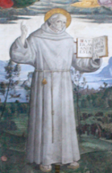
Siena College Franciscan Italy Pilgrimage
Tuesday 19 May ~ Sunday 31 May 2020

Day 1: Tuesday, May 19 USA / ITALIA
We depart Siena College in front of Siena Hall for our gateway city airport where we board our non-stop overnight flight to Roma, Italia. Dinner and breakfast aloft.

Day 2: Wednesday, May 20 ORVIETO / SIENA Feast Bernardine of Siena
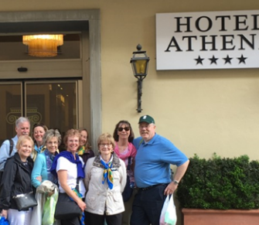
Upon arrival in Rome, we are met by our Italian/English speaking tour director Priscella who is with us throughout our pilgrimage. Our motor coach takes us to historic Orvieto, among the most dramatic cities in Europe, rising above the almost-vertical faces of tuff cliffs that are completed by defensive walls built of the same stone. We stroll through the cobblestone streets and take in the highlights of the city. We enjoy lunch at the Ristorante San Francesco, a former Franciscan refectory before we continue our journey to the home of our college’s patron: Bernardine of Siena. We get settled in for four nights at the Hotel Athena which offers a splendid view of the surrounding countryside characterized by its gently rolling hills, the profile of cypress trees and old farmhouses which add touches of color to the skyline. After a brief respite we enjoy a Tuscan dinner at Athena’s “Il Mangia” known for its tradition of fine food. www.hotelathena.com

Day 3: Thursday, May 21 –SIENA
This morning affords time to wake at our leisure, with free time to shop or meander through the gothic streets and Contrada of Siena. After lunch on our own, we meet our local guide Roberta, who introduces us to the wonders of Siena as she orients us to Bernardine’s home. Among the sites we’ll enjoy include the Dominican Church of Catherine of Siena, Siena’s great fan-shaped piazza Il Campo, the Palazzo Pubblico with its civic museum featuring precious frescos and the Duomo with its impressive black and white striped façade and wonderful floor mosaics. In the evening, we gather in Bernardine’s Contrada for a brief Prayer Service, a visit to the Contrada's museum and a festive dinner to celebrate with “Bernie’s” townsfolk and offer a toast to the founding Franciscan friars of the college and all who continue to embrace and exhibit the mission of Siena.

Day 4: Friday, May 22 FIRENZE
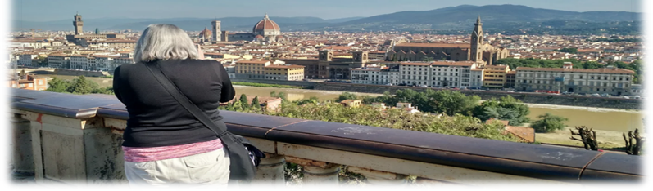
A full day awaits us as we begin the day with a short ride through the Tuscan countryside stopping at the Piazza Michelangelo, taking in the beauty and wonders of Florence. We’ll enjoy a leisurely walk into Florence, the jewel of the Renaissance. Others may ride the coach where we’ll meet at the Basilica of Santa Croce, one of the first missions of the Franciscans, this basilica in the Piazza Santa Croce, holds the tombs of many famous Florentines, including Galileo, Rossini, Michelangelo and Machiavelli. We’ll wander the narrow streets of Florence to the Piazza della Signoria, dominated by the Palazzo Vecchio and its embattlement-crowned tower. Across from the Palazzo, we visit the Loggia dei Lanzi to view Cellini’s bronze statue of Perseus and Giambologna’s The Rape of the Sabines and Hercules. We’ll walk to Florence’s gothic Santa Maria dei Fiori cathedral, the Duomo, with its dome completed by Brunelleschi in 1240; its campanile by Giotto; and the Baptistery, Florence’s oldest building, with gleaming bronze doors by Ghiberti. After a café break we’ll make our way to the Academy of Fine Arts to admire Michelangelo’s original David. The rest of the afternoon is free for lunch, personal adventure or shopping in this city of the Medici family. You may choose to visit the Uffizi Gallery, which holds the greatest collection of Italian paintings in the world, featuring works by Giotto, Leonardo, Raphael and Michelangelo; or perhaps you’ll simply walk across the Ponte Vecchio. In the early evening, we’ll head back to Siena for a relaxing Tuscan supper.
Day 5: Saturday, May 23 / SIENA
Today affords us free time to explore Bernardine’s city at our leisure. The adventuresome may want to climb the 300 step iconic tower overlooking Siena’s piazza il compo. Medieval art lovers may enjoy the Pinacoteca, an uncrowded colorful museum which traces the history of the city. In the evening we’ll enjoy a Tuscan dining experience at Ristorante La Compagna del Vinattieri.

Day 6: Sunday, May 24 SIENA / CORTONA / ASSISI Dedication Basilica Francis of Assisi
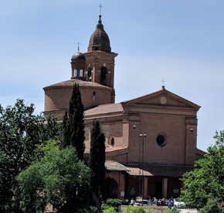
We begin our Sunday morning with a visit to the Basilica all’Osservanza of St. Bernardine our patron, considered the most eminent preacher of the fourteenth century. We join local Sienese parishioners to celebrate a typical Sunday Mass. Bernardine endorsed the construction of the chapel on this hill overlooking the city of Siena. We’ll visit his “cell” which has been recreated inside the friary along with the museum that displays his relics, including habit and the icon with the IHS trigram he displayed during his sermons. The simple architecture of the outside of the basilica contrasts with the elegant and harmonious interior, in typical Renaissance style; its remarkable works of art are important testaments to the Sienese and Florentine art produced between the fourteenth and sixteenth centuries. Departing Siena, we journey “Under the Tuscan Sun” to Cortona, home of Franciscan St. Margaret of Cortona’s church which affords splendid views. After lunch on our own with plenty of time to explore this medieval city we travel on to the mystical town of Assisi and the Hotel Fontebella. Dinner tonight at Il Frantoio provides a breath taking panorama of the valley below while we enjoy traditional Umbrian cuisine. www.fontebella.com

Day 7: Monday, May 25 ASSISI
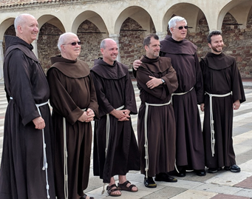
This morning we wake to the sound of bells from the churches of Assisi. To ground us in the heritage of Francis and Clare, we begin with Eucharist at the tomb of the patron of the Friars. Following Mass we’ll pause for a group photo with the basilica as our backdrop. One of the friars will share the story of Francis through the frescos of the basilica. After some time for coffee, we’ll embark on a walking tour with our friars. At the Basilica of Santa Chiara, we venerate Clare’s tomb and the original San Damiano crucifix that spoke so powerfully to St. Francis. Kneeling before the cross, we pray Francis’ words: Most high and glorious God, enlighten the darkness of my heart and give me a correct faith, a certain hope, a perfect charity, sense, and knowledge so that I may carry out your holy and true command. The afternoon is free for lunch and time to revel in the spirit of Assisi. This evening we stroll to a local restaurant, Ristorante Medevio Assisi, for dinner.

Day 8: Tuesday, May 26 ASSISI
Our morning is free to explore Assisi at our leisure. After lunch on our own, taxis take us to the Church of San Damiano where Francis prayed before the cross and wrote the “Canticle of Creation,” and Clare lived for many years. Then it's up the hills of Assisi to the Hermitage of the Carceri, where Francis and his friars retreated from the world to pray and fast. In the glass-walled chapel that overlooks the valley, we pause for prayer. After time for contemplation in the quiet of this hermitage, we return to Assisi. Dinner tonight at Il Frantoio, overlooking the valley of Assisi.

Day 9: Wednesday, May 27 ASSISI
This morning we ride into the valley of Santa Maria degli Angeli pausing at Rivo Torto, one of the first ministry sites of the friars and then onto the Basilica of St. Mary of the Angels, which houses Francis’ Church of the Little Portion, the Portiuncula. This birthplace of the Franciscan Order is known as a place of reconciliation, which will be the focus of our reflection. Our coach returns us to Assisi (walking is an option) where the afternoon is free for lunch at a local trattoria with time to explore the winding, cobblestone streets of Assisi. This evening we’ll wander up the hillside for a final sunset view of the valley to enjoy dinner at a lovely local ristorante, Le Terrazze di Properzio.

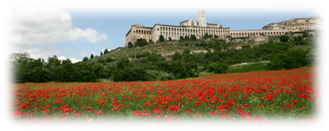
Day 10: Thursday, May 28 ASSISI / GRECCIO / ROMA
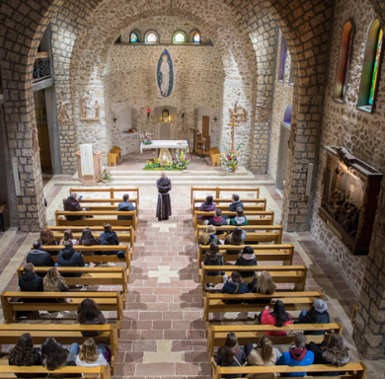
This morning we travel south toward Rome, stopping in the Rieti Valley to visit the town of Greccio, where Francis brought to life the Christian story of the incarnation. We celebrate a “Christmas” service in the Sanctuary of Greccio surrounded by crèches from around the world. Lunch will be together at the acclaimed Il Nido overlooking the scenic Rieti Valley. We continue on to the eternal city, where we are met by our Roman guides at the gates of St. Isadore’s Irish Franciscan Friary. We’ll enjoy a “Baroque walk”, of well-known sites of Ancient & Old Rome, including the gates of St. Isadore, Spanish Steps, the Trevi Fountain, the Arch of Constantine, the Pantheon, concluding at Piazza Narvona. Before concluding our day, we check into Il Cantico. Following a relaxing dinner, you may enjoy a short walk to St. Peter’s square designed by Bernini or simply enjoy the view from the rooftop terrace. www.ilcantico.it

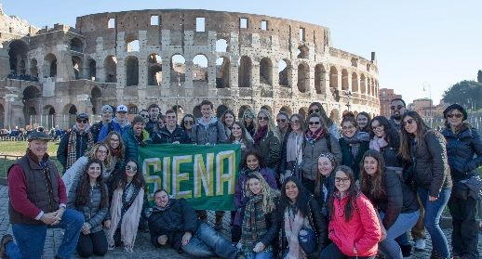
Day 11: Friday, May 29 ROMA
This morning we rejoin our Roman guides who will lead our tour of the Coliseum, the largest amphitheater in the world a marvel of Roman architecture and engineering, and the Roman Forum concluding at Ara Coeli (a Franciscan Church since the 1250's boasting a famous fresco of Bernardine of Siena). The afternoon is free for lunch on our own and exploring Roma. In the evening we stroll to Ristorante Le Terme del Colosseo to enjoy the culinary delights of Rome in a festive celebration of Italy’s capital city.

Day 12: Saturday, May 30 STATO DELLA CITTÀ DEL VATICANO
Early this morning we celebrate Eucharist at the tomb of St. Peter after which we’ll enjoy the stillness of this magnificent basilica and encounter the beauty of The Pieta taking in the magnificent dome of this major basilica also designed by Michelangelo. where we’ll have time for lunch on our own. Rejoining our guides they’ll lead us through a delightful adventure as we marvel at the treasures of the Vatican Museum and Gallery, Raphael’s Rooms with their wonderful frescos, and Michelangelo’s handiwork in the Sistine Chapel. Following lunch on our own the rest of the afternoon is free before we relish our final night in Roma!

Day 13: Sunday, May 31 ROMA / USA Pentecost
Today we say “Arrivederci Italia” as we make our way home with memories to last a lifetime for the final journey home to Siena College.

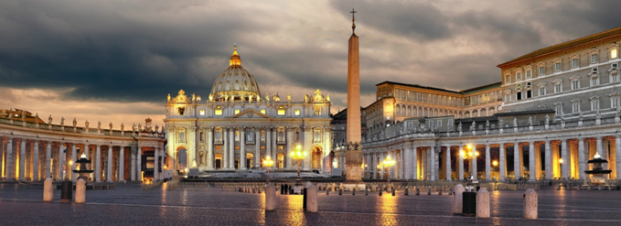

This itinerary is subject to change.

Siena College Pilgrimage to Franciscan Italy 2020 TERMS AND CONDITIONS

IMPORTANT NOTICE for individuals needing assistance: Our tour operates outside the U.S. where the Americans with Disabilities Act (ADA) is not applicable and facilities for disabled individuals are limited. Most transportation services, including tour buses, are not equipped with wheelchair ramps or lifts. We cannot provide individual assistance to any tour participant for walking, dining, while in their room, on flight, getting on and off motor coaches and other vehicles, or other personal needs. A qualified and physically able companion(s) must accompany travelers who need special assistance. It is the tour participant’s responsibility to arrange for such assistance prior to making a reservation.

DEPOSITS AND RESERVATIONS: A $410 (cash discount $400) per person deposit is required at the time of reservation, along with the full name, address, telephone number, e-mail address of the individual traveling and a signed release and waiver of liability.

NEXT PAYMENT of $1,025.00(cash discount $ 1,000.00) is due Nov. 1, 2019. FINAL PAYMENT of the remaining balance is due February 1, 2020.

ALL PAYMENTS ARE NON-REFUNDABLE: Your pilgrimage was priced using the lowest available airfare and group hotel rates. Due to special deposits required and in order to comply with the demands of our airlines and hotels, we are not able to offer refunds except as required by the NYS Truth in Travel Act.

TRAVEL INSURANCE: To avoid loss, we highly recommend that tour participants have the following types of insurance:
- Trip interruption insurance
Covers cancellation of a tour due to medical problems before departure. Also covers participants who must return home early due to illness, injury or emergency.
- Hospitalization and evacuation insurance
Covers injury or accident while touring. [Please check your health insurance to determine whether you are covered for travel abroad.]
- Theft and loss of luggage
[Before buying additional insurance, check your homeowners insurance. You may already be covered while traveling.]

PASSPORTS: A valid passport is required for all travelers. Passport must be valid to December 1, 2020 or later. For information on acquiring a US Passport, refer to the Department of State website at: https://travel.state.gov/content/travel/en/passports/apply-renew-passport.html

RESPONSIBILITY: The tour operator, Siena College, Loudonville, NY acts only in the capacity of agent in making arrangements with various transportation companies, hotels, restaurants, contractors and persons carrying out services in connection with the tour as described in the brochure and/or online documentation. Siena College, its trustees, officers, employees, and agents do not assume any liability whatsoever for any claim, injury, damage, loss, accident or delay to person or property because of any acts of war or terrorism, force majeure, any act of default or other acts or omissions of any hotel, carrier, restaurant, company or person rendering any of the services in connection with the pilgrimage. The carriers, accommodations, and other suppliers providing services are independent contractors and are neither agents nor employees with Siena College. All travel tickets, coupons and documents for services issued are subject to the terms and conditions specified by the supplier and to the laws of the countries in which the services are supplied.
- The tour operator reserves the right at its discretion to change or alter any part of the itinerary, hotel accommodations or aircraft equipment without notice. The right is reserved to decline or accept or retain at any time any person as participant in any tour, or to cancel any tour.
- The schedules contained herein are subject to change without notice.
- All rates are quoted in US currency based on exchange rates in effect at the time of printing of the tour brochure/online posting and are subject to adjustment without prior notification.
- Rates are based on the number of participants. In the event of changes therein, rates are subject to adjustment without prior notification.
- All tickets, coupons, tariffs, rules or contracts in use by any carrier, hotel, restaurant or other contractor rendering services shall constitute the sole contract between such contractor and the tour participant.
- The contract in use by transportation companies concerned shall constitute the sole contract between the transportation companies and the tour participant. The airline(s) providing transportation are not to be held responsible for any act, omission, or event during the time that passengers are not on board their aircraft or conveyances. In the event the air carrier with whom the chartering organization has a contract to perform the air transportation described is delayed in performance or unable to perform with such aircraft, the provision of the relevant Civil Aeronautics Board Economic Regulations and/or relevant IATA/ARC regulation shall govern the right and obligations of the parties.

