**TABLE OF CONTENTS**

**ECONOMICS**

**I AM NOT AN ICONOCLAST. BUT FREEDOM MIGHT NOT MAKE US HAPPY.**

Author: Samuel A. Necrason

Faculty Mentor: Dr. Scott Trees

**ECONOMICS OF SUBJECTIVE WELL-BEING**

Author: Ankit Desai

Faculty Mentor: Manimoy Paul

**CLOSING THE CHASM: USING AID TO IMPROVE HEALTH OUTCOMES**

Author: Samuel A. Necrason

Faculty Mentor: Dr. Smita Ramnarain

**THE NEW LABOR FORCE: MORE (ARTIFICIALLY) INTELLIGENT THAN EVER**

Author: Samuel A. Necrason

Faculty Mentor: Dr. Larry Medsker

**AN EVALUATION OF THE ALBANY COUNTY COMMUNITY ACCOUNTABILITY BOARDS**

Authors: Karen Kirker and Dylan Keyer

Faculty Mentor: Dr. Ashley Provencher

**ENTREPRENEURSHIP**

**HELPIR (HOW EVERY LITTLE PROBLEM IS RESOLVED)**

Authors: Marlee Wacholder, Peter Tasca and Sage Stebbins

Faculty Mentor: Prof. Matthew Cusack

**TEACH ME**

Authors: Jen Hogan and Kevin Danaher

Faculty Mentor: Prof. Matthew Cusack

**SUNDIAL**

Authors: Simon Bruno and Julian Lavelle

Faculty Mentor: Prof. Matthew Cusack

**FINEST TIDE OYSTERS**

Author: Rob Ewing

Faculty Mentor: Prof. Matthew Cusack

**FINANCE**

**EFFECT OF CASH CONVERSION CYCLE ON LIQUIDITY ANALYSIS**

Author: Senan Lonergan

Faculty Mentor: Dr. Jenny Zhao

**MARKETING**

**CORPORATE ACTIVISM: MARKETING IMPACT ON TODAY’S SOCIETY**

Authors: Matthew Potts, Michael Corcoran, Michael Talarico and Kenneth Newman

Faculty Mentor: Dr. Raj Devasagayam

**EMOTIONAL BRANDING AND SOCIAL MEDIA USAGE: TOWARDS AN UNDERSTANDING OF THE “*SCHOOL OF BUSINESS”* BRAND**

Author: Heather Leo

Faculty Mentor: Dr. Cheryl Buff

**THE LINK: PARENT COMPANIES AND THEIR PRODUCT LINES**

Authors: Heather Leo, Chandler Gibbons, Neill Dickenson and Julia Jobin

Faculty Mentor: Dr. Raj Devasagayam

**UNDERSTANDING HOARDING BEHAVIOR: A MARKETING PERSPECTIVE**

Authors: Jennifer DeMaria and Diana King

Faculty Mentor: Dr. Raj Devasagayam

**QUANTITATIVE BUSINESS/MANAGEMENT**

**FACTORS AFFECTING RETENTION AT SIENA COLLEGE**

Author: Kyle Aberasturi and Haleigh Topetro

Faculty Mentor: Dr. Manimoy Paul

**LEGO GROUP – 2016 SPENCER-RIMS RISK MANAGEMENT CHALLENGE**

Authors: Michael O’Connell, Amelia Hastings, Anthony Perre and Dylan Cirrilla

Faculty Mentor: Dr. John O’Neill

**I AM NOT AN ICONOCLAST. BUT FREEDOM MIGHT NOT MAKE US HAPPY.**

***Samuel A. Necrason, Siena College***

***Dr. Scott Trees, Siena College***

***ABSTRACT***

*Does freedom make people happy? The arguments surrounding the issue are antithetical; some claim “of course”, while others claim “of course not”. To determine the relationship between freedom and happiness, data was gathered from countries around the world on happiness, freedom, and other variables that may influence happiness. The data was applied in an economic model, and the model suggested that freedom might not make people happy.*

**INTRODUCTION**

“Life, liberty, and the pursuit of happiness”. The iconic operative claim of the United States Declaration of Independence, a brick in the foundation of a country grounded in the belief that freedom is the gateway to happiness. A statement so profound, a true declaration of independence that has inspired novel policymakers, fervent patriots, and beloved heroes to craft the history of their beloved country for over 230 years. A faulty premise?

Does freedom make people happy?

This paper presents a framework to understand the relationship between freedom and happiness. It has been suggested that freedom, in fact, may not make people happier. By conducting a global, cross-sectional econometric analysis, the model applied in this study suggests that freedom may not be a “gateway to happiness”.

**LITERATURE REVIEW**

Understanding happiness is a presumably important, but admittedly difficult, feat due to the erratic, intangible nature of the human spirit. Academics have tried to understand happiness for scholastic eons. In the Philosophy 101 requisite read, “Aristotle’s Function Argument”, Aristotle offers that the *ergon* (telos, or function) of man is to preform rational activity well. Scholars have clarified, for those not familiar with ancient Greek, that *ergon* is exercised in pursuit of *eudaimonia*, or “living well”. *Eudaimonia*, as philosophy scholars have also conveniently clarified, is not necessarily happiness. In an attempt to paraphrase and interpret a 2000-year old philosophical argument into a simple declaration: a good (but not necessarily happy) life is a rational life. I Two millenniums removed from the suggestions of Aristotle, man is yet to live a completely rational life. Fortunately, this has kept economists employed. Perhaps in an irrational pursuit, scholars are still attempting to understand something that most people enjoy: *happiness*. In addition to simply understanding what happiness is, there have been several attempts to investigate what makes people happy. It has been proposed that freedom, or the ability to think and act without restraint, may have some influence on happiness.

Economist Amartya Sen emphasizes the importance of freedom in many of his works, and would propose that freedom is an important, if not critical, part of a rich (assumedly happy) life. Harvard psychologist Dan Gilbert, the inspiration of this study, argues the contrary.

In a 2004 TED talk, *The Surprising Science of Happiness,* Gilbert suggests that freedom hinders happiness.ii In this presentation, Gilbert makes a distinction between two types of happiness, “synthetic happiness”, and “natural happiness”. He claims that synthetic happiness, or “what we make when we don't get what we wanted” is “…every bit as real and enduring as the kind of [natural] happiness you stumble upon when you get exactly what you were aiming for.” After presenting a handful of psychological studies, Gilbert presents the following foundation for his thesis:

…[T]hat freedom -- the ability to make up your mind and change your mind -- is the friend of natural happiness, because it allows you to choose among all those delicious futures and find the one that you would most enjoy. But freedom to choose, to change and make up your mind, is the enemy of synthetic happiness.

**ECONOMIC MODEL**

The interest of this study is not to compare preferences of hotdogs to hamburgers on an individual scale. Instead, this study presents a macroeconomic analysis of the influence of national features, both tangible and intangible, such as income and freedom, on perhaps the most tantalizing intangible of all: happiness.

The central economic model of this study challenges a core assumption of many introductory level microeconomic analysis courses: the “more is better” condition, or the principle of non-satiation. Rather, the model proposed in this study offers a more realistic relationship: “more is not *always* better”.

Before examination of the data, it is expected that more freedom may not necessarily result in more happiness. The return of happiness to freedom is expected to eventually be diminishing, and likely turn negative after a certain threshold (a parabolic form).

The expectation of diminishing happiness returns to freedom is partially founded on anecdotal assumptions, as well as the review of psychological studies, such as Dan Gilbert’s “Decisions and Revisions: The Affective Forecasting of Changeable Outcomes”. Happiness is expected to eventually diminish with increases in freedom for a simple reason: freedom can be overwhelming. When provided with absolute freedom, the cognitive dissonance that results from the array of possibilities may hinder happiness.iii Of course, a baseline level of freedom, as to not be subject to undue oppression, can improve happiness.

To illustrate the proposed model, consider two confectionary stores. Each store has three categories of sweets. Store A offers two selections in each category, and Store B offers nine. Clearly, the selection of 6 candies in Store A is much easier to navigate than the 27 choices in Store B. Customers of Store A are likely given “just enough” freedom, where they can satisfy their craving for sweets while avoiding any food allergies. Relative to the patrons of Store A, the shoppers at Store B are likely afforded too much freedom, and are more likely to be overwhelmed by, or regret, their choices.

**EMPIRICAL METHODOLOGY**

**Data Description**

Happiness, the dependent variable in this study, is measured by a simple yet eloquent poll conducted by Gallup, which asks respondents about their “experienced well-being”. This metric is used in various other studies, such as the Happy Planet Index composed by the new economics foundation (nef). Nef eloquently defends the variable as an acceptable measure of happiness by claiming [i]f you want to know how well someone’s life is going, your best bet is to ask them directly.

…[E]xperienced well being is assessed using a question called the ‘Ladder of Life’ from the Gallup World Poll. This asks respondents to imagine a ladder, where 0 represents the worst possible life and 10 the best possible life, and report the step of the ladder they feel they currently stand on. iv

This scale of 1-10 provides an easy to interpret measure of happiness across countries.

The primary explanatory variable, “freedom”, for the sake of this study, is considered the degree to which societal institutions allow for people to choose how they work, produce, consume, and invest their resources. Freedom is measured using The Heritage Foundation’s Index of Economic Freedom, which considers a total of ten categories, quantitative and qualitative, that fall within four broad categories: rule of law (property rights, freedom from corruption); limited government (fiscal freedom, government spending); regulatory efficiency (business freedom, labor freedom, monetary freedom); and open markets (trade freedom, investment freedom, financial freedom).v

As briefly mentioned in the proposed economic model, a minimum degree of freedom is likely critical for people to be happy; however, there are other factors that may improve happiness. In addition to freedom, this study will consider and control for other important ancillary dynamics. The control variables in this study include health, education, income, inequality, safety, religiosity, and cannabis consumption.

The adage that “health is wealth” implies that health is an important factor to a fruitful life. This adage, coupled with the standards of macroeconomic studies, suggests that health will be an important control variable in this study.

In this study, the concept of health is measured using life expectancy. Life expectancy is an elegant variable that captures the health of a nation in a simple manner. Consideration was given to other mortality indications, such as crude death rates and infant mortality. However, life expectancy seems to be the most reliable measure of health, particularly when examining happiness. Crude death rates may be considerably distorted by temporary factors such as disease outbreak or war. Infant mortality rates are a good measure of a health system, but not personal health. Life expectancy, however, reasonably captures general personal health on an aggregate basis, based on the premise that healthier people live longer. Health status indicators (such as obesity or heart disease), health determinants (such as smoking and breastfeeding), are all likely inappropriate metrics for this study due to regional discrepancies. These variables may be utilized in further investigation of the relationship between health and happiness.

Education is widely considered a critical variable in many macroeconomic studies, so it will also be used as a control variable in this study. Education is measured using the methodology of the Human Development Index (HDI). This measure is compiled considering the …mean of years of schooling for adults aged 25 years and expected years of schooling for children of school entering age. Expected years of schooling estimates are based on enrolment by age at all levels of education. Expected years of schooling is capped at 18 years. The indicators are normalized using a minimum value of zero and maximum aspirational values of 15 and 18 years respectively. The two indices are combined into an education index using arithmetic mean.

Income will also be controlled for in this study, due to the likely influence income has on happiness. In this study, income is measured by gross national income (GNI) per capita, in terms of purchasing power parity (PPP). GNI per capita, PPP is the total income of a country, divided by the number of residents within a country, in an international dollar amount. This measures the average income for each person within a country, and the purchasing power that income holds in respect to the price of goods and services within their country.

GNI per capita, PPP alone may not provide a robust control for the impact that income may have on happiness. The distribution of income within a population may also influence happiness, so inequality will also be used as a control variable in the study. The standard Gini index will be the measure of inequality in this study. According to the WorldBank, the Gini Index measures the extent to which the distribution of income or consumption expenditure among individuals or households within an economy deviates from a perfectly equal distribution. A Lorenz curve plots the cumulative percentages of total income received against the cumulative number of recipients, starting with the poorest individual or household. The Gini index measures the area between the Lorenz curve and a hypothetical line of absolute equality, expressed as a percentage of the maximum area under the line. Thus a Gini index of 0 represents perfect equality, while an index of 100 implies perfect inequality.vi

Although important, the theoretical arguments of relative versus absolute inequality, as well as racial and gender inequality are beyond the scope of this study. These may be areas for further investigation between the relationship of income inequality and happiness.

As suggested by the Declaration of Independence, safety and happiness are likely closely related.vii As such, this study will control for the influence safety may have on happiness by measuring the intentional homicide rate, per 100,000 persons within a country. Intentional homicide rate is applied with the following assumption: the more homicides within a country, the less “safe” that country is considered.

Beyond physical safety, some individuals may argue for the importance of “safety of the soul” in a happy life. The function of religion, a complex and heated area of study well beyond the scope of this study, will be simplified as “a happiness factor”. Thus, it will be important to control for religion. Religiosity will be measured using data from a simple yes/ no poll conducted by Gallup, in which respondents are asked whether religion is important to them or not.

Lastly, cannabis consumption will be controlled for in this study. Cannabis has been associated with feelings of euphoria, as well as contrary sensations that may decrease happiness.viii Cannabis use will be measured by the general prevalence of cannabis use of persons between the ages of 15 and 64, expressed as a percentage of the total population.

**REGRESSION EQUATION**

Using the BLUE method of OLS, the following multivariate regression equation will be used in the empirical analysis of this study:ix

*Happiness = β1 + β2Freedom + β3Health + β4Income + β5Edu + β6Pot + β7Inequal + β8Crime +*

*β9Religion*

It is expected that freedom will not have a significant influence on happiness. As stated in the model and the methodology sections of this paper, freedom likely does not make an individual happier. Health, income, and education, however, all likely have significant, positive, relationships with happiness. These three these variables likely exhibit a “more is better” dynamic when considering happiness. Inequality and crime may both have a significant, negative relationship with happiness (less is better). Lastly, cannabis consumption and religion may exhibit an insignificant relationship with happiness, due to their variable and potentially self-contradictory nature.

Complete data for a sample of 87 countries has been gathered for this regression analysis.

The complete dataset includes countries from an array of geographic, political, and income groups. A brief overview of this information can be found in the table below:

**Metadata Analysis**

|  |  |
| --- | --- |
|  | **Region** |
| **Income Group** | **Europe Middle**  **East & Latin East & Sub-**  **Asia & Central America & North North South Saharan Grand**  **Pacific Asia Caribbean Africa America Asia Africa Total** |
| High income: nonOECD | - 4 4 - - - - **8** |
| High income: OECD | 2 21 1 1 2 - - **27** |
| Low income | 1 - 1 - - - 5 **7** |
| Lower middle income | 3 5 5 2 - 3 3 **21** |
| Upper middle income | 2 9 11 1 - - 1 **24** |
| **Grand Total** | **8 39 22 4 2 3 9 87** |

**RESULTS**

After running the complete multivariate regression, it was determined that there was a substantial degree of multi co-linearity, as well as little additional explanatory value, with the inclusion of β5 (Education) in the model. This is likely due to the high correlation between income and education, as suggested by the following scatterplot:



**Simple Regression: Income and**

**Education**

1.20

1.00

0.80

Education Index (2013)

**Education Index**

0.60

0.40

0.20

Linear (Education Index

(2013))

0.00

0 20 40 60 80

**GNI per capita, PPP (thousands)**

y = 8E-06x + 0.5296

R² = 0.62832

The new regression model,

*Happiness = β1 + β2Freedom + β3Health + β4Income + β6Pot + β7Inequal + β8Crime + β9Religion*

exhibited an acceptable degree of multi co-linearity for analysis. This model was also investigated for other violations of assumptions, including heteroscedasticity and autocorrelation. It was determined that this model was suitable for analysis. After running the refined regression model with a 95% confidence interval, the following results were obtained:

**Model Summary**

Adjusted R

Std. Error of

Model R R Square

Square

the Estimate

1

.857a .735 .711 .618353339

a. Predictors: (Constant), Religion is Important, Percent of Population, Annual Cannabis Use, Percent of Population, Intentional Homicide Per 100,000, Life Expectancy at Birth (2013), Economic Freedom (2015), Gini Coefficient, GNI Per Capita, PPP

**Coefficientsa**

|  |  |  |  |  |  |
| --- | --- | --- | --- | --- | --- |
| Model | Unstandardized  Coefficients | | Standardized  Coefficients | t | Sig. |
| B | Std. Error | Beta |
| 1 (Constant) Economic Freedom (2015)  Life Expectancy at Birth  (2013)  GNI Per Capita, PPP Annual Cannabis Use, Percent of Population Gini Coefficient  Intentional Homicide  Per 100,000  Religion is Important, Percent of Population | -.374 | 1.122 |  | -.333 | .740 |
| -.016 | .010 | -.129 | -1.575 | .119 |
| .065 | .014 | .406 | 4.565 | .000 |
| 5.297E-5 | .000 | .679 | 6.064 | .000 |
| .053 | .024 | .147 | 2.185 | .032 |
| .013 | .011 | .104 | 1.210 | .230 |
| .021 | .006 | .262 | 3.465 | .001 |
| .555 | .396 | .124 | 1.401 | .165 |

a. Dependent Variable: Well-being

(0-10)

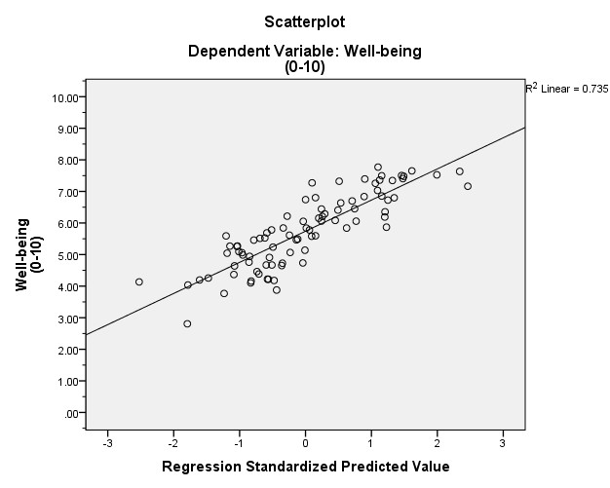

As anticipated, the primary explanatory variable, Economic Freedom (β2), did not have a significant relationship with happiness as suggested by the |t-stat| < 2 and p-value > 0.05). The model suggests that freedom, indeed, does not improve happiness. This is fascinating.

Consider the work of Nobel Prize winning economist Amartya Sen (briefly mentioned in the Literature Review section of this paper), whose primary publication, “Development as Freedom”, suggests that the freedoms considered in this study are the vehicle for economic development and a robust life. In consideration of a robust (and presumably happy) life, the results of this study suggest otherwise. In respect to Sen, further consideration may be given to the relationship between freedoms and economic development. Furthermore, dismantling the Heritage Foundation Index of Economic Freedom to consider the relationships between certain *types* of freedom and happiness is an area for further consideration (as well as considering other metrics of freedom and happiness than those used in this study).

Nonetheless, the suggestion of this model, that there is no significant relationship between freedom and happiness, challenges the popular assumption that “more free is more better”. Freedom, the illusory act of balancing free will with proper societal intervention and obligations, may be a hapless pursuit if happiness is the end goal. Beyond suggesting that there is no relationship between freedom and happiness, the model in this study suggests that four of the seven control variables (β3, Life Expectancy; β4 Income; β6, Cannabis Consumption; and β8, Crime) have statistically significant relationships with happiness.

Of the control variables that exhibited significant t-stats and p-values, the beta value of cannabis use (β6), 0.053, has the most considerable practical implications. Consider the following scenario: if a Sample A has 19% more cannabis users than Sample B, this model projects that Sample A will be an entire “rung” on the “ladder of life” higher (no pun intended) than Sample B, ceteris paribus.Although health (β3), was statistically significant in the model, consider the beta value of health, approximately 0.065. This means that with a 1-year in life expectancy, happiness will increase by 0.065 points. To illustrate the meaning of this value, consider the following ceteris paribus scenarios:

|  |  |
| --- | --- |
| *Improving Life Expectancy Improves happiness by by* | |
| 1 year 0.065 | points on a scale of 1-  10 |
| 5 years 0.325 |
| 10 years 0.65 |
| 20 years 1.3 |
| 40 years 2.6 |

The model suggests that living 20 years longer can result in a subject being 1.3 points happier on a scale of 1-10. However, increasing life expectancy at birth within a country by 20 years is relatively a relatively large feat. To better understand the relationship between health and happiness, further investigation into this area may be beneficial.

In respect to the relationship between income and happiness, this model suggests that

increasing GNI per capita, PPP (β4), by $20,000 will have a 1-point increase in happiness (β4 had a beta value of 5.297E-5, or 0.00005297). To put this in change in perspective, $20,000 is the difference in per capita income between Turkey and France. In other words, money *may* buy happiness, but it will take a lot of it.

Surprisingly, of the last statistically significant control variables, the beta value of homicide

rates (β8) was positive (0.021). This suggestion that an increase in homicide rates will increase perceived well being is blatantly counterintuitive. When new data becomes available, this relationship should be reconsidered with the existing model. If the existing model suggests a similar finding, constructing a new model with a different form could provide further insight into this unexpected relationship.

In respect to the control variables considered statistically insignificant in this model, the

suggestion that inequality (β7) has no relationship with happiness contradicted the deductive expectations expressed in the Empirical Methodology section of this paper. When subject to a simple regression model, the t-stat of inequality was even less statistically significant (|0.595|). What does this mean? According to the application of this data, income inequality does not influence happiness. Aside from the popular outcry that income inequality poses a threat to global economic stability (an issue beyond the scope of this paper), this model suggests that actual income inequality does not make people any more or less happy.

The final control variable, religiosity (β9), exhibited the expected outcome of “no relationship” (with a t-stat and p-value of 1.41 and 0.165, respectively). As previously suggested, the function of religion is as mysterious as religions themselves. This model supports the suggestion that religion does not necessarily make people happy.

The adjusted R-square value of 0.711 implies that the variables included in the model explain 71% of the movement in the variable of interest, perceived well-being. Considering the perceived complexity of what makes people happy, providing explanation to 71% of happiness is likely considered to be a substantial contribution to the study of the “economics of happiness”.

**CONCLUSION**

What makes people happy? Freedom? Arguments on this issue are conflicting. Amartya Sen, widely (and personally) regarded as an innovative, top-tier economist would likely claim that freedoms, indeed, are critical for a rich and happy life. Harvard psychologist Dan Gilbert suggests otherwise. Gilbert argues in his TED talk, “The Surprising Science of Happiness”, that freedom can be an impediment to happiness.

Intuitively, freedom may be closely associated with happiness. However, after internalizing the influence freedom has on happiness, it may be suggested that freedom can be overwhelming, and potentially hinder happiness. The results of this study suggest that freedom has no influence on happiness. Rather, factors such as health and income, and even cannabis consumption, can make people happy. Perhaps an equally valid question, what makes people unhappy, is peripherally addressed in this study. This study suggests that widely considered “important” aspects of life, such as religion and inequality, do not make people unhappy, nor do they make people happy. They simply just “are”.

The Results section of this paper makes a best-effort attempt at addressing areas for further investigation as well as potential shortcomings of the applied model. As with any economic analysis, the exhaustive list of the pitfalls and assumptions in this study can only be identified addressed with the efforts of the academic community at-large. Although this study suggests that freedom does not improve happiness, this is study is not a dismal prognosis for humanity, nor is it an affirmation for oppressive government regimes. Rather, this study attempts to provide a beacon of light to those not afforded an “abundance of freedom”. Many will argue, including Dan Gilbert, that happiness can be synthesized even when subject to the most dire of circumstances. As a closing recommendation from the author: do not wait for freedom- find happiness.

**ENDNOTES**

i Information on how to locate Aristotle’s complete *Nicomachean Ethics* can be found in the

References section

ii Information on how to locate Gilbert’s complete TED talk can be found in the References section iii This statement suffices as an adequate paraphrase of Gilbert’s study, and the general premise of the “Free choice paradigm” presented by Jack Brehm

iv Information on how to locate the Happy Planet Index website can be found in the References section

v Information on how to locate the Economic Freedom Index website can be found in the References section

vi Information on how to locate the WorldBank description of the Gini coefficient can in the

References section

vii Information on how to locate the complete transcribed version of the Declaration of

Independence can be found in the references section

viii More information on this study can be found in the References section

ix The proposed regression model is not in the same order as the explanation of the data listed under the “Data Description” section of this paper, due to the fact that data analysis was completed for a related, project completed prior to the composition of this paper

**REFERENCES:**

Aristotle, & Ross, W. (1994). Nicomachean Ethics. 1.7. Retrieved August 2015 from Internet

Classics Archive. <http://classics.mit.edu/Aristotle/nicomachaen.html>

Aristotle’s Nicomachean Ethics is widely considered cornerstone in philosophy. In this study only Chapter 1, Section 7, the “Function Argument” was referenced.

Brehm, J. (1956). Postdecision Changes In The Desirability Of Alternatives. *The Journal of*

*Abnormal and Social Psychology*, 52(3), 384-389. doi:10.1037/h0041006

Brehm is a major contributor to the psychological field of studying cognitive dissonance. This particular publication seems to provide the framework for a large portion of Dan Gilbert’s argument in the TED talk referenced in this paper.

Gilbert, D. (2004, September 1). The surprising science of happiness. [Video File]. Retrieved from:

<http://www.ted.com/talks/dan_gilbert_asks_why_are_we_happy?language=en>

In this TED talk, Gilbert explains many fascinating psychological theories. In respect to this study, the premise that freedom may hinder happiness, and the concept of synthetic happiness, were most referenced.

Happy Planet Index, the new economics foundation. (2015) *HPI, Experienced well-being.*

*2015*. [Data File] Retrieved from <http://www.happyplanetindex.org/data/>

The experienced well-being data from nef’s HPI served as the independent variable in this study. This measure asks respondents where they consider, on a scale of 1-10 their quality of life to be.

Index of Economic Freedom, The Heritage Foundation. (2015) *Index of Economic Freedom,* *2015*.

[Data File]. Retrieved from <http://www.heritage.org/index/download>.

This index from the heritage foundation provided data to serve as the primary explanatory (X) variable in the study.

Sen, A. (1999). Development as Freedom. New York: Knopf.

Sen’s Development as Freedom was often paraphrased in this paper. Development as Freedom focuses on international development and argues that development entails a set of linked freedoms including political freedoms, freedom of opportunity, and economic protection from abject poverty.

The Declaration of Independence: A Transcription (paragraph 2). The U.S. National Archives and Records Administration. (n.d.). Retrieved August 2015 from <http://www.archives.gov/exhibits/charters/declaration_transcript.html>.

This is the transcript of the Declaration of Independence briefly mentioned throughout the paper.

The Heritage Foundation (2015). About the Index. Retrieved August 2015 from <http://www.heritage.org/index/about>.

An entry published by The Heritage Foundation that describes the elements and methodology of creating the Economic Freedom Index that was used in this study. The Heritage Foundation measured economic freedom based on 10 quantitative and qualitative factors, grouped into four broad categories, or pillars, of economic freedom: Rule of Law (property rights, freedom from corruption);Limited Government (fiscal freedom, government spending);Regulatory Efficiency (business freedom, labor freedom, monetary freedom); and Open Markets (trade freedom, investment freedom, financial freedom).

New economics foundation. (2015). About the HPI. Retrieved from <http://www.happyplanetindex.org/about/>.

An entry published by the new economics foundation that describes the methodology of creating their happy planet index. In this study, the “well-being” element (from a Gallup World Poll) was used to measure happiness.

Osborne, G., & Fogel, C. (2008). Understanding the Motivations for Recreational Marijuana Use Among Adult Canadians. *Substance Use & Misuse*, 43. 539–572. Retrieved August 2015. doi:10.1080/10826080701884911

This study seeks to explain why adults use marijuana, as well as some of the common side effects associated with cannabis consumption.

United Nations Development Programme, United Nations. (2014). *2014 Human Development Statistical Tables.* [Data File] Retrieved from <http://hdr.undp.org/en/data>

The education component of this index was used was applied as a control variable to measure education in the regression model.

United Nations Office on Drugs and Crime, United Nations (2012). *World Drug Report 2012.*

[Data File]. Retrieved from https://[www.unodc.org/unodc/en/data-and-analysis/WDR-](http://www.unodc.org/unodc/en/data-and-analysis/WDR-)

2012.html

The data on cannabis use, measuring the prevalence of cannabis use of persons aged 15-64 was applied as a control variable in this study.

United Nations Office on Drugs and Crime, United Nations (2013). *Global Study on*

*Homicide.* [Data File]. Retrieved from <http://www.unodc.org/gsh/en/data.html>

The data on intentional homicide rates, measured per 100,000 persons, was applied as a proxy for crime in the model.

Wingia, Gallup International. 2012. *Global Index of Religiosity and Atheism*. [Data File].

Retrieved from <http://www.wingia.com/web/files/news/14/file/14.pdf>

The data in Table 6 of this report, which contains the results of the yes/ no survey conducted by Gallup, asking respondents whether or not religion was important to them was applied as a measure of religiosity in this study.

World Health Organization, Global Health Observatory (2015) *Life Expectancy at Birth* [Data File]. Retrieved from <http://apps.who.int/gho/data/node.main.688?lang=en>

Life expectancy was used as a variable to measure health, a control variable in the regression model.

WorldBank, The WorldBank Group. (2015). *GINI Index (World Bank estimate)*. [Data File] Retrieved from <http://data.worldbank.org/indicator/SI.POV.GINI>

In addition to applying this data on Gini coefficient estimates as a control for income inequality in the model, the description of the Gini index was referenced in this paper.

WorldBank, The WorldBank Group. (2015). *GNI per capita, PPP (current international $).* [Data File]. Retrieved from <http://data.worldbank.org/indicator/NY.GNP.PCAP.PP.CD>

GNI Per capita was used as a variable to measure income, a control variable in the regression model. This data was eventually unused in the applied regression model.

**ECONOMICS OF SUBJECTIVE WELL-BEING**

***Ankit Desai, Siena College***

***Manimoy Paul, Siena College­­­­­***

***ABSTRACT***

*This study is to attempt to find a relationship between the well-being factor of a country and other economic factors of a country. We took well-being data scaled from 0-10, 0 being the worst possible life and 10 being the best possible life. In this study, the data was analyzed using stepwise regression. It was found that variables; ecological impact, life expectancy, unemployment, and Income GINI coefficient showed the strongest relationship to subjective well-being.*

**INTRODUCTION**

Subjective Well-being is a very abstract concept; people have had difficulty describing what subjective well-being truly is. Philosophers, psychologists, biologists and now even economists search for the true meaning of well-being.

Subjective Well-Being - includes the presence of positive emotions and moods (e.g., contentment, happiness), the absence of negative emotions (e.g., depression, anxiety), satisfaction with life, fulfillment and positive functioning” or simply “judging life positively and feeling good” according to the Center for Disease Control and Prevention (2013).

*The Cantril Self-Anchoring Scale, developed by pioneering social researcher Dr. Hadley Cantril, consists of the following:*

* *“Please imagine a ladder with steps numbered from zero at the bottom to 10 at the top.”*
* *“The top of the ladder represents the best possible life for you and the bottom of the ladder represents the worst possible life for you.”*
* *“On which step of the ladder would you say you personally feel you stand at this time? (ladder-present)”*
* *“On which step do you think you will stand about five years from now? (ladder-future)”*

(GALLUP POLL, 2015)

The Cantril Self-Anchoring Striving Scale:

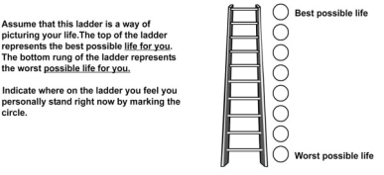

***“Thriving****-- wellbeing that is strong, consistent, and progressing. These respondents have positive views of their present life situation (7+) and have positive views of the next five years (8+). They report significantly fewer health problems, fewer sick days, less worry, stress, sadness, anger, and more happiness, enjoyment, interest, and respect.”* ***(GALLUP POLL, 2015)***

***“Struggling****-- wellbeing that is moderate or inconsistent. These respondents have moderate views of their present life situation OR moderate OR negative views of their future. They are either struggling in the present, or expect to struggle in the future. They report more daily stress and worry about money than the "thriving" respondents, and more than double the amount of sick days. They are more likely to smoke, and are less likely to eat healthy.”* ***(GALLUP POLL, 2015)***

***“Suffering****-- wellbeing that is at high risk. These respondents have poor ratings of their current life situation (4 and below) AND negative views of the next five years (4 and below). They are more likely to report lacking the basics of food and shelter, more likely to have physical pain, a lot of stress, worry, sadness, and anger. They have less access to health insurance and care, and more than double the disease burden, in comparison to "thriving" respondents.”* ***(GALLUP POLL, 2015)***

Well-being affects us, as human beings through our aspirations, our contribution to society and how we live our lives with each other. “It’s proven that people with higher happiness levels tend to perform better in the labor market and to earn more income in the future” (Diener et al. 2003; and Graham, Eggers, and Sukhtankar, 2004). Well-being is the measurement of life satisfaction that people spend their lives aiming to improve, which is why well-being of a country might be an even more important factor for world leaders and economist to look at than money. This is an investigation exploring the relationship of well-being and specific economic variables. Subjective well-being is a much broader term for happiness. Richard Ryan and Edward Deci (2001) defined well-being “as a complex construct that concerns optimal experience and functioning derived from two general perspectives: the hedonic approach, which focuses on happiness and defines well-being in terms of pleasure attainment and pain avoidance; and the Eudaimonic approach, which focuses on meaning and self-realization and defines well-being in terms of the degree to which a person is fully functioning”. But whether it is the hedonic approach or the Eudaimonic approach, our end goal is to find out which economic variables are related to happiness in the form of overall subjective well-being. This article will stand to say that there is something that economists and policyholders are looking for to make people happy. The data for the well-being factor of a country was taken from the Happy Planet Organization, which was originally collected from the Gallup World Poll global survey on well-being. The method Gallup used was Cantril Scale survey. The survey taker was asked to imagine themselves on a ladder and the top of the ladder meant the best possible life and the bottom of the latter meant the worst possible life; it was asked of the survey taker where they stood on that ladder (Gallup 2009). But why is it important for a country’s economy to consider its well-being? According to Andrew J. Oswald, “economic things matter only in so far as they make people happy” (Oswald, 1997). People struggle for their entire lives in pursuit of what makes their life worth living, but this is what makes this study so significant. We believe it can be pinpointed by first determining what economic variables are related to the well-being factor for a country’s people. But what are the economic variables that cause a country’s well-being to improve? Some research has shown income does not directly cause growth in well being (see, Easterlin, 2001) while other research points to longevity as an important part in an improved well-being factor (see, Veenhoven, 1996). Richard Easterlin concluded that “subjective well being varies directly with income and inversely with material aspirations”, meaning that some people find happiness by earning higher income and others do not. However, obtaining material possessions will not make anyone happier no matter how much they desire it (see, Easterlin, 2001). Ruut Veenhoven (1996) argued that “an evident advantage to measuring quality of life by longevity alone is that the subjects’ appraisal of life is acknowledged” and that “the longer and happier the citizens live, the better the provisions and requirements of society apparently fit with their needs and capacities” (Veenhoven, 1996). The variables that were used in this study however are: life expectancy, ecological footprint, infant mortality, household final consumption expenditure, health care, intentional homicides, expense, military expenditure, total natural resources rent, agriculture, unemployment, fertility rate and the GINI Coefficient (the definitions and sources of the variables can be found in **appendix I**). Although we found some variables to be unrelated, this only brings us to the point that governments and it’s citizen’s may be putting our attention in the wrong places if our ultimate goal happiness.

**HYPOTHESES**

I have collected few hypotheses from the past authors on this topic. The hypotheses are listed below:

Life Expectancy and Well Being of a Country:

With a higher life expectancy people are can live their lives to the fullest and fulfill all of their aspirations with close loved ones enjoying the longevity in their lives. But Veenhoven found in his research that people might live long, but not happily. “For instance, in a repressive nation, where healthy lifestyle is enforced and/or where blind medical technology stretches life too long” (Veenhoven 1996). After a certain age, life becomes much more difficult to enjoy as your body becomes weaker and weaker. According to Veenhoven (1996), a long life doesn’t always make you happy, especially when you aren’t control of it. However, Ed Diener and Micaela Y. Chan (2011) found from their study that there is strong evidence supporting that a high subjective well-being causes better health and longevity. So the hypothesis is:

**Null Hypothesis #1: There is no relationship between life expectancy and well-being factor of a country.**

**Alternative Hypothesis #1: Higher the life expectancy, the higher the well-being factor will be for a given country.**

Military Expenditure and Well Being of a Country:

It was expected that with a higher military expenditure in a country, people would be unhappier, because in more oppressive countries such as North Korea and Zimbabwe, there is a great cost in their militaries. According to Marcus Noland, a Senior Fellow in the Institute for International Economics, “by standard statistical measures, North Korea is the world’s most militarized society, and domestic propaganda incessantly proclaims the virtues of “military-first” politics” (Noland, 2003). He also stated “given the regime’s extreme preference for guns over butter, the North Korean economy does not produce enough output to sustain the populations biologically, and population maintenance is increasingly aid-dependent” (Noland, 2003). North Korea is a country filled with oppressed starving people, because of its excessive military policies, with this is an example of how Military Expenditure can negatively impact the well-being factor of a country. So the hypothesis to test is:

**Null Hypothesis #2: There is no relationship between military expenditure of GDP and a country’s well-being factor.**

**Alternative Hypothesis #2: Higher the military expenditure of GDP for a country, lower the country’s well-being factor.**

Household Consumption and Well-Being of a Country:

Consumption is one of the major factors of Gross Domestic Product along with investment and government spending, but does this specific contribution affect our well being considering that household consumption is a factor predominately controlled by the consumer or the people of the nation? Bruce Headey, Ruud Muffels and Mark Wooden published a study on weather money can buy happiness based on the effects of wealth, income and consumption. According to their study, “household living standards matter significantly to happiness” (Headey, Muffels, Wooden, 2007). If people are spending more, the economy tends to grow and do better, if household consumption is increasing it is expected that a higher well-being value will follow, because people will spending money on their family so they can all live comfortably. So the hypothesis to test is:

**Null Hypothesis #3: There is no relationship between household expenditure of GDP and well-being factor of a country.**

**Alternative Hypothesis #3: Higher household expenditure of GDP of a country will result in a higher well-being score.**

Health Expenditure and Well-Being of a Country:

People’s health is one of the most important things on people’s minds, especially in the weight and nutrition conscience generation we now live in. Bruce Kirkcaldy, Adrian Furnham and Ruut Veenhoven (2005) studied healthcare and subjective well-being in nations. Their research concluded that there is a possibility that healthcare can indirectly cause people to be happier because they are more likely to be happier if they are healthier, but more socioeconomic data along with healthcare expenditure is needed in order to see how well-being changes (Kirkcaldy, Furnham, Veenhoven, 2005). The possibility that people struggle financially with paying for healthcare can also cause well-being to drop. So the hypothesis to test is:

**Null Hypothesis #4: There is no relationship between healthcare expenditure of a country and the well-being of a country.**

**Alternative Hypothesis #4: Higher proportion of healthcare expenditure of a country will result in a lower well-being score.**

Homicides and Well-Being of a Country:

Homicides affect everyone negatively. When there is a murder, the community is on alert; the victims loved ones are in a state of grief and even the offender may fell guilty of the act. There are many things put into motion in our society today when a homicide occurs. Happiness might be one of those factors in motion; our study will show whether it is. In Ruut Veenhoven’s (2005) study, “Happiness in Hardship”, unexpectedly found that in Latin American countries, which are rank fairly high in well-being, tend to have some of the highest homicide rates. Veenhoven (2005) also found that “newspaper coverage of homicides tripled in the USA during the last decade, while homicide rates actually fell”. So the hypothesis to test is:

**Null Hypothesis #5: There is no relationship between well-being of a country and intentional homicide rates of a country.**

**Alternative Hypothesis #5: Higher homicide rates leads to lower ranking in well-being for countries.**

Government Expense and Well-Being of a Country:

Given that the governments are establish order amongst people and make choices to better their people’s lives, it would only seem reasonable that on of world government goals should be to achieve or maintain a higher level of well-being for it’s people. Lana Malesevic Perovic and Silvia Golem (2010) investigated the relationship between government spending and happiness in transition countries. Transition countries are countries that are moving to a free market economy. Their research proved that “government expenditure significantly and non-linearly influences happiness in transition countries” (Perovic, Golem, 2010). They believed that government spending up to a certain threshold would positively affect people’s well-being, but any point after the threshold, government expenditure would only negatively impact people’s well-being (Perovic and Golem, 2010). Their study proved that excessive and unnecessary spending of government assets could make people unhappy, and thus lowering the people’s well-being, the reasoning behind this is because the government would fuel this spending with taxpayer’s dollars, which would mean that people would be paying more taxes. So the hypothesis to test is:

**Null Hypothesis #6: There is no relationship between government expenditure of GDP and the well-being factor of a country.**

**Alternative Hypothesis #6: Higher proportion of government expenditure will result in a higher well-being factor of a country.**

Total Natural Resources Profit and Well-Being of Country:

People have manipulated natural resources for selfish motivations and pursuits. These selfish acts of corruption negatively affect the well-being of people that are involved. Carlos Leite and Jens Weidmann (1999) argue that natural resource abundance creates opportunities for profit-seeking behavior and is an important factor in determining a country’s level of corruption. In another study, Margit Tavits’ (2008) found “that governments could have a significant impact on people’s well-being and when governments are clean, well-being increases but not when governments are corrupt”. So the hypothesis to test is:

**Null Hypothesis #7: There is no relationship between total natural resources rent of GDP and well-being value of a country.**

**Alternative Hypothesis #7: Higher the total natural resources rent of GDP in a country will result in lower well-being value of a country.**

Agriculture and Well-Being of a Country:

Agriculture includes hunting, fishing, forestry, and cultivating crops and livestock production. If countries have a high percentage of agriculture out of their GDP, then this will show whether if the country is highly agricultural or industrial. As countries move to more industrial economies, quality of life and well-being tend to increase. So the hypothesis to test is:

**Null Hypothesis #8: There is no relationship with agriculture from GDP of a country and the well-being factor of a country.**

**Alternative Hypothesis #8: Higher percentage of agriculture from GDP of a country will result in lower well-being factor.**

Fertility Rate and Well-Being of a Country:

Well-being is not just about the immediate source of happiness; it is more about the long-term sense of happiness. Children are a major part of our lives, but does having them improve our well-being or does it actually do the exact opposite. Rachel MaRgolis and Mikko MyRskyla developed a study called “A Global Perspective on Happiness and Fertility. They used linear regression models to estimate the association between number of children and happiness (MaRgolis, MyRyskyla, 2011). They explored how the relationship between fertility and happiness varies by age, sex, health and marital status. They found that “the association between happiness and fertility evolves from negative to neutral to positive above age 40, and is strongest among those who are likely to benefit most from support from children in their later years” (MaRgolis, MyRyskyla, 2011). So the hypothesis to test is:

**Null Hypothesis #9: There is no relationship between fertility rate and the well-being of a country.**

**Alternative Hypothesis #9: The more children birth on average per mother, the higher the country’s well-being factor.**

Unemployment and Well-Being of a Country:

After attending 4 years of higher education at a college, the first priority in many people’s minds is getting a job; so much so that it is the main reflection of the experience they had over the last 4 years. This study will put test whether there is a relationship between well-being and unemployment. According to Bruno S. Frey and Alois Stutzer, unemployment tends effects well-being of not only those who are unemployed but those who are also not unemployed (Frey, Stutzer, 2001). They stated that if unemployment increases, it’s expected that crime, violent protest, and uprisings would also increase (Frey, Stutzer, 2001). The authors also spoke about that if the employed know that other people close to them are losing their jobs they tend to feel sad about their unemployed friends and family, while worrying they may fall in the same category (Frey, Stutzer, 2001). As Silvia Golem and Lana Malesevic (2010) put it, “higher unemployment rates increase welfare expenditures that need to be financed through increased taxes and increased taxes directly lower the well-being of tax-payers, i.e. those employed”. Satya Paul (2001) also observed that unemployment degrades human skills and causes social isolation along with reducing income. People need purpose in their lives to be happy and that’s what many jobs in the world offer, without purpose and sense of accomplishment then life can become very empty for people. So the hypothesis test is:

**Null Hypothesis #10: Unemployment rate will have no relationship with the well-being value of a country.**

**Alternative Hypothesis #10: Higher unemployment rate will result in lower well-being value of a country.**

GINI Income and Well-Being of a Country:

Gini Income Coeficient measures the income inequality of nation, the higher the coefficient the more the income inequality of a country, but does income inequality reflect on the well-being of others. If people truly can live happily will less than should it matter? This study will bring insight to whether GINI income of nation can affect the well-being factor of a nation. Other researchers like, Shigehiro Oishi, Selin Kesebir, and Ed Diener (2011) investigated the relationship between income inequality and happiness in the United States over a thirty-seven years period. Their research concluded “Americans were on average less happy in years with more societal income inequality”(Oishi, Kesebir, Diener, 2011). The authors reasoning for this was that “it was not the reduced income but the lowered levels of perceived fairness and trust that made low-income American feel less happy in the years with greater income inequality” (Oishi, Kesebir, Diener, 2011). However, Maarten Berg and Ruut Veenhoven (2010) studied the relationship of income inequality and happiness in 119 countries and found that “greater income differences in a nation go together with somewhat greater happiness of the average citizen and do not create greater inequality of happiness”. What Berg and Veenhoven (2010) hypothesized that income inequality, up to a particular threshold, is acceptable. Unfortunately, Berg and Veenhoven, “could not identify that particular turning point, however their data did suggest a modest positive effect of income inequality within the range that exists in the present day world. So the hypothesis to test is:

**Null Hypothesis #11: Gini income coefficient will have no relationship with the well-being factor of a country.**

**Alternative Hypothesis #11: Higher Gini income coefficient will result in lower well-being factor of a country.**

Ecological Impact and Well-Being of a Country:

According to Global Footprint Network (2015), “Sustainable human development will occur when all humans can have fulfilling lives without degrading the planet”. This indicates that if we are to live the comfortable happy lives we have now then we must make sure that it can be sustainable, especially since all countries have limited resources. So this implies that there might be a relationship with ecological sustainability and well-being, further research will show us if this is the case. “Sustainable happiness is a concept that can be used by individuals to guide their actions and decisions on a daily basis; at the community level, it reinforces the need to genuinely consider social, environmental and economic indicators of well-being so that community happiness and well-being are sustainable; at the national and international level it highlights the significance of individual and community actions for the well- being of all—now and into the future” (O’Brien, 2008). Catherine O’Brien studied ecological impact and how examining it can lead to a more sustainable form of happiness. She concluded that “on a daily basis, there are countless choices that individuals, organizations, and governments make that could contribute to sustainable happiness, whether we look at an individual’s commute to work, an organization’s procurement policies, or a nation’s foreign trade policies” (O’Brien, 2008). So the hypothesis to test is:

**Null Hypothesis #12: Ecological Impact will have no relationship with the well-being of a country.**

**Alternative Hypothesis #12: Lower ecological impact will result in a higher well-being score.**

Infant Mortality and Well-being of a Country

The loss of a child can be significantly life changing. Death has always brought emotional distress to people that are surrounded by it so it is possible that death can have an impact on people’s wellbeing. “De Frain and Ernst (1978: 988) asked parents about their adjustment to sudden death of their infant in their study. These parents typically report a drastic drop in their personal happiness at the death of their infant, followed by a gradual recovery to the original level in 2 to 3 years”. Although there is a period of recovery, the study does show a drop in happiness, which is a factor of subjective well-being. So the hypothesis to test is:

**Null Hypothesis #13: Infant mortality rate will have no relationship with the well-being factor of a country.**

**Alternative Hypothesis #13: Higher infant mortality rate will result in a lower well-being factor of a nation.**

**DATA ANALYSIS**

We spoke about life expectancy’s relationship to happiness before, but now let’s look at the data in the form of scatter plot:

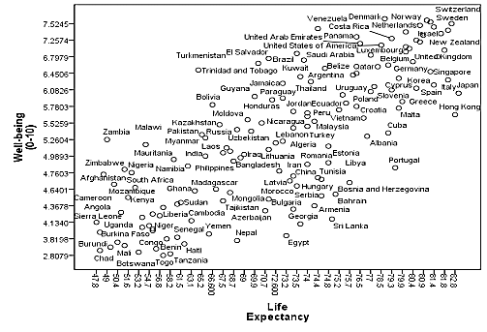

As the data above shows that life expectancy has positive diagonal correlation to well-being factor of a country. The countries that have high well-being factor scores, like Switzerland and Norway, also have higher life expectancy; these countries are located in the top right corner of the graph. Countries with a lower well-being factor score are located in the bottom left corner, where life expectancy is lowest, these countries are predominately African countries like Mali, Chad, Burundi, Togo, Uganda, etc. There are countries with high life expectancy and low well-being factor scores, such as Sri Lanka. There are also, countries, like Trinidad and Tobago, with life expectancy being low and well-being factor score being high. Both of these unexpected conditions will be further discussed in the methodology section of this study.

The graph below shows the correlation between well-being factor of countries and unemployment in scatter plot form: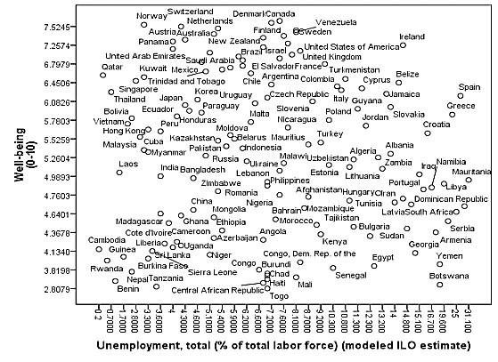

The graph shows that there is a negative diagonal correlation between the unemployment percentage of total labor force and the well-being factor of a country, meaning that as unemployment is higher, the well-being factor is low and when unemployment lower, the well-being factor of a country is high. Naturally this makes sense because people are happy with employment, however there is at the bottom left corner of the graph, several African and Asian countries with both a low well-being factor and a low unemployment percentage.

Below is the data on well-being factor of a country and data on infant mortality of a country per 1000 births in scatter plot form:

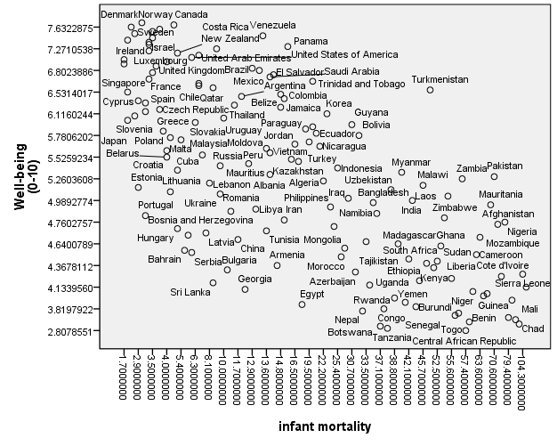

The graph shows a negative diagonal relationship between infant mortality and the well-being factor of a country. Denmark, Norway, Canada, and Sweden are among some of the countries with highest well-being factor and have the lowest infancy mortality rates. As for countries like Benin, Chad, Guinea, and Mali, where infancy mortality rates are at the highest in the world, have the lowest well-being values. In Jeffery Sachs and Pia Malaney (2002) study, they found “poverty is concentrated in the tropical and subtropical zones, the same geographical boundaries that most closely frame malaria transmission”. “The extent of the correlation suggests that malaria and poverty are intimately related” (Sachs, Malaney, 2002). They concluded, African countries have shown that malaria directly and indirectly accounts for an extremely high proportion of infant and child deaths (Sachs, Malaney, 2002). Which may explain why there are such a high number of African countries with high infant mortality. There are countries like Sri Lanka and Turkmenistan that do not follow this trend. Sri Lanka has both a low infant mortality rate and a low well-being value and Turkmenistan has both a high mortality rate and a high well-being value.

Below is the data on well-being factor of a country and data on military expenditure, in percentage of GDP, of a country in scatter plot form:

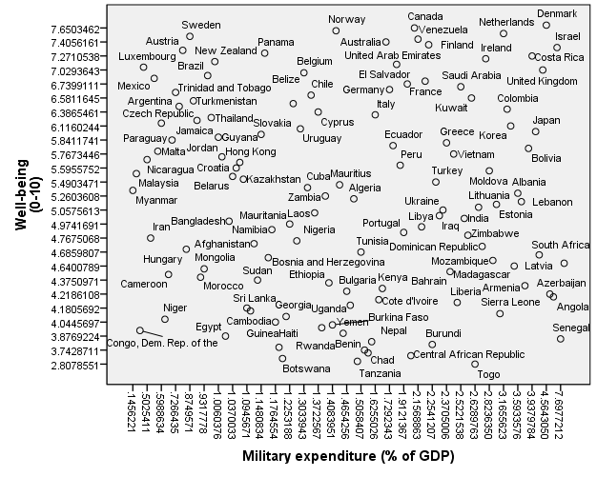

The graph shows little correlation between military expenditure and well-being factor of a country. There is a slight concentration of countries in both the bottom right and top left corners of the graphs suggesting a negative diagonal correlation between military expenditure and the well-being factor of a country. But there are still many countries spread out throughout the graph suggesting that there is no correlation between military expenditure of a country and well-being of a country.

Below is the data on well-being factor of a country and data on household final consumption expenditure, in percentage of GDP, of a country in scatter plot form:

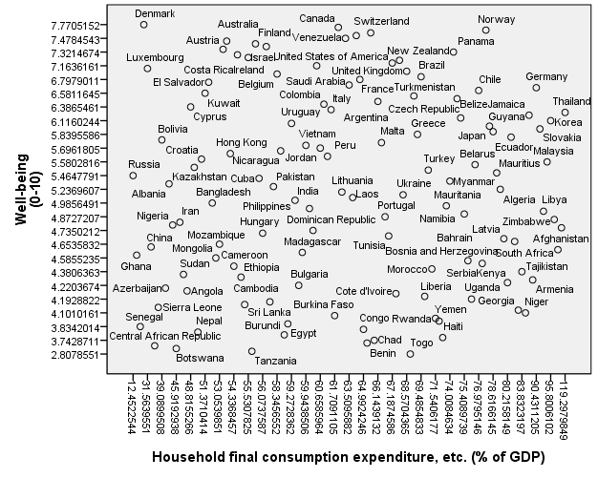

The graph above shows that household consumption has little correlation to the well-being factor of a country. There is a concentration of North American, South American and European countries in the top of the graph, where well-being factor is highest, while the Asian and African Countries are spread out from the middle to the bottom of the graph.

Below is the data on well-being factor of a country and data on total health expenditure, in percentage of GDP, of a country in scatter plot form:

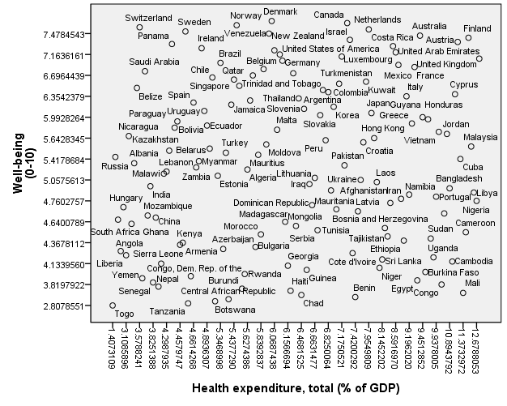

The graph above shows little correlation between Health Expenditure and the well-being factor of a country. This data is very similar to what was observed in the graph before, when observing the relationship between household consumption and the well-being factor of a country, this may suggest that there is correlation between health expenditure and household final consumption.

Below is the data on well-being factor of a country and data on intentional homicides per 100,000 people in scatter plot form:

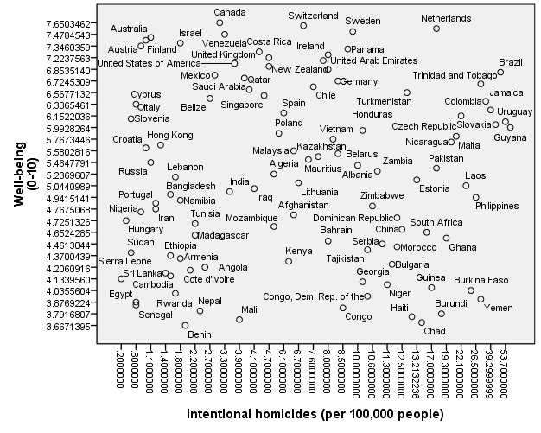

The graph above shows a slight negative diagonal correlation when following a diagonal line between Australia (Located in top left corner of graph) to Yemen (located in bottom right corner of graph). There is also a high concentration of countries in bottom left corner of the graph, where intentional homicides are low and well-being factor of countries are also low. Unexpectedly Brazil, Netherlands, Trinidad and Tobago and Columbia all have both high intentional homicide rates and high well-being values.

Below is the data on well-being factor of a country and data on government expenditure, in percentage of GDP, of a country in scatter plot form:

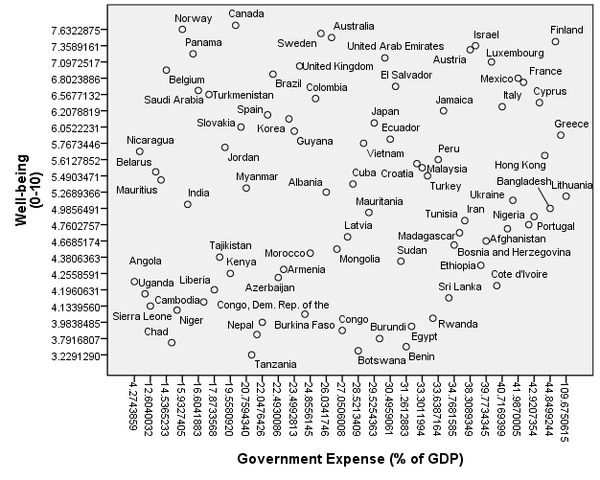

The graph above shows government expense of countries having a negative diagonal correlation with the well-being factor of countries, from Norway (located in the top left corner) to Cote d’Ivoire. There is also a cluster of countries located at the bottom left corner and top right corners of the graph that do not fall within the negative diagonal line.

Below are the data on well-being factor of a country and data on total natural resources rent (profit), in percentage of GDP, of a country in scatter plot form:

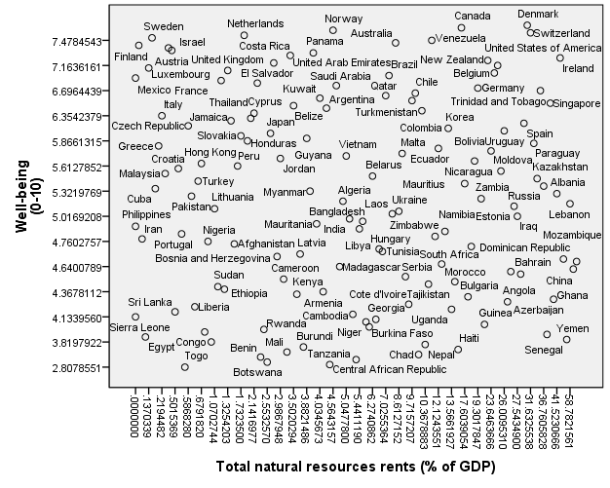

The data shows no actual correlation between the two variables. All of the countries seem very much spread out throughout the graph. This implies that the null hypothesis, where total natural resources rent is not related to the well-being factor of a country. Further research will conclude this hypothesis.

Below is the data on well-being factor of a country and data on agriculture, in percentage of GDP, of a country in scatter plot form:

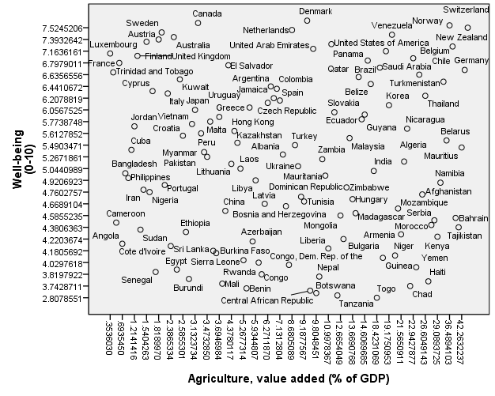

The data shows no actual correlation between the two variables. All of the countries seem very much spread out throughout the graph. This implies that the null hypothesis maybe true, but the data will show for sure.

Below is the data on well-being factor of a country and data on income GINI coefficient of a country in scatter plot form:

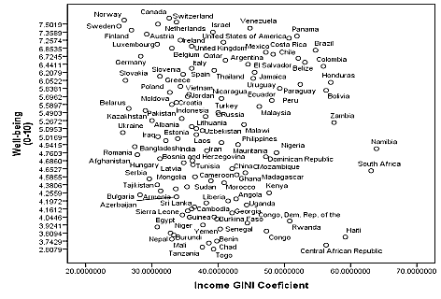

There is neither a positive nor a negative correlation between income GINI coefficient and the well-being factor of a country, however the data does show that the range where most of the countries lie is between 30 and 50.

Below is the data on well-being factor of a country and data on fertility rate per total births per woman of a country in scatter plot form:

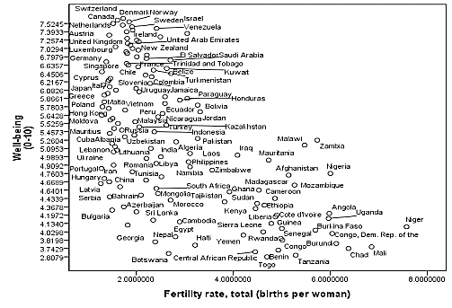

The graph shows fertility rate having negative diagonal correlation with well-being factor of a country. It would seem that the higher fertility rates would have the countries with the lowest well-being values. There are countries, like Georgia, Bulgaria and Azerbaijan with lower fertility rates, but still low well-being values. There are no countries with a fertility rate of above 5.8 births per woman with a well-being value above 5.2, suggesting that after fertility rate above 6 birth, may only decrease a country’s well being value.

Below are the data on well-being factor of a country and data on ecological impact; hectares per capita, of a country in scatter plot form:

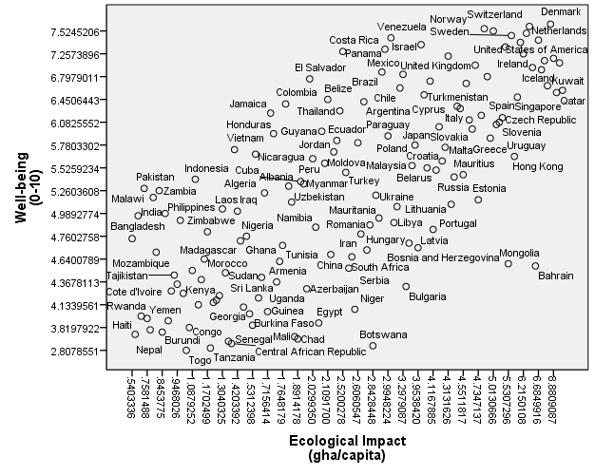

The data was collected from the happy planet index. Ecological impact measures the usage of environmental resources on average per person for each country. The graph shows a positive diagonal correlation between ecological impact of a country and well-being factor of a country. This shows that having a higher ecological footprint value may increase a country’s well-being value.

**METHODOLOGY AND RESULTS**

We ran the cross correlation analyze between all of our variables order to test for multiple correlation, as shown in **appendix ii**. It was found that life expectancy and infant mortality were highly negatively correlated; with a Pearson correlation of -.909.This would suggest that as life expectancy goes up, infant mortality goes down. Countries with high life expectancy tend to have the best medical care and available medicine, which would result in having low infant mortality. However infant mortality was positively correlated with fertility rate, with a Pearson correlation of .860, suggesting that there are couples attempting to have children of their own and either start a family or expand on their current family. But life expectancy and well-being are both positively correlated, with a Pearson correlation of .724, meaning that if people are happier when they live longer lives, then if they are willing to give up that chance to be happier so they can bare a child, may imply that there is an even greater reward in raising a child, which explains why in these low income countries people would take the risk of having children. According to the data collected, low-income countries like Zambia, Uganda, Mali, and Yemen all had a fertility rate of at least 4 infants per woman, whereas these countries also had high infant morality rates. This shows that there are women trying to bare children in conditions that aren’t suitable for childbirth, because they want to have a family. But because of the multiple correlations we removed fertility rate and infant mortality from the model.

In order to test the relationship of our economic variables and well-being factor of a country we used stepwise regression. Stepwise regression is the process of building a model by removing or adding variables. In this case we took 12 independent variables from the start and then removed 7 at the end to build a model that showed variables with a strong relationship with happiness. After 4 steps, our final model shows life expectancy, ecological impact, unemployment, GINI coefficient, and fertility rates as the remaining variables with the strongest relationship to well-being as shown below:

|  |  |  |  |  |  |  |  |  |
| --- | --- | --- | --- | --- | --- | --- | --- | --- |
| Variables | Step 1 |  | Step 2 |  | Step 3 |  | Step 4 |  |
|  | Coefficients | P Value | Coefficients | P Value | Coefficients | P Value | Coefficients | P Values |
| (Constant) |  | .914 |  | .629 |  | .974 |  | .179 |
| Life  Expectancy | .430 | .001 | .414 | .001 | .449 | .000 | .576 | .000 |
| Ecological Impact (gha/capita) | .546 | .000 | .579 | .000 | .574 | .000 | .367 | .000 |
| Military expenditure (% of GDP) | .106 | .284 | .070 | .401 |  |  |  |  |
| Household final consumption expenditure, etc. (% of GDP) | .047 | .711 |  |  |  |  |  |  |
| Health expenditure, total (% of GDP) | .070 | .558 | .035 | .707 |  |  |  |  |
| Intentional homicides (per 100,000 people) | .181 | .099 | .186 | .045 | .126 | .105 |  |  |
| Government Expense (% of GDP) | -.094 | .368 | -.088 | .335 | -.039 | .595 |  |  |
| Total natural resources rents (% of GDP) | -.010 | .933 |  |  |  |  |  |  |
| Agriculture, value added (% of GDP) | -.069 | .612 | -.077 | .400 |  |  |  |  |
| Unemployment, total (% of total labor force) (modeled ILO estimate) | -.133 | .180 | -.130 | .147 | -.140 | .073 | -.130 | .021 |
| Income GINI Coefficient | .159 | .112 | .137 | .137 | .164 | .043 | 06 | .001 |

In the first step, both total natural resource rent and household final consumption was removed. The variable, total natural resources rent, had the lowest relationship with happiness with a significance of .933. Although natural resources are linked to things that lead to happiness like transportation and fuel for cars and homes, it is not exclusively used for these purposes. Household consumption had a significance of .711, based on this household consumption was removed because it had a low relation to happiness. As Easterlin’s (2001) study had stated, material aspirations are inversely related to happiness. Although, this study shows that household consumption is not inversely related, because it is not related at all to happiness, it does show that nice cars and a luxurious living area do not make people happy.

After removing total natural resources rent and total household consumption, in the second step, unexpectedly healthcare expenditure was removed as well as military expense and agriculture. Healthcare expenditure had a .707 significance to happiness. Healthcare expenditure may also mean that a country’s people are suffering from many diseases and ailments, which explains the low relationship. Military expenditure showed to have a .401 significance to happiness. The reasons for this result maybe because military expenditure may have both positive and negative impacts on well-being depending on the situation of each country. Like Marcus Noland (2003), stated oppressive countries like North Korea, have a “guns over butter policy” but other countries are not as oppressive and spend their money to defend their country like in the USA, where people find comfort and safety from their military. Agriculture had a significance of .400 in relationship to happiness. Based on those figures, agriculture was removed because the model could still be further improved. This result can be explained because a dominant agricultural country would be much likely to be a poorer country compared to predominantly industrial country like the Canada.

In the third step, variables, government expense and intentional homicide were removed from the model. Government expense had a significance of .595 in relationship to happiness. Based on this statistic it was found that government expense did not have a strong enough relationship to happiness and therefore were removed from the model. The reasoning behind this is proved by Perovic and Golem’s (2010) conclusion that government spending up to a certain threshold would positively affect people’s well-being, but any point after the threshold, government expenditure would only negatively impact people’s well-being. Intentional homicides had a significance of .105 in relationship to happiness. Based on this value it was found that intentional homicide did not have a strong enough relationship to happiness and therefore removed from the model. Veenhoven (2004) found a similar result when studying homicidal rates. He found that Latin American countries had homicidal rates even though they were high on the well-being scale while other countries like Yemen and Chad with similarly high homicidal rates but lower on well-being scale (Veenhoven 2004).

In the final step, there was a significant relationship between well-being and the following independent variables; life expectancy, ecological footprint, unemployment, and income GINI Coefficient. Below is the revised final stepwise regression model:

**Final Stepwise Regression Coefficients**

|  |  |  |
| --- | --- | --- |
| Model | Standardized Coefficients | P value |
| (Constant) |  | .179 |
| Life Expectancy | .576 | .000 |
| Ecological Impact | .367 | .000 |
| Unemployment (% of total Labor force) | -.130 | .021 |
| Income GINI Coefficients | .206 | .001 |

R Square = .662

People who live long lives will always be happier, because people are always looking back wishing they had more time to do the tasks and accomplish the goals they set for themselves early on in life. With a high life expectancy people can accomplish those goals and complete those tasks. As the graph shown before in the data analysis, there is a trend, as live expectancy increases, so does well being. Almost all of the countries with low life expectancy are third world countries, which are struggling with civil wars, famine, disease, and lack of available clean water, while you have first world countries like Netherlands, Switzerland, Denmark, Australia, and New Zealand where well-being is at it’s highest.

As shown in the model above, unemployment is significantly related to subjective well-being with a significance score of .021. Also, unemployment is inversely correlated with the well-being factor of a country, with Pearson correlation of -.111. This is important because policymakers should know that if more jobs can be developed people would be happier. Even if it’s a job they will not like, it is better than having no job at all. People are happier when they are working towards something and have some sort of purpose, jobs can offer that to people. Without purpose or having something to work towards, people’s lives become very meaningless and thus people are unhappy. The graph that was analyzed for is an indicator of our results, as we see Australia, Switzerland, Denmark, and Norway in the top left corner of the graph where unemployment is low and well-being is high.

The Gini index is highly related to well-being meaning as the higher a country is toward perfect inequality the distribution of household income the happier people are. Having income distributed absolutely equally or absolutely unequally will not increase a countries well-being factor, this is why in the data graph we analyzed before, many of the countries were in a range between 30 and 50. If countries were perfectly equal, the job market would be very chaotic and people would not be happy. However more people would be happier with a certain amount of inequality, because they would be earning the amount they work for. “Most studies of the U.S. and Europe find that inequality has modest or insignificant effects on happiness” (Graham 2005). Most countries fall around 39 in the GINI index which shows that there isn’t a massive amount of inequality in household income, but there is just enough for people to be satisfied with their respective incomes.

Ecological Impact measures how much of the earth’s resources, in hectares of land, is being used to support each person. This measurement can help find how if people’s resource consuming activities can be sustainable for the future. People are usually living happier lives if they have luxuries like electricity, cars, fast food, public transportation, etc. because these things are convenient and comfortable, but these are also resource-consuming activities. Even though this source of happiness has a negative impact on the country’s bio capacity, it should only reinforce the importance of resources in our lives and happiness. We should take steps to preserve as much of these resources as we can for the future. The Happy Planet Organization stated that if every person is allotted 178 acres of land worth of resources to consume on their lives, then the earth could sustain itself.

**CONCLUSION**

This paper showed that life expectancy, footprint, employment, income inequality and having children have a significant impact in a country’s level of well-being. According to Richard Easterlin, “the factors that ordinarily determine how happy people feel are making a living, family life, and health”(Easterlin, 2001). The question of whether governments should take action to improve the well-being of its people is shown by the military expenditure and government expenditure being removed from the regression. However this does not mean governments should not be involved, because income equality, ecological impact, and employment remain, as significant variables that show that government involvement in these sectors are needed. Also many governments in lower income countries can significantly increase their life expectancy if go through more peaceful routes in politics and increase emphasis on health and producing clean water.

**APPENDIX 1:**

|  |  |  |
| --- | --- | --- |
| Variables | Variables | Variables |
| Well-Being | Well-Being | Well-Being |
| Life Expectancy | Life Expectancy | Life Expectancy |
| Ecological Impact (gha/capita) | Ecological Impact (gha/capita) | Ecological Impact (gha/capita) |
| Military expenditure (% of GDP) | Military expenditure (% of GDP) | Military expenditure (% of GDP) |
| Household final consumption expenditure, etc. (% of GDP) | Household final consumption expenditure, etc. (% of GDP) | Household final consumption expenditure, etc. (% of GDP) |
| Health expenditure, total (% of GDP) | Health expenditure, total (% of GDP) | Health expenditure, total (% of GDP) |
| Intentional homicides (per 100,000 people) | Intentional homicides (per 100,000 people) | Intentional homicides (per 100,000 people) |
| Expense (% of GDP) | Expense (% of GDP) | Expense (% of GDP) |
| Total natural resources rents (% of GDP) | Total natural resources rents (% of GDP) | Total natural resources rents (% of GDP) |
| Agriculture, value added (% of GDP) | Agriculture, value added (% of GDP) | Agriculture, value added (% of GDP) |
| Unemployment, total (% of total labor force) (modeled ILO estimate) | Unemployment, total (% of total labor force) (modeled ILO estimate) | Unemployment, total (% of total labor force) (modeled ILO estimate) |
| Income GINI Coefficient | Income GINI Coefficient | Income GINI Coefficient |
| Fertility Rate | Fertility Rate | Fertility Rate |
| Infant Mortality (per 1000 live births) | Infant Mortality (per 1000 live births) | Infant Mortality (per 1000 live births) |

**APPENDIX 2:**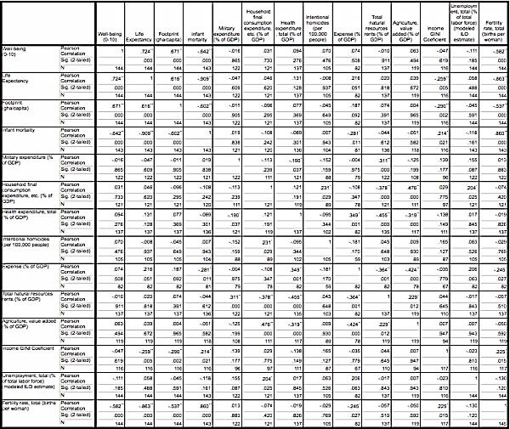

**REFERENCES:**

1. "Data | The World Bank." *Data | The World Bank*. Web. 15 Aug. 2015.
2. Easterlin, Richard A. "Income and Happiness: Towards a Unified Theory." *The Economic Journal* (2001): 465-84. Print.
3. Graham, Carol. "The Economics of Happiness." *World Economics* 6.3 (2005): 41-55. Print.
4. Oswald, Andrew. "Happiness and Economic Performance." *The Economic Journal* (1997). Print.
5. Paul, S. (2001): “A Welfare Loss Measure of Unemployment with an Empirical Illustration”, The Manchester School, Vol. 69, No. 2, pp. 148-163
6. Graham, C. (2003). Does Happiness Pay? An Exploration Based on Panel Data from Russia. *Why Inequality Matters: Lessons for Policy Form the Economics of Happiness*.
7. Oishi, S., Kesebir, S., & Diener, E. (2011). Income Inequality and Happiness. *Psychological Science,* 1095-1100.
8. Frey, B., & Stutzer, A. (2001). What Can Economists Learn from Happiness Research? *Journal of Economic Literature,* 402-435.
9. Margolis, R., & Myrskylä, M. (2011). A Global Perspective on Happiness and Fertility. *Population and Development Review,* 29-56.
10. Perovic, L., & Golem, S. (2010). Investigating Macroeconomic Determinants of Happiness in Transition Countries. *Eastern European Economics,* 59-75.
11. Kirkcaldy, B., Furnham, A., & Veenhoven, R. (2005). Health Care and Subjective Well-being in Nations. *Research Companion to Organizational Health Psychology*.
12. Headey, B., Muffels, R., & Wooden, M. (2007). Money does not Buy Happiness: Or Does It? A Reassessment Based on the Combined Effects of Wealth, Income and Consumption. *Soc Indic Res Social Indicators Research,* 65-82.
13. Veenhoven, R. (1996). Happy life-expectancy. *Soc Indic Res Social Indicators Research,* 1-58.
14. Berg, M., & Veenhoven, R. (2010). Income Inequality and Happiness in 119 Nations: In Search for an Optimum that Does Not Appear to Exist. *Happiness and Social Policy in Europe*.
15. Veenhoven, R. (2005). Happiness in Hardship. *Economics and Happiness,* 243-266.
16. Understanding How Gallup Uses the Cantril Scale. (2009). Retrieved July 22, 2015.
17. About the HPI | Happy Planet Index. (n.d.). Retrieved August 22, 2015.
18. Noland, M. (2003). Famine and Reform.
19. Tavits, M. (2008). Representation, Corruption, and Subjective Well-Being. *Comparative Political Studies,* 1607-1630.
20. Leite, C., & Weidmann, J. (1999). Does Mother Nature Corrupt? Natural Resources, Corruption, and Economic Growth. *SSRN Electronic Journal SSRN Journal*.
21. O'Brien, C. (2008). Sustainable Happiness: How Happiness Studies Can Contribute to a More Sustainable Future. *49*(4), 289-295.
22. Sachs, J., & Malaney, P. (2002). The economic and social burden of malaria. *Nature,* *415*, 680-685.
23. DeFrain, J. D. and Ernst, L.: 1978, 'The psychological effect of sudden infant death syndrome on surviving family members', Journal of Family Practice 6, pp. 985-989.
24. Understanding How Gallup Uses the Cantril Scale. (2015). Retrieved October 5, 2015, from http://www.gallup.com/poll/122453/Understanding-Gallup-Uses-Cantril-Scale.aspx?g_source=cantril&g_medium=search&g_campaign=tiles
25. Well-being Concepts. (2013, March 6). Retrieved October 5, 2015, from http://www.cdc.gov/hrqol/wellbeing.htm
26. Ryan, R., & Deci, E. (2001). On Happiness and Human Potentials: A Review of Research on Hedonic and Eudaimonic Well-Being. *Annual Review of Psychology Annu. Rev. Psychol.,* 141-166.
27. Diener, E., & Chan, M. (2011). Happy People Live Longer: Subjective Well-Being Contributes to Health and Longevity. *Applied Psychology: Health and Well-Being,* 1-43.
28. Our Human Development Initiative. (2015, September 23). Retrieved October 5, 2015, from http://www.footprintnetwork.org/en/index.php/GFN/page/fighting_poverty_our_human_development_initiative/
29. Sawatzky, R., Ratner, P., Johnson, J., Kopec, J., & Zumbo, B. (2010, February 3). Self-reported physical and mental health status and quality of life in adolescents: A latent variable mediation model. Retrieved October 17, 2015, from <http://hqlo.biomedcentral.com/articles/10.1186/1477-7525-8-17>

**CLOSING THE CHASM: USING AID TO IMPROVE HEALTH OUTCOMES**

***Samuel A. Necrason, Siena College***

***Dr. Smita Ramnarain, Siena College***

**INTRODUCTION**

This study seeks to provide insight into a simple question: *does aid improve general health outcomes?*

The existing literature provides an inconclusive answer to this straightforward question. Although aid disbursements have grown notably over the past 15 years, it is uncertain if these efforts are effectively improving general health outcomes. Nonetheless, because health is a “global good”, improving global health merits global interest. Improved health is associated with economic spillovers that typically result in national income gains, such as a more productive, longer working labor force. The health-income cycle can be self-perpetuating; to illustrate, consider that as global life expectancy has doubled over the past 100 years, global GDP has increased exponentially.

However, these “global gains” have not been evenly distributed- there is a proverbial chasm between rich and poor countries. Today, there are 3.5 billion people living in 82 countries with a GNI per capita of less than $4,125. Conversely, there are 1 billion people living in 32 countries with an average GNI per capita of over $44,000 (World Bank, 2013). In an attempt to close the development chasm, multilateral organizations, non-governmental organizations (NGOs), and individual countries provide development assistance to poor countries. Development assistance may be in the form of concessionary loans (loans with terms notably more favorable for borrowers than traditional market loans), grants, or direct contributions. Sometimes, development assistance is for a specific application, such as improving infrastructure or disease prevention.

Although the efficacy of aid is uncertain, aid disbursements have continued to grow over the last 10 years. This paper seeks to examine if two types of aid, official development assistance (ODA) and development assistance for health (DAH), are effectively improving health outcomes. Due to the aggregated nature of ODA, population health benefits from this general aid measurement may not be apparent; however, the impact of DAH should be apparent in health statistics. Although DAH is intended to improve population health, populations may not experience broad health improvements (such as an increase in life expectancy or a reduction in infant mortality) due to systematic inefficiencies, such as fragmented disbursement systems and divided agendas.

In light of these hypothetical considerations, this empirical analysis of this paper suggests two things: aid may not be distributed on the basis of need, and aid may not be effective in improving general health outcomes. As with any study, the methodology in this paper has caveats, and richer data may provide a deeper insight into the research question. However, the conclusion that aid may not improve health outcomes should, at the very least, invoke curiosity into the subject of economic development. More optimistically, this research should promote a systematic evaluation, and continuous improvement, of the global development agenda.

**LITERATURE REVIEW**

**Contextualizing Capabilities, Health, and Aid**

The modern era of health has more resources than ever: global health spending totaled over $5 trillion in 2013, and there are over 59 million health workers worldwide (World Bank,

2013; WHO, 2006). However, the demand for health resources is swelling as the global population ages and expectations associated with a “healthy life” continue to grow. Although 6.7% of global GDP is allocated to health spending, the global health system may be facing a serious supply shortage. A 2006 World Health Organization report estimated a shortage of 2.4 million healthcare workers in the global system- with shortages most pronounced in low-income countries (WHO, 2006). To partially address these shortages, richer countries have extended resources to poorer countries in the form of aid.

For the past 25 years, the central focus of the foreign aid agenda has been human development. The concept of human development is illustrated nicely by Amartya Sen in his seminal work, Development as Freedom. In Development as Freedom, Sen offers that access to certain “capabilities” such as literacy, health, and political freedom enable people to participate in economic activities (Sen, 1999). This argument is reasonable, as the human capital associated with health and education have been noted to improve productivity, and subsequently, income (de la Fuente, 2011). Ergo, a focus on human development should address the core concerns associated with development, including poor health and low income.

However, investing resources in human development has not always been the priority of foreign aid. Prior to the human development era, aid efforts largely focused on improving economic growth through structural adjustment. Eventually, this approach was accepted to be faulty; as a 1996 United Nations paper notes, “during 1960-1992 not a single country succeeded in moving from lopsided development with slow human development and rapid growth to a virtuous circle in which human development and [economic] growth can become mutually reinforcing” (UNDP, 1996). Without human capital, a country does not have sustainable resources to improve their economic status. Adjusting tariffs and welcoming multinational organizations does not directly benefit the people that compose an economy; and any expected spillovers are not guaranteed. In other words, *people* create economic development, not isolated policies.

Although the aid agenda may have been realigned, the efficacy of the seemingly reasonable human development approach has been contested. Namely, prior research suggests that aid programs may not effectively improve health outcomes (Williamson, 2008; WHO evaluation). As noted, health is critical to enabling economic development, so this should be of concern to the global community. This research paper seeks to address the question *does aid improve health outcomes?*

**Measuring Health**

Health is typically measured by aggregate metrics or specific “health characteristics”. Aggregate metrics, such as life expectancy or infant mortality, allow for inductive cross-country comparisons. For instance, “population A has a longer life expectancy than population B, so population A is likely healthier, and likely has access to a better health system”. Because this is an aggregate study, aggregate population health metrics will be applied.

More focused “health characteristics”, such as the prevalence of a particular disease, may provide insight into the epidemiological composition of a specific population. These characteristics may be useful in further research of this topic, particularly research conducted on a by-country basis.

**Income and Health**

Aside from understanding how health is measured, it is important to understand what affects health. Oftentimes, factors that influence health are interrelated and self-perpetuating, such as income and education. To maintain a reasonable scope, this study will focus on the factors most pertinent to developing countries.

Income is associated with many personal health outcomes, including infant and adult mortality, morbidity, and disability (NCIOM, 2009; Marmot 2002). These personal health implications of income are intuitive and align nicely with the capabilities framework previously introduced. With increases in income, a population can be more capable to improve their health with access to healthcare and healthy foods, more time to exercise, and safer living conditions (NCIOM, 2009). On an aggregate basis, income may influence the quality of important health-related institutions that influence capabilities, including medical, sanitation, and education infrastructure (Rodgers, 2002).

It should be noted that income does not have a linear relationship with health outcomes; rather, health returns to income are more pronounced in lower income populations (Rehkoph et al., 2008). The non-linear relationship can be attributed to diminishing returns from an income- enabled healthy lifestyle. For instance, an increase in income that enables the transition from no medical treatment to basic medical treatment will substantially decrease the likelihood of health complications (Rodgers, 2002). However, because of the limitations of human biology and medicine, the health return from increasing income eventually plateaus. Additionally, there may be reverse causality between income and health, suggesting that income may improve health, and health may improve income (Deaton, 2002).

Because health returns to income are more pronounced in lower-income populations, income inequality can also influence health. If a share of income were to be transferred from an upper income decile to a lower income decile, population health would improve with no additional aggregate income. In respect to income, inequality, and health in the developing countries examined in this study, past research suggests that the relationship between inequality and health outcomes is most pronounced in less-developed countries (Subramanian and Kawachi, 2003)[1].

**Institutions**

To a certain extent, mitigating income inequality may be considered an institutional responsibility. Institutions, defined in this paper as “the governance and culture responsible for crafting societal arrangements”, are responsible for many factors that influence health outcomes. Because a free-market healthcare system may be subject to market failure, governments are typically responsible for developing a healthcare system and prioritizing healthcare spending (Tang et al., 2002). Although governments are responsible for the oversight of a healthcare system, egalitarian access to service is not guaranteed.

In lower-income countries, governments tend to prioritize providing healthcare to higher- income individuals and urban populations, as well as purchasing name-brand pharmaceutical drugs (World Bank, 1993). Governments may spend funds on populations with less need to meet certain benchmarks in an easy, low-cost manner (Radelet, 2002). These tendencies may precipitate inequalities within a health systems and neglect to provide medical treatment where it is most needed- such as poor, rural, or fragile populations. Furthermore, spending national resources on health may not be a priority for governments; for instance, in some developing countries, while foreign aid receipts increased, domestic health spending stagnated or reversed between 1990 and 2000 (Dodd et al., 2007). Examining where these domestic funds were reallocated could be of interest in a further investigation.

Beyond health systems, governments may influence health through a multitude of channels such as education, war, and sanitation. For instance, political instability and war can devastate the infrastructure, health, and general composition of a country (Sidel and Levy, 2008). War is much more prevalent in developing countries, as a 2001 United Nations report explains, “the armed-conflict situation in countries afflicted by war typically also suffer sharp inequalities among social groups. It is this, rather than poverty, that seems to be a critical factor, although poor countries have been far more likely to be involved in armed conflicts than rich ones.” This relationship between institutions, war, health, and inequality illustrates the complex web of issues in developing countries.

In spite of these issues, it should be noted that institutions in developing countries have the ability successfully implement measures to improve population health. For instance, Nepal’s Second Rural Water Supply & Sanitation Project improved access to potable water for over 1million people, and reduced morbidity by diarrheal disease among young children by over 80% in the project area (World Bank, 2014). Institutions also have a notable role in providing access to education. As Sen noted, the success of this project also illustrates the integral relationship between sanitation and health outcomes.[2] Education is a fundamental capability that is critical for economic development. The benefits of education are long-lasting and widespread; a 2011 World Bank report explains “a child who has received a good education is more likely to develop into a better parent, make informed decisions, earn a better living, adopt new technologies, cope with crises and be a responsible citizen” (World Bank, 2011). At a fundamental level, improving education enables better transmission and application of health knowledge, increases the human capital stock of a population, and can directly reduce the risk of disease (World Bank, 1993; Cutler and Lleras Muney, 2006). One NBER report cites that an additional four years of education can lower five- year mortality by 1.8 percentage points, as well as generate noteworthy income increases (Cutler and Lleras Muney, 2006).

Unfortunately, a lack of education has plagued low-income countries; a CEPR study suggests, “in 2010 the level and distribution of educational attainment in developing countries are comparable to those of the advanced countries in the late 1960s” (Barro and Lee, 2010). Undoubtedly, it is difficult to establish a strong education system if a country is in persistent conflict and has meager resources for necessary capital investments. To address the educational resource constraints in low-income countries, members of the OECD development assistance committee (DAC) have increased aid disbursements for education by 34% between

2005 and 2014 (OECD, 2015). Efforts to improve education in poor countries have been relatively fruitful; between 1999 and 2009, an extra 52 million children enrolled in primary school, and primary school enrollment climbed to 89% in developing countries (UN, 2011).However, trends in gender disparity and dropout rates may result in fewer children completing school (UNESCO 2011).

The myriad of interrelated issues that influence health outcomes, from low income and high inequality, to persistent war and poor educational attainment, are most pronounced in developing countries. Improving health is difficult with weak institutional framework and meager resources persistent in lower-income countries have hindered improvements in health. So why are developing countries in this “poor people, poor health, poor institutions” predicament?

**The Path Dependency Theory of Development**[3]

For many countries, their “developing” status may be the product of historical events. Colonialism, in particular, has largely contributed to the lagging economic progress in many low- income countries. During the colonial era, imperialistic countries obtained resources such as currency, labor, commodities, and income (from taxation) from less-fortified countries. This resource exploitation was used to generate wealth directly and indirectly (from market manipulation, production of goods, etc.) for the colonizing country (Cypher, 2014).

Under colonial control, the economic development of a colonized area was subject to the will of the colonizer. Oftentimes, developing a sustainable economy within colonial territories was of little priority for imperial forces, so existing infrastructure and resources were ravaged within said colonies (Cypher, 2014). Although the era of traditional colonialism concluded over a century ago, many sovereign nations that were once colonies have seen modest growth and health improvements relative to their imperial captors; and the academic community suggests this phenomena is not simply correlation.

During the decolonization process, borders were hastily drawn with little consideration of their

efficacy, oftentimes grouping rival religious sects or creating boundaries inconsistent with geographical features. Furthermore, imperial forces established governments and appointed the leaders of newly “free” nations without accordance of the colonial people (Easterly, 2006). As a product of imperial decision-making, post-imperial states are often depleted of resources and riddled with conflict. The friction within these countries has hindered the establishment of functional institutions- institutions that are critical for improving population health and advancing economic progress.

The unfortunate circumstances in many developing countries have not gone unnoticed by the international community. Subsequently, foreign aid and economic development programs have been established in an effort to remediate the ailing economies and populations within developing countries.[4] This paper seeks to evaluate the efficacy of these aid programs, particularly in the improvement of health outcomes.

**Aid: Forms and Functions**

There are two common types of aid: official development assistance (ODA), and country-programmable aid (CPA). ODA is typically for special purpose needs, whereas CPA can be utilized by recipient governments in a more flexible manner (Kharas, 2007). Aid disbursements have grown notably since 2000, with a 66% increase in ODA aid since 2000. As of 2014, ODA totaled $135 billion and CPA totaled $105 billion (OECD, 2015). So where are these billions coming from?

**Figure 1: Aid by Source**

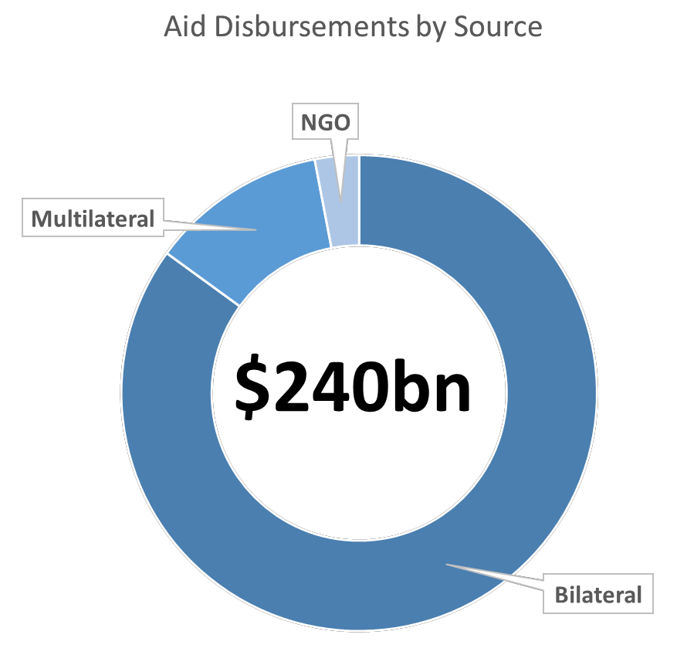

There are three primary forms of entity-recipient aid relationships: bilateral aid, which is a direct disbursement of aid from one country to another country; multilateral aid, which is aid administered from an

organization composed of several countries (such as the United Nations Development Program); and non-governmental organization (NGO) aid, which is provided by a non-governmental entity such as ActionAid. Most aid is disbursed in a bilateral form, while approximately 12% of aid is disbursed by multilateral organizations. Disbursements from NGOs are uncertain (Kharas, 2007).

As noted in Subsection A, the goal of aid has largely shifted from generating economic growth in poor countries to advancing human development in these countries (World Bank, 2000). Human development can be illustrated by Amartya Sen’s “capabilities approach” to development, which emphasizes that assets both tangible and intangible, such as income, education, health, and freedom are critical for development (Sen, 1999). The impetus of the human development agenda is reflected in the Millennium Development Goals (MDGs) established by the United Nations in 2000. The eight MDGs make no explicit mention of economic growth, implying a confidence that development will be the product of pursuing a human-development approach to aid.[5] Of these eight goals, three are directly related to health, while the other five are related to mechanisms that influence health (UN, 2008).Although human development efforts such as the MDGs are outlined, are these aid programs effectively implemented, and do these efforts improve the health of poor populations? In a 2015 evaluation of the MDGs, the United Nations Development Programme notes that the goals were largely unmet, mostly due to a narrow focus on specific metrics and a universal strategy for all countries. The paper later recommends generating a more tailored approach to human development, addressing regional concerns rather than conforming to a single agenda across all countries (UNDP, 2015). The difficulties of human development may be compounded by systematic issues; a 2007 World Health Organization report explains that the framework for the transmission of health aid is fragmented and impedes the efficacy of these efforts (Dodd et al., 2007). Other research efforts suggest that aid may be ineffective at improving health outcomes, citing data and the public choice hypothesis that “foreign assistance… has the potential to damage future growth opportunities”. (Williamson 2008).

The weak achievement of the MDGs and other health improvement efforts may be partially attributable to the fundamental nature of these programs. Targeting specific diseases, such as the “big three” (malaria, tuberculosis (TB), and HIV/ AIDS), may divert aid from more long-term general health investments. Although targeted efforts towards global health issues such as the “big three” are important (16% of deaths in low income countries are attributable to these diseases), sustainable health systems may better provide “core care” services that have higher population health returns per dollar spent (World Health Organization, 2007; World Bank, 1993). Moreover, general infrastructure investments may improve the capacity of countries to administer preventative treatment, and could reduce the prevalence of the “targeted diseases” that are diverting funds from the general health system. An improved system could create a self- perpetuating cycle of improved health, less strain on the health system, and more capacity to deliver treatment.

Nonetheless, targeted, or “vertical”, aid efforts were largely the priority *du jour* over the last 15 years. As of 2005, 50% of development assistance for health (DAH) was for off-budget programs in recipient countries, which mostly consisted of vertical efforts (Foster, 2005). For instance, two agencies with a targeted focus (GAVI and GAFTM) accounted for 9% of this spending (Dodd et al., 2007). To contrast, consider that only 20% of DAH was for national programs in these countries (Foster, 2005). As noted, the imbalance of general program funding can make it difficult for developing nations to improve the basic capacity and infrastructure of their health systems, which may impede sustainable, long-term advancements in health.

If aid could be more effectively spent, why are targeted efforts the impetus of the health aid strategy? As a 2005 WHO report notes, “donors have historically found it easier to make longer term commitments to specific expenditure programmes or projects” (Foster, 2005). This may be attributable to a lack of confidence in, or perceived corruption of, the governments of developing countries. However, these assumptions may be partially unfounded; the United Kingdom’s Department for International Development estimates that only 0.015 percent of their foreign aid was lost due to fraud in 2010 (DFID, 2011). Although outright aid fraud may not be a serious issue, misuse of health funds is not uncommon in recipient countries (World Bank,

1993). Furthermore, aligning stakeholders in the health system makes general aid transmission difficult (Dodd et al., 2005). These stakeholders range from finance ministries, to sanitation agencies, to end consumers (the population). Coordinating the priorities of these diverse stakeholders is difficult in any country- developing or not.

Difficulty developing and expanding sustainable health systems is compounded by the variable nature of aid. Oftentimes, aid commitments are only for a year in advance, and may be volatile and unpredictable; thus making long-term investments difficult for developing countries (Dodd et al., 2007). The lack of long-term DAH commitments was addressed in the 2005 Paris Declaration, which noted the absence of a unified global health agenda (OECD, 2005). Finding a balance between targeted global solutions and “local solutions for local problems” is beginning to shape the contemporary aid agenda. For instance, the United Nations is moving past the narrow MDGs, towards new, more general “sustainable development goals” (SDGs) (UN,

2015)[6].

As the efficacy of aid programs improve, health outcomes in developing countries should exhibit higher marginal returns. Increasing aid expenditures may help improve global health towards milestones such as the MDGs; however, it is important to assure that increases in DAH do not result in a deprioritization of domestic health funding in recipient countries (Mishra and Newhouse, 2007; Dodd et al., 2005).

Beyond addressing the gaps in aid strategy, delivering aid to the “last mile” of rural communities, as well as fragile states, should be a priority on the global aid agenda. Although the cost of delivering aid to these populations is more costly than delivering aid to urban populations or middle-income countries, rural and fragile states are often in the worst health, and have the most need for aid (Dodd et al., 2005).

The pitfalls of aid programs seem to be part of an iterative learning process. As the common aid agenda transitioned from growth-centric to human-centric, the human centric approach to aid is now becoming more refined. Sustainability is the name of the new game.

**EMPIRICAL ANALYSIS**

**The Aid Disbursement Hypothesis**

To examine if aid has been effective at improving health outcomes, the question of *why* countries receive aid will first be addressed. Past research suggests that aid may be disbursed on the basis of strategic interests (Boone, 1996). Because the aid agenda has been evolving, this paper seeks to test a more optimistic hypothesis: countries with the most need will receive the most aid. To test this hypothesis, two criterion for need will be considered: income and health. The measures of each criterion, as well as the data sources, are highlighted in Table 1.

**Table 1: Metrics for Testing Aid Disbursement Hypothesis**

**Criterion Measure (Abbreviation) Source**

|  |
| --- |
| *Aid* Net official development assistance; per capita (ODA pc) World Bank |
| *Health Aid* Development assistance for health; per capita (DAH pc) World Health Organization |
| GDP per capita; normalized for purchasing power parity  *Income* World Bank  (GDPpc PPP)[7] |
| *Health* Life expectancy at birth; years World Bank |
| *Health* Infant mortality; per 1,000 live births World Bank |

For most measures, the 5-year average value between 2006 and 2010 will be considered. In the event of incomplete data availability for a country, the mean value between the most recent year(s) is inferred. This is justified based on the assumption that the variables of interest are not materially volatile. Only countries with full data available on the variables of interest were considered in each analysis.

The two types of aid considered in this analysis, official development assistance (ODA) and development assistance for health (DAH), both seek to promote economic development and welfare within recipient countries. The ODA totals exclude receipts that are not explicitly related to economic development, such as military aid or nuclear energy (OECD). DAH funds are aggregated in this study, and do not consider if funds are for general health investments or targeted efforts.

To measure income need, this analysis uses GDP per capita, normalized for purchasing power parity. It should be noted that GDP per capita does not capture income inequality, so the “need” for a considerable share of a population may be misrepresented. Nonetheless, the purchasing power parity normalizes for price and exchange rate discrepancies, allowing reasonable cross-country comparison of national income.

The two measures of health in this analysis, life expectancy and infant mortality, provide an aggregate measure of population health, allowing for a normalized comparison of health across countries. Countries with a shorter life expectancy or higher infant mortality rate are considered less healthy. The measurement techniques and caveats associated with these variables are described in greater detail in Subsection E.

Analysis suggests that ODA is not significantly correlated with need. The poorest 15 countries, on average, receive the 69th most ODA (139 countries were considered). Similarly, the 15 countries with the shortest life expectancy received, on average, the 68th most ODA.

DHA, however, is significantly correlated with need. Countries with low income or poor health outcomes typically receive the most DHA. This may indicate that DHA is not subject to strategic interests, and may be more appropriately allocated. Additional information on the top aid recipients, as well as scatterplots of the aid-need measurements, can be found in the Appendix. Table 2 details the correlation coefficients of aid and need.

**Table 2: Results of the Aid Disbursement Hypothesis**

|  |
| --- |
| ODApc DAHpc |
| Pearson  -0.140 -0.191* GDPpc Correlation  N 167 116 |
| Pearson  Life Life 0.092 -0.430**  Expectancy Correlation    N 171 119 |
| Pearson  Infant Infant -0.070 0.259**  Mortality Correlation  N 165 119 |

*\*\*Correlation is significant at the 0.01 level (2-tailed); *Correlation is significant at the 0.05 level (2-tailed)*

Although certain types of aid, such as DAH, may be disbursed on the basis of need; it is uncertain if aid programs effectively improve health outcomes. The following subsections of the Empirical Analysis will seek to determine if aid effectively improves general health outcomes.

**Fundamental Hypothesis**

From an overview perspective, it is possible that aid is effective at improving general health outcomes. Table 14 illustrates the improvements in life expectancy and infant mortality between 2000 and 2010. The dramatic increases in DHA and ODA over this period reflect a strengthening global commitment to economic development, and, more specifically, human development. The figures in the chart are average figures from 119 countries.

**Table 14: Changes in Global Averages, General Health and DHA**

Year Infant Mortality

|  |  |  |  |  |
| --- | --- | --- | --- | --- |
|  | | Expectancy | Capita | Capita |
| 2000 | 55 | 62 | $1.86 | $34.28 |
| 2001 | 54 | 62 | $2.68 | $36.01 |
| 2002 | 52 | 63 | $3.15 | $39.56 |
| 2003 | 50 | 63 | $4.13 | $43.24 |
| 2004 | 48 | 63 | $4.72 | $46.35 |
| 2005 | 46 | 64 | $5.43 | $51.56 |
| 2006 | 45 | 64 | $5.97 | $49.35 |
| 2007 | 43 | 64 | $6.41 | $52.54 |
| 2008 | 42 | 65 | $7.87 | $63.36 |
| 2009 | 40 | 65 | $8.37 | $59.93 |
| 2010 | 39 | 65 | $8.81 | $58.23 |
| **10-Year** | **-29.50%** | **5.42%** | **372.79%** | **69.90%** |
| **Change** |  |  |  |  |

Life

DHA Per

ODA Per

To test the strength of the relationship between aid and health outcomes, the following regression model will be tested with various specifications:

!"#$%ℎ!! = !(!"#!!!!"# + !!! + û! )

Where health (Health) is measured by life expectancy in one specification, and infant mortality in another specification; aid (Aid) is measured by net official development assistance (ODA) in one specification and development assistance for health (DAH) in another specification; Z is the vector of controls; and û is the error term. The observations of country *i* are from base period *t*, 2010, or a 2010 minus a lagged period, *lag*, where specified.

If aid is effective at improving health outcomes, the relationship should be significant at the 95% confidence level (or greater), and the coefficient should be positive in life expectancy models, and negative in infant mortality models. The following subsection provides a theoretical justification of this model, as well as details on the vector of controls, Z.

**Theoretical Justification of the Model**

**HEALTH**

Aside from the wide availability of data on life expectancy and infant mortality, these variables were selected because they provide an aggregate measure of population health. Because this study is an overview investigation, rather than a by-country case analysis, the characteristics of these metrics are favorable.

Life expectancy is applied as a measure of health because it is the most widely used method for summarizing population mortality, and normalizes the demographic composition of a population, including age distribution (NRC, 2010). This allows for reasonable comparisons across countries with variable demographic compositions. In respect to the “capabilities” framework presented in the Literature Review Section, a longer life expectancy is closely associated with a healthier life and more social development (WHO 2015). Ergo, life expectancy may be a reasonable indicator of both health and economic development.

However, applying life expectancy as the only measure of population health would subject this research to pitfalls of the variable. Life expectancy calculations are based on projections and formulas, and require a highly functional national reporting system to provide accurate data (NRC, 2010; Mishra and Newhouse, 2007). In developing countries, formal health reporting systems are lackluster, so life expectancy data may not provide a fully reliable measure of population health. Furthermore, past research suggests that life expectancy is slow to respond to economic conditions (Mishra and Newhouse, 2007). In respect to the treatment of the variable, life expectancy is a “truncated” variable- there is a theoretical floor and ceiling for the possible values life expectancy may assume. To mitigate the influence of variable truncation, a log will be applied to life expectancy in certain specifications.[8]

A second measure of general health, infant mortality, will in certain specifications. Infant mortality data may be more accurate than life expectancy data because it is not reliant on a national reporting system (data is also collected from household surveys) nor is the data based on predictive equations (UN, 2006; Herzer and Nagel, 2015). Furthermore, compared to life expectancy, infant mortality is more responsive to changes in economic conditions (Boone,

1996). Beyond measuring the number of infant deaths before reaching one year of age, infant mortality reflects several characteristics that may influence health, such as population nutrition, education, and quality of healthcare (Mishra and Newhouse, 2007). From the concept of capabilities, these elements of infant mortality are integral to economic development. Although infant mortality measures are not as truncated as life expectancy, a log will also be applied to infant mortality in certain specifications.[9]

**AID**

In respect to aid, ODA or DAH will be considered in the specifications. From the literature, it is suggested that health outcomes vary relative to different types of aid (Shpak,2012; Williamson 2008; Dodd et al., 2007; Mishra and Newhouse, 2007). Two studies in particular - Williamson (2008), and Mishra and Newhouse (2007) - investigate health outcomes associated with net ODA and DAH.

The results of the aforementioned studies are conflicting. In the Williamson study, the model is similar to that presented in this paper, but utilizes fixed effects methodology. Williamson tests both health aid and overall foreign aid, and arrives at the conclusion that “health aid is ineffective at improving human development” (p. 200). Little explanation is given as to why this may be the case, save for a brief reference to the hypotheses presented by Bauer and Easterly in previous works. Williamson does offer that institutions may influence human development, and proposes that it is uncertain if health is an outcome or an input to development. Health, indeed, may be both an outcome *and* an input to development, as the capabilities framework would suggest.

However, the Mishra and Newhouse study suggests that it is possible to improve health outcomes with aid. Mishra and Newhouse developed a model similar to the Williamson study (and this paper), and employ both OLS and GMM techniques. In a discussion of the results, the authors suggest that “the effect of doubling health aid reduces infant mortality by approximately

2 percent” (p. 21). It is conceded that this observation implies a substantial increase in aid (a factor of 15 from 2004 levels) would be necessary to meet the infant mortality targets established by the MDGs. When explaining the null relationship between ODA and health outcomes, the authors suggest that DAH may be less fungible than ODA when seeking to improve health outcomes, because ODA may not be used for health-related purposes (p. 27). In a divergence from the central hypothesis, the authors present a model that suggests health aid may attract additional domestic resources for health, which could compound the health benefits from aid.

In respect to the application of the aid variables, both studies instrument aid with a lagged measure of aid to address concerns of endogeneity. Because this study employs OLS with cross-sectional data (instead of pooled data, or the application of fixed effects or GMM techniques), a lag is applied in certain specifications based on a theoretical explanation- health may not be contemporaneously responsive to changes in the economic environment.

**CONTROL VARIBLES**

Based on review of the pertinent factors that may influence health, a set of control variables will be included in the specifications. A detailed explanation of the relationship between the set of controls and health can be found in the Literature Review Section of this paper.

To mitigate concerns of multi-collinearity, certain collinear measurements (such as income and health care spending or education) will not be applied together in the same model. Also, to fit an OLS model, a logarithm was applied to certain measurements that exhibit a nonlinear relationship with health.[10] Table 15, below, explains the control variables, their measurement techniques, and sources.

**Table 15: Control Variables, Measurements and Sources**

**Control Measure (Abbreviation) Source**

|  |
| --- |
| Log(GDP per capita); normalized for purchasing power  *Income Income* World Bank parity (log(GDP))[11] |
| *Healthcare Spending* Log(Healthcare spending per capita); nominal (log(HCS)) World Bank |
| Secondary education enrolment; age-standardized  *Education* UNESCO  percent of population (Edu) |
| *War and Peace* Global Peace Index; Likert 1-5 (War) Vision of Peace |
| *Pollution Exposure* PM2.5 air pollution; population weighted exposure (Env) WorldBank |
| GINI Index; area between income distribution and Lorenz  *Inequality Inequality* WorldBank curve of perfect income equality (Inequal) |

**Results**

The results of the various models, where health is a function of aid and a vector of controls, are detailed in Tables 16-19. The original model specifications are:

(1a) !"#$ !"#$%&'(%) = !! + !! !"# + !! !"#$%& + !! !"# + !! !"# + !! !"#$%&' (1b) !"#$"% !"#$%&'$( = !! + !! !"# + !! !"#$%& + !! !"# + !! !"# + !! !"#$%&' (2a) !"#$ !"#$%&'(%) = !! + !! !"# + !! !"#$%& + !! !"# + !! !"# + !! !"#$%&' (2b) !"#$"% !"#$%&'$( = !! + !! !"# + !! !"#$%& + !! !"! + !! !"# + !! !"#$%&'

Equations 3 and 4 test the original model with a logarithm applied to the dependent variables (to mitigate for possible truncation); equations 5 through 10 test the original model with various lags applied to aid, in an effort to determine when aid seems to be the most effective at improving general health outcomes; and equations 11 through 14 are robustness checks that substitute variables (education and healthcare spending) for the measurement of income.

**Table 16: Original Model Results**

(1a)

|  |  |  |
| --- | --- | --- |
| **ODApc DAHpc**  **Dependent log(GDPpc) War Env Inequal**  **(3-yr lag) (3-yr lag)** |  | **Adj. R2 N** |
| 0.000** 0.001**  **LE** 0.528 0.722 0.442  (14.218) (-0.300) | 0.550 86 |
| 0.000** 0.014* 0.006**  **IM** 0.701 0.560  (-41.491) (0.483) (0.623) | 0.645 86 |
| 0.043* 0.000** 0.001**  **LE** 0.601 0.314  (-0.244) (13.369) (-0.300) | 0.533 78 |
| 0.000** 0.013* 0.011*  **IM** 0.227 0.292  (-40.100) (0.514) (0.634) | 0.581 78 |

(1b)

(2a)

(2b)

*\*Indicates significance at the 95% level; **Indicates significance at the 99% level*

The original model suggests that 3 years after a DAH disbursement, every $1 increase in DAH per capita may increase population life expectancy by 0.04 years. Although health expenditures eventually exhibit diminishing returns, this model suggests that a $25 increase in per-capita DAH may increase the average life expectancy in the recipient country by an entire year. However, the infant mortality model suggests that DAH does not effectively decrease life expectancy. All models support the suggestion that health may be influenced by income and inequality. The following table (Table 17) highlights the results of the same model with a logarithm applied to life expectancy and infant mortality.

**Table 17: Log Transformation of Dependent Variables in Original Model Results**

|  |  |  |
| --- | --- | --- |
| **Dependent ODApc DAHpc**  **(3-yr lag) (3-yr lag) log(GDPpc) War Env Inequal** |  | **Adj. R2 N** |
| **log(LE) 0.572 0.000** 0.695 0.503 0.000** (0.096) (-0.002)** | **0.529 86** |
| **log(IM) 0.463 0.000** 0.226 0.017* 0.000** (-0.649) (0.006) (0.013)** | **0.702 86** |
| **log(LE) 0.064 0.000** 0.650 0.380 0.001** (0.092) (-0.002)** | **0.513 78** |
| **log(IM) 0.016* 0.000** 0.007** 0.002** (0.010) (-0.523) 0.155 (0.007) (0.010)** | **0.647 78** |

(3a)

(3b)

(4a)

(4b)

*\*Indicates significance at the 95% level; **Indicates significance at the 99% level*

Similarly, the logarithm specifications provide relative support for the hypothesis that DAH may improve health outcomes. In these specifications, DAH has a significant relationship with infant mortality, rather than life expectancy. Additionally, these specifications reinforce the relationship between health outcomes, income, and inequality.

To investigate if aid is more effective at improving general health outcomes after various periods of time, lags were applied to aid. Table 18 details the results of this investigation.

**Table 18: Various Lags to Aid in Original Model Results**

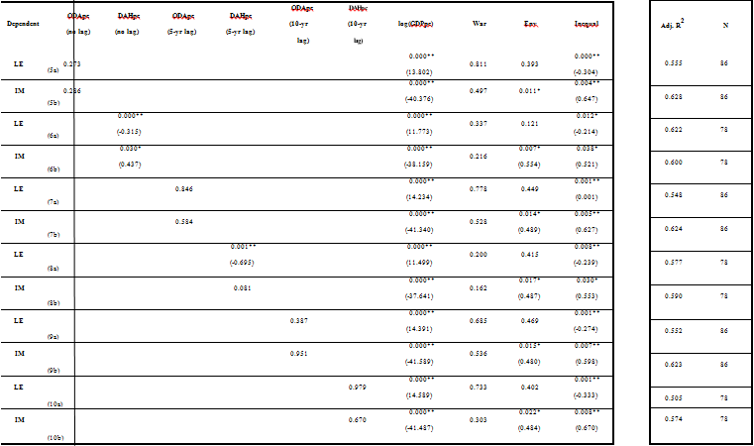

*\*Indicates significance at the 95% level; **Indicates significance at the 99% level*

The results of the various lag specifications suggest that the impact of DAH is most effective in the same year it is disbursed. However, as noted in the justification of this specification, research suggests that life expectancy may be slow to respond to changes in the economic environment. The significance of aid may be the result of omitted or confounding variables (or the application of cross-sectional OLS). Neither ODA nor DAH were significant after 10 years, which supports the suggestion of Mishra and Newhouse that “ten years may be too long to expect to observe an effect of health aid” (p. 19).

Specifications 1 through 10 all suggest that there is a significant relationship between health outcomes, income, and inequality. Subsequently, to test the strength of this relationship, health care spending and education were applied as proxies for income in a robustness check of the specifications. Because the GINI coefficient is the most available, and commonly applied, measure of inequality, no proxy was applied to test the strength of the health and inequality relationship. Table 19, below, details the results of the robustness checks.

**Table 19: Robustness Checks**

|  |
| --- |
| **ODApc DAHpc**  **Dependent (3-yr (3-yr log(HCSpc) Edu War Env Inequal lag) lag)** |
| **LE** 0.490 0.000** 0.396 0.406 0.000** (10.473) (-0.393) |
| **IM** 0.635 0.000** 0.857 0.017* 0.000** (-32.442) (0.487) (0.903) |
| **LE** 0.023* 0.000** 0.000**  (-0.023) (10.397) 0.906 0.312 (-0.404) |
| **IM** 0.150 0.000** 0.624 0.017* 0.000** (-34.048) (0.499) (0.992) |
| **LE** 0.837 0.000** 0.847 0.423 0.080 (24.575) |
| **IM** 0.829 0.000** 0.521 0.873 0.484 (-80.925) |
| **LE** 0.043* 0.000**  (-0.257) (22.387) 0.712 0.687 0.095 |
| **IM** 0.330 0.000** 0.425 0.750 0.432 (-79.381) |

*\*Indicates significance at the 95% level; **Indicates significance at the 99% level*

|  |
| --- |
| **Adj. R2 N** |
| 0.476 86 |
| 0.600 86 |
| 0.471 78 |
| 0.575 78 |
| 0.508 86 |
| 0.701 86 |
| 0.484 78 |
| 0.663 78 |

The results of the robustness check provide further support for the income-health relationship found in the other specifications. Unlike other specifications, the relationship between inequality and both life expectancy and infant mortality was found to be insignificant in the education specifications. Interestingly, the relationship between DAH and life expectancy was found to be significant in both of the robustness checks.

In consideration of all specifications in this study, there is a prevailing conclusion: there is not a strong relationship between aid and improved general health outcomes.[12] Only 7 of the

28 specifications considered suggested that there might be a relationship between aid and health outcomes. Additionally, in relative support of the conclusion provided by Mishra and Newhouse, there seems to be little relationship between ODA and improved health outcomes.

**CONCLUSION**

The analysis of this paper arrives at a prevailing conclusion: the current structure of aid may be broken. General aid does not seem to be disbursed on the basis of income or health need; rather, aid may be disbursed on the basis of strategic interests. Additionally, aid does not seem to effectively improve general health outcomes. This may be attributed to the overwhelming support for “targeted” aid programs that focus on the treatment of specific diseases, rather than the systematic improvements that can produce a higher margin of population health returns. Moreover, the array of stakeholders and patchwork of disbursement agencies may impede the effective allocation of aid resources. As the global aid strategy develops a more “tailored” approach to improving health outcomes, these trends may change. Subsequently, it may be useful to replicate this study in the “post-MDG” era, to evaluate the efficacy of aid strategies that are labeled as more sustainable.

However, as with any study, the approach and methodology of this paper provides areas for improvement and further investigation. The data used in this study could be extended for a pooled-OLS investigation, or extended and applied in a fixed-effects or Gaussian mixture model to understand by-country dynamics more effectively. Additionally, alternative measures of the variables could produce different results. Nonetheless, it may be difficult to fully remediate the potential for recursive causality between health and aid in any investigation (it is not definitive that aid does not influence health outcomes and health outcomes do not influence aid disbursements).

To arrive at a more in-depth understanding of the relationship between aid and health, a series of intra-country case analyses may also be beneficial. By using less-aggregated measures of aid, and considering the epidemiological and other compositions of a country, a more nuanced conclusion would most certainly arise. However, the aggregate measures used in this study do provide a general framework for evaluating the efficacy of the aid agenda as a whole.

From a policy perspective, the conclusions of this paper have been partially addressed by pivotal organizations such as the United Nations. The acknowledgement of MDG shortcomings, and the development of the SDGs, reflects an impetus for improving data collection and reevaluating aid disbursement strategies. Because health is a global good, developing effective strategies to improve global health merits global interest. Assuming that aid is good because it sounds like a good notion is a lazy perspective. Challenging the status quo, evaluating *if*, *why*, and *how* aid works will generate discussion on how the chasm can be closed. Although discourse serves as a starting point, allocating necessary resources, developing stakeholder cooperation, and evaluating progress are the critical elements of closing the chasm.

**APPENDIX**

**Chart 1: Aid Disbursement Hypothesis Scatterplots**

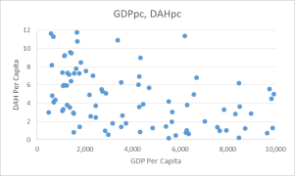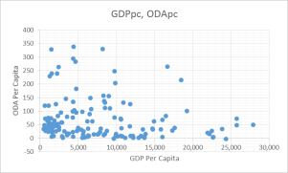

*The axes of these charts were trimmed to show data points within 2 standard deviations of the mean (95% of data)

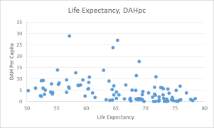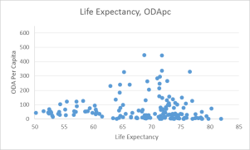

*The axes of these charts were trimmed to illustrate the relationships more clearly

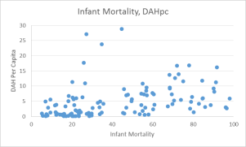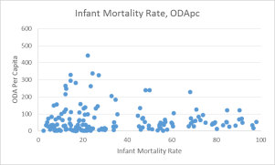

*The axes of these charts were trimmed to illustrate the relationships more clearly

**Table 3: Income and ODA Rank**

**Poorest 15 Countries Top 15 ODA Recipients**

*Top 30 ODA/ bottom 30 GDP; **Top 15 ODA/ bottom 15 GDP

|  |  |  |  |  |  |  |  |  |  |  |
| --- | --- | --- | --- | --- | --- | --- | --- | --- | --- | --- |
| GDPpc | | GDP  rank | ODApc | ODA  rank |  |  | GDPpc | GDP  rank | ODApc | ODA  rank |
| Congo, Dem. | $545 | 140 | $36 | 91 |  | Palau | $12,590 | 28 | $1,624 | 1 |
| Rep. |  |  |  |  |  |  |  |  |  |  |
| Liberia* | $636 | 139 | $226 | 21 |  | Tuvalu | $3,110 | 93 | $1,513 | 2 |
| Malawi | $654 | 138 | $60 | 69 |  | Marshall | $3,243 | 90 | $1,186 | 3 |
|  |  |  |  |  |  | Islands |  |  |  |  |
| Burundi | $669 | 137 | $59 | 71 |  | Micronesia, | $3,119 | 92 | $1,078 | 4 |
|  |  |  |  |  |  | Fed. Sts. |  |  |  |  |
| Niger | $763 | 136 | $39 | 85 |  | West Bank and | $3,837 | 84 | $605 | 5 |
|  |  |  |  |  |  | Gaza |  |  |  |  |
| Mozambique | $817 | 135 | $81 | 49 |  | Solomon | $1,671 | 113 | $485 | 6 |
|  |  |  |  |  |  | Islands* |  |  |  |  |
| Central African | $830 | 134 | $50 | 76 |  | Cabo Verde | $5,465 | 70 | $433 | 7 |
| Republic |  |  |  |  |  |  |  |  |  |  |
| Ethiopia | $885 | 133 | $37 | 89 |  | Kosovo | $7,195 | 58 | $429 | 8 |
| Guinea | $1,136 | 132 | $22 | 103 |  | Samoa | $5,277 | 73 | $381 | 9 |
| Rwanda | $1,156 | 131 | $87 | 47 |  | Tonga | $4,593 | 78 | $365 | 10 |
| Togo | $1,160 | 130 | $47 | 78 |  | Dominica | $9,542 | 44 | $365 | 11 |
| Sierra Leone | $1,219 | 129 | $81 | 50 |  | Vanuatu | $2,759 | 96 | $363 | 12 |
| Guinea-Bissau | $1,232 | 128 | $79 | 51 |  | Grenada | $11,058 | 36 | $317 | 13 |
| Burkina Faso | $1,279 | 127 | $68 | 62 |  | St. Kitts and | $20,819 | 6 | $282 | 14 |
|  |  |  |  |  |  | Nevis |  |  |  |  |
| Eritrea | $1,317 | 126 | $33 | 97 |  | Seychelles | $19,126 | 7 | $267 | 15 |

**Table 4: Income and DAH Rank**

**Poorest 15 Countries (with DAH data) Top 15 DAH Recipients**

*Top 30 DAH/ bottom 30 GDP; **Top 15 DAH/ bottom 15 GDP

|  |  |  |  |  |  |  |  |  |  |  |
| --- | --- | --- | --- | --- | --- | --- | --- | --- | --- | --- |
| GDPpc | | GDP  rank | DAHpc | DAH  rank |  |  | GDPpc | GDP  rank | DAHpc | DAH  rank |
| Congo, Dem. | $545 | 116 | $5 | 62 |  | Botswana | $12,283 | 22 | $63 | 1 |
| Rep. |  |  |  |  |  |  |  |  |  |  |
| Liberia* | $636 | 115 | $15 | 16 |  | Namibia | $7,702 | 42 | $50 | 2 |
| Malawi** | $654 | 114 | $17 | 13 |  | Guyana | $5,162 | 58 | $38 | 3 |
| Burundi | $669 | 113 | $7 | 41 |  | Solomon | $1,671 | 90 | $31 | 4 |
|  |  |  |  |  |  | Islands* |  |  |  |  |
| Niger | $763 | 112 | $6 | 54 |  | Swaziland | $5,569 | 55 | $28 | 5 |
| Mozambique** | $817 | 111 | $16 | 14 |  | Rwanda** | $1,156 | 107 | $23 | 6 |
| Central African | $830 | 110 | $5 | 59 |  | Timor-Leste* | $1,426 | 95 | $23 | 7 |
| Republic |  |  |  |  |  |  |  |  |  |  |
| Ethiopia | $885 | 109 | $7 | 50 |  | Zambia | $2,790 | 74 | $23 | 8 |
| Guinea | $1,136 | 108 | $3 | 74 |  | Equatorial | $33,062 | 1 | $21 | 9 |
|  |  |  |  |  |  | Guinea |  |  |  |  |
| Rwanda** | $1,156 | 107 | $23 | 6 |  | Lesotho | $1,945 | 84 | $20 | 10 |
| Togo | $1,160 | 106 | $5 | 60 |  | Djibouti | $2,383 | 79 | $18 | 11 |
| Sierra Leone* | $1,219 | 105 | $11 | 25 |  | Suriname | $13,032 | 19 | $18 | 12 |
| Guinea-Bissau* | $1,232 | 104 | $12 | 21 |  | Malawi** | $654 | 114 | $17 | 13 |
| Burkina Faso | $1,279 | 103 | $8 | 40 |  | Mozambique** | $817 | 111 | $16 | 14 |
| Eritrea | $1,317 | 102 | $7 | 42 |  | Haiti* | $1,502 | 93 | $15 | 15 |

**Table 5: Life Expectancy and ODA Rank**

**15 Countries with Shortest Life Expectancy Top 15 ODA Recipients**

Life

Expectancy

Life Expectancy rank

ODApc

ODA

rank

Micronesia,

Life

Expectancy

Life Expectancy rank

ODApc

ODA

rank

Sierra Leone 44 138 $81 45

Lesotho 46 137 $73 50

Botswana* 46 136 $135 27

Central

Fed. Sts. West Bank and Gaza Solomon Islands

68 71 $1,078 1

72 45 $605 2

67 78 $485 3

African

Republic

47 135 $50 72 Cabo Verde 73 35 $433 4

Swaziland 47 134 $52 71 Kosovo 69 63 $429 5

Congo, Dem.

Rep.

48 133 $36 87 Samoa 72 50 $381 6

Mozambique 49 132 $81 44 Tonga 72 48 $365 7

Côte d'Ivoire 49 131 $44 75 Vanuatu 70 55 $363 8

Chad 49 130 $38 82 Grenada 72 47 $317 9

Zimbabwe 49 129 $42 79 Seychelles 73 37 $267 10

Angola 50 128 $13 111 Kiribati 67 76 $266 11

St. Vincent

Nigeria 50 127 $24 97

Equatorial

and the

Grenadines

72 49 $266 12

Guinea

50 126 $60 65 Timor-Leste 65 88 $247 13

São Tomé

Burundi 52 125 $59 67

and Principe

65 85 $246 14

Zambia 52 124 $88 41 Suriname 70 59 $228 15

*Top 30 ODA/ bottom 30 Life Expectancy; **Top 15 ODA/ bottom 15 Life Expectancy

**Table 6: Life Expectancy and DAH Rank**

**15 Countries with Shortest Life Expectancy Top 15 DAH Recipients**

Life

Expectancy

Life

Expectancy rank

DAHpc

DAH Rank

Life

Expectancy

Life

Expectancy rank

DAHpc

DAH Rank

Sierra Leone* 44 119 $11 25 Botswana** 46 117 $63 1

Lesotho** 46 118 $20 10 Namibia 60 81 $50 2

Botswana** 46 117 $63 1 Guyana 65 67 $38 3

Central

African

Republic

47 116 $5 59

Solomon

Islands

67 60 $31 4

Swaziland** 47 115 $28 5 Swaziland** 47 115 $28 5

Congo, Dem.

Rep.

48 114 $5 62 Rwanda 60 83 $23 6

Mozambique** 49 113 $16 14 Timor-Leste 65 69 $23 7

Côte d'Ivoire 49 112 $6 53 Zambia** 52 105 $23 8

Equatorial

Chad 49 111 $3 73

Guinea**

50 107 $21 9

Zimbabwe* 49 110 $11 22 Lesotho** 46 118 $20 10

Angola 50 109 $4 67 Djibouti 59 86 $18 11

Nigeria 50 108 $4 66 Suriname 70 44 $18 12

Equatorial

Guinea*

50 107 $21 9 Malawi* 52 104 $17 13

Burundi 52 106 $7 41 Mozambique** 49 113 $16 14

Zambia* 52 105 $23 8 Haiti 61 78 $15 15

*Top 30 DAH/ bottom 30 Life Expectancy; **Top 15 DAH/ bottom 15 Life Expectancy

**Table 7: Infant Mortality and ODA Rank**

**15 Countries with Highest Infant Mortality Rate Top 15 ODA Recipients**

Infant

Mortality

Infant

Mortality rank

ODApc

ODA

rank

Infant

Mortality

Infant

Mortality rank

ODApc

ODA

rank

Sierra Leone 116 142 $81 49 Palau 18 42 $1,624 1

Angola 115 141 $13 115 Tuvalu 28 68 $1,513 2

Central

African

Republic

105 140 $50 76

Marshall

Islands

Micronesia,

32 76 $1,186 3

Somalia 102 139 $59 70

Chad 97 138 $38 86

Congo, Dem.

89 137 $36 91

Rep.

Fed. Sts. West Bank and Gaza Solomon

Islands

35 78 $1,078 4

21 53 $605 5

27 67 $485 6

Mali 88 136 $69 59 Cabo Verde 24 59 $433 7

Nigeria 87 135 $24 101 Samoa 16 36 $381 8

Equatorial

Guinea

84 134 $60 69 Tonga 15 27 $365 9

Lesotho 82 133 $73 54 Dominica 16 31 $365 10

Côte d'Ivoire 82 132 $44 79 Vanuatu 24 62 $363 11

Guinea-

Bissau

80 131 $79 50 Grenada 12 18 $317 12

St. Kitts and

Afghanistan* 79 130 $192 23

Nevis

11 15 $282 13

Mozambique 78 129 $81 48 Seychelles 12 19 $267 14

Guinea 76 128 $22 103 Kiribati 49 97 $266 15

*Top 30 ODA/ bottom 30 Infant Mortality; **Top 15 ODA/ bottom 15 Infant Mortality

**Table 8: Infant Mortality and DAH Rank**

**15 Countries with Highest Infant Mortality Rate Top 15 DAH Recipients**

Infant

Mortality

Infant

Mortality rank

DAHpc

DAH

rank

Infant

Mortality

Infant

Mortality rank

DAHpc

DAH

rank

Sierra Leone* 116 119 $11 25 Botswana 43 66 $63 1

Angola 115 118 $4 67 Namibia 41 62 $50 2

Central

African

Republic

105 117 $5 59 Guyana 34 57 $38 3

Solomon

Somalia 102 116 $4 71

Islands

27 49 $31 4

Chad 97 115 $3 73 Swaziland 70 97 $28 5

Congo, Dem.

Rep.

89 114 $5 62 Rwanda 53 79 $23 6

Mali 88 113 $9 32 Timor-Leste 58 87 $23 7

Nigeria 87 112 $4 66 Zambia 59 89 $23 8

Equatorial

Guinea**

84 111 $21 9

Equatorial

Guinea

84 111 $21 9

Lesotho** 82 110 $20 10 Lesotho 82 110 $20 10

Côte d'Ivoire 82 109 $6 53 Djibouti 66 93 $18 11

Guinea-

Bissau*

80 108 $12 21 Suriname 24 43 $18 12

Afghanistan* 79 107 $10 28 Malawi 62 90 $17 13

Mozambique** 78 106 $16 14 Mozambique 78 106 $16 14

Guinea 76 105 $3 75 Haiti 67 95 $15 15

*Top 30 DAH/ bottom 30 Infant Mortality; **Top 15 DAH/ bottom 15 Infant Mortality

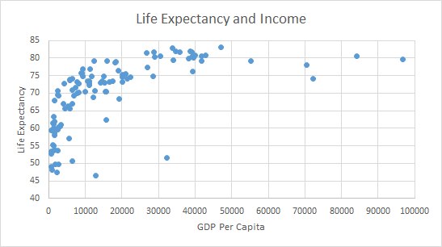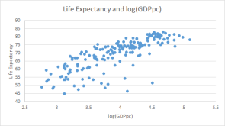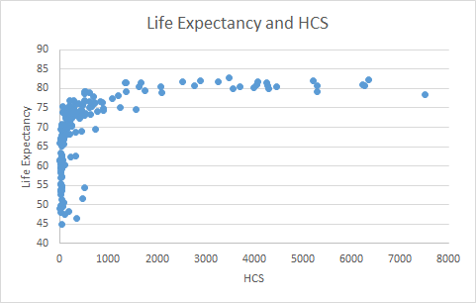**Chart 2: Logarithmic Transformation Visualizations**

|  |
| --- |
|  |
|  |
|  |
|  |

**Table 20: Meta-Analysis Summary**

*Each “1” indicates that the variable was significant at the 95% confidence level*

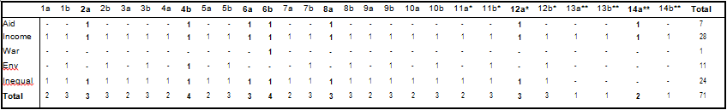

*Health care spending was used as a proxy for income in these specifications, **Education was used as a proxy for income in these specifications

**Table 21: World Bank Region and Income Group (Complete Dataset)**

|  |
| --- |
| High income: High income: Low Lower middle Upper middle Grand  **World Bank Region**  nonOECD OECD income income income Total |
| East Asia & Pacific 9 4 2 12 10 **37** |
| Europe & Central Asia 13 24 0 8 12 **57** |
| Latin America &  16 1 1 6 17 **41**  Caribbean |
| Middle East & North  7 1 0 6 7 **21**  Africa |
| North America 1 2 0 0 0 **3** |
| South Asia 0 0 2 5 1 **8** |
| Sub-Saharan Africa 2 0 26 14 6 **48** |
| **Grand Total 48 32 31 51 53 215** |

**LIST OF COUNTRIES**

|  |  |  |  |
| --- | --- | --- | --- |
| Afghanistan | Dominica | Lesotho | Saudi Arabia |
| Albania | Dominican Republic | Liberia | Senegal |
| Algeria | Ecuador | Libya | Serbia |
| American Samoa | Egypt, Arab Rep. | Liechtenstein | Seychelles |
| Andorra | El Salvador | Lithuania | Sierra Leone |
| Angola | Equatorial Guinea | Luxembourg | Singapore |
| Antigua and Barbuda | Eritrea | Macao SAR, China | Sint Maarten (Dutch part) |
| Argentina | Estonia | Macedonia, FYR | Slovak Republic |
| Armenia | Ethiopia | Madagascar | Slovenia |
| Aruba | Faeroe Islands | Malawi | Solomon Islands |
| Australia | Fiji | Malaysia | Somalia |
| Austria | Finland | Maldives | South Africa |
| Azerbaijan | France | Mali | South Sudan |
| Bahamas, The | French Polynesia | Malta | Spain |
| Bahrain | Gabon | Marshall Islands | Sri Lanka |
| Bangladesh | Gambia, The | Mauritania | St. Kitts and Nevis |
| Barbados | Georgia | Mauritius | St. Lucia |
| Belarus | Germany | Mexico | St. Martin (French part) |
| Belgium | Ghana | Micronesia, Fed. Sts. | St. Vincent and the Grenadines |
| Belize | Greece | Moldova | Sudan |
| Benin | Greenland | Monaco | Suriname |
| Bermuda | Grenada | Mongolia | Swaziland |
| Bhutan | Guam | Montenegro | Sweden |
| Bolivia | Guatemala | Morocco | Switzerland |
| Bosnia and Herzegovina | Guinea | Mozambique | Syrian Arab Republic |

|  |  |  |  |
| --- | --- | --- | --- |
| Botswana | Guinea-Bissau | Myanmar | Taiwan, China |
| Brazil | Guyana | Namibia | Tajikistan |
| Brunei Darussalam | Haiti | Nepal | Tanzania |
| Bulgaria | Honduras | Netherlands | Thailand |
| Burkina Faso | Hong Kong SAR, China | New Caledonia | Timor-Leste |
| Burundi | Hungary | New Zealand | Togo |
| Cabo Verde | Iceland | Nicaragua | Tonga |
| Cambodia | India | Niger | Trinidad and Tobago |
| Cameroon | Indonesia | Nigeria | Tunisia |
| Canada | Iran, Islamic Rep. | Northern Mariana Islands | Turkey |
| Cayman Islands | Iraq | Norway | Turkmenistan |
| Central African Republic | Ireland | Oman | Turks and Caicos Islands |
| Chad | Isle of Man | Pakistan | Tuvalu |
| Channel Islands | Israel | Palau | Uganda |
| Chile | Italy | Panama | Ukraine |
| China | Jamaica | Papua New Guinea | United Arab Emirates |
| Colombia | Japan | Paraguay | United Kingdom |
| Comoros | Jordan | Peru | United States |
| Congo, Dem. Rep. | Kazakhstan | Philippines | Uruguay |
| Congo, Rep. | Kenya | Poland | Uzbekistan |
| Costa Rica | Kiribati | Portugal | Vanuatu |
| Côte d'Ivoire | Korea, Dem. Rep. | Puerto Rico | Venezuela, RB |
| Croatia | Korea, Rep. | Qatar | Vietnam |
| Cuba | Kosovo | Romania | Virgin Islands (U.S.) |
| Curaçao | Kuwait | Russian Federation | West Bank and Gaza |
| Cyprus | Kyrgyz Republic | Rwanda | Yemen, Rep. |
| Czech Republic | Lao PDR | Samoa | Zambia |

|  |  |  |  |
| --- | --- | --- | --- |
| Denmark | Latvia | San Marino | Zimbabwe |
| Djibouti | Lebanon | São Tomé and Principe |  |

*Full data was not available for all countries; please note number of observations (n-count)* *where applicable.*

**LIST OF COUNTRIES WITH GDP DIVIDED BY POPULATION**

Andorra Isle of Man Argentina Liechtenstein

Aruba Monaco

Channel Islands San Marino

Greenland Syrian Arab Republic

**THE MILLENIUM DEVELOPMENT GOALS**

In September of the year 2000, leaders of 189 countries met at the United Nations in New York and endorsed the Millennium Declaration, a commitment to work together to build a safer, more prosperous and equitable world. The Declaration was translated into a roadmap setting out eight time-bound and measurable goals to be reached by 2015, known as the Millennium Development Goals, namely:

1) Eradicate extreme poverty and hunger

• Reduce by half the proportion of people whose income is less than $1 a day

* Achieve full and productive employment and decent work for all, including women and young people

• Reduce by half the proportion of people who suffer from hunger

2) Achieve universal primary education

• Ensure that all boys and girls complete a full course of primary schooling

3) Promote gender equality and empower women

• Eliminate gender disparity in primary and secondary education preferably by 2005, and in all

levels of education no later than 2015

4) Reduce child mortality

• Reduce by two thirds the mortality of children under five

5) Improve maternal health

• Reduce maternal mortality by three quarters

• Achieve universal access to reproductive health

6) Combat HIV/AIDS, malaria and other diseases

• Halt and reverse the spread of HIV/AIDS

• Achieve, by 2010, universal access to treatment for HIV/AIDS for all those who need it

• Halt and reverse the incidence of malaria and other major disease

7) Ensure environmental sustainability

• Integrate principles of sustainable development into country policies and programmes; reverse the loss

of environmental resources

• Reduce biodiversity loss, achieving, by 2010, a significant reduction in the rate of loss

• Halve the proportion of people without access to safe drinking water and basic sanitation

• Improve the lives of at least 100 million slum dwellers by 2020

8) Develop a global partnership for development

• Develop further an open, rule-based, predictable, non-discriminatory trading and financial

system

• Add developing states ress special needs of the least developed countries, landlocked countries and

small island developing states

• Deal comprehensively with developing countries’ debt

• In cooperation with pharmaceutical companies, provide access to affordable essential drugs in

developing countries

• In cooperation with the private sector, make available the benefits of new technologies, especially

information and communications technologies

For more information, please visit: [www.un.org/millenniumgoals](http://www.un.org/millenniumgoals)

**SUSTAINABLE DEVELOPMENT GOALS**

**Goal 1** End poverty in all its forms everywhere

**Goal 2** End hunger, achieve food security and improved nutrition and promote sustainable agriculture

**Goal 3** Ensure healthy lives and promote well-being for all at all ages

**Goal 4** Ensure inclusive and equitable quality education and promote lifelong learning opportunities for all

**Goal 5** Achieve gender equality and empower all women and girls

**Goal 6** Ensure availability and sustainable management of water and sanitation for all

**Goal 7** Ensure access to affordable, reliable, sustainable and modern energy for all

**Goal 8** Promote sustained, inclusive and sustainable economic growth, full and productive employment and decent work for all

**Goal 9** Build resilient infrastructure, promote inclusive and sustainable industrialization and foster innovation

**Goal 10** Reduce inequality within and among countries

**Goal 11** Make cities and human settlements inclusive, safe, resilient and sustainable

**Goal 12** Ensure sustainable consumption and production patterns

**Goal 13** Take urgent action to combat climate change and its impacts*

**Goal 14** Conserve and sustainably use the oceans, seas and marine resources for sustainable development

**Goal 15** Protect, restore and promote sustainable use of terrestrial ecosystems, sustainably manage forests, combat desertification, and halt and reverse land degradation and halt biodiversity loss

**Goal 16** Promote peaceful and inclusive societies for sustainable development, provide access to justice for all and build effective, accountable and inclusive institutions at all levels

**Goal 17** Strengthen the means of implementation and revitalize the global partnership for sustainable development

**REFERENCES:**

Boone, Peter. 1995. “Politics and the Effectiveness of Foreign Aid,” National Bureau of Economic Research, NBER Papers in International Finance and Macroeconomics, Working Paper 5308. National Bureau of Economic Research: Cambridge, MA (1995). Accessed 2015, <http://www.nber.org/papers/w5308.pdf>

Briggs, David. 2003. “Environmental pollution and the global burden of disease,” British Medical

Bulletin 68 vol. 1 (2003) 1-24. Accessed 2015, doi: 10.1093/bmb/ldg019

Cutler, David M., and Lleras-Muney, Adriana. 2006. “Education and Health: Evaluating Theories and Evidence,” NBER Working Paper No. 12352. Accessed 2015, doi: 10.3386/w12352

Cypher, James M. 2014. The Process of Economic Development. London: Routledge, 2014. Department for International Development. 2011. Annual Report and Accounts 2010-11,

Volume 1: Annual Report. London: The Stationery Office (2011). Accessed 2015,

https://[www.gov.uk/government/uploads/system/uploads/attachment_data/file/67477/A](http://www.gov.uk/government/uploads/system/uploads/attachment_data/file/67477/A)

nual-report-2011-vol1.pdf

Dodd, Rebecca, Schieber, George, Cassels, Andrew, Fleisher, Lisa, and Gottret, Lisa. 2007. “Aid Effectiveness and Health,” WHO/HSS/healthsystems/2007.2 Working Paper 9. Accessed 2015, <http://www.who.int/healthsystems/gf3.pdf>

Easterly, William. 2006. The White Man’s Burden: Why the West’s Efforts to Aid the Rest have

Done So Much Ill and So Little Good. (London: Penguin, 2006), 269-305.

Foster, Mick. 2005. Fiscal Space and Sustainability: Towards a Solution for the Health Sector. World Health Organization, High Level Forum on the Health Millennium Development Goals. WHO: Geneva (2005), 67-92. Accessed 2015,<http://www.who.int/hdp/publications/hlf_volume_en.pdf>

Herzer, Dierk, Nagel, Korbinian, and Nunnenkamp, Peter. 2015. “How Does FDI Affect

Health?,” International Economic Journal 29 no. 4 (2015), 1-25. Accessed 2015, doi:

10.1080/10168737.2015.1103772

Kharas, Homi. 2007. “Trends and Issues in Development.” Wolfensohn Center for Development at The Brookings Institution, Working Paper 1. Accessed 2015, [http://www.brookings.edu/~/media/research/files/papers/2007/11/development-aid](http://www.brookings.edu/%7E/media/research/files/papers/2007/11/development-aid) kharas/11_development_aid_kharas.pdf

Krugman, Paul. 1995. Development, Geography and Economic Theory. Cambridge, MA: The

MIT Press, 1995.

Marmot, Michael. 2002. “The Influence of Income On Health: Views Of An Epidemiologist,” Health Affairs 21, vol. 21 no. 2 (2002): 31-46. Accessed 2015, doi: 10.1377/hlthaff.21.2.31

Misra, Prachi, and Newhouse, David. 2007. “Health Aid and Infant Mortality,” International Monetary Fund, Fiscal Affairs and Research Departments, Working Paper 07/100. IMF: Washington, DC (2007). Accessed 2015,

https[://w](http://www.imf.org/external/pubs/ft/wp/2007/wp07100.pdf)ww[.imf.org/external/pubs/ft/wp/2007/wp07100.pdf](http://www.imf.org/external/pubs/ft/wp/2007/wp07100.pdf)

National Research Council. 2010. Accounting for Health and Health Care: Approaches to Measuring the Sources and Costs of Their Improvement. Panel to Advance a Research Program on the Design of National Health Accounts, Committee on National Statistics. Division of Behavioral and Social Sciences and Education. (Washington, DC: The National Academies Press), 119-124. Accessed 2015,<http://www.nap.edu/read/12938/chapter/7>

North Carolina Institute of Medicine Task Force on Prevention. 2009. Prevention for the Health of North Carolina: Prevention Action Plan. (Morrisville, NC: North Carolina Institute of Medicine), 243-272. Accessed 2015, <http://www.nciom.org/wp>content/uploads/NCIOM/projects/prevention/finalreport/Prevention-Chpt11.pdf

Organization for Economic Co-Operation and Development. 2005. Paris Declaration and Accra Agenda for Action. Accessed 2015,<http://www.oecd.org/dac/effectiveness/parisdeclarationandaccraagendaforaction.htm>

Organization for Economic Co-Operation and Development. Development Assistance

Committee. 2015. ODA 2014 Technical Note. Paris: OECD, 2011.

Rehkoph, DH, Berkman, LF, Coull, B, and Krieger, N. 2008. “The non-linear risk of mortality by income level in a healthy population: US National Health and Nutrition Examination Survey mortality follow-up cohort, 1988-2001,” BMC Public Health 8, (2008). Accessed 2015, doi:10.1186/1471-2458-8-383

Sen, Amartya. 1999. Development as Freedom. Oxford: Oxford University Press, 1999.

Shpak, Solomiya. 2012. “Effectiveness of Foreign Aid to Health: Case of Developing Countries.” Master’s thesis, Kyiv School of Economics, 2012. Accessed 2015, [http://webcache.googleusercontent.com/search?q=cache:Hfxk4tYT7rUJ:www.kse.org.u](http://webcache.googleusercontent.com/search?q=cache%3AHfxk4tYT7rUJ%3Awww.kse.org.u)

/download.php%3Fdownloadid%3D111+&cd=1&hl=en&ct=clnk&gl=us

Sidel, VW, and Levy, BS. 2008. “The health impact of war,” International Journal of Injury

Control and Safety Promotion 15 vol. 4 (2008): 189-195. Accessed 2015, doi:

10.1080/17457300802404935

Subramanian, S.V., and Kawachi, Ichiro. 2003. “Income Inequality and Health: What Have We

Learned So Far?” Epidemiologic Reviews 28, (2004). Accessed 2015, doi:

10.1093/epirev/mxh003

UNESCO. 1975-2014. “Total Secondary Net enrolment rate.” UNESCO Institute for Statistics.

Accessed 2015, http://data.un.org/Data.aspx?d=UNESCO&f=series%3ANER_23

UNICEF, WHO, The World Bank and UN Population Division. 2006. “Levels and Trends of Child Mortality in 2006: Estimates developed by the Inter-agency Group for Child Mortality Estimation,” Working Paper. New York, 2007. Accessed 2015,<http://www.childmortality.org/files_v20/download/Levels%20and%20Trends%20of%20> hild%20Mortality%20in%202006%20(Working%20Paper).pdf

United Nations Development Programme. 2015. Evaluation of the Role of the UNDP in Supporting the National Achievement of the Millenium Development Goals. Independent Evaluation Office. New York: UNDP (2015): xi-xxiv. Accessed 2015, <http://web.undp.org/evaluation/evaluations/thematic/mdg.shtml>

United Nations. 2000. The Millennium Development Goals. New York, 2000. Accessed 2015, <http://www.un.org/en/mdg/summit2010/pdf/List%20of%20MDGs%20English.pdf>

United Nations. 2008. Official list of MDG indicators. New York, 2008. Accessed 2015, http://mdgs.un.org/unsd/mdg/host.aspx?Content=indicators/officiallist.htm

United Nations. 2015. Sustainable Development Goals. Accessed 2015, <http://www.un.org/sustainabledevelopment/sustainable-development-goals/>

Vision of Humanity. 2010. “Global Peace Index 2010, Global Rankings.” Institute for Economics and Peace. Accessed 2015, [http://www.visionofhumanity.org/#page/indexes/global](http://www.visionofhumanity.org/%23page/indexes/global) peace-index/2010

Williamson, Claudia R. 2008. “Foreign Aid and Human Development: The Impact of Foreign Aid to the Health Sector,” Southern Economic Journal 15 no. 2 (2008), 188-207. Accessed

2015, doi: 10.2307/20112034.

World Bank. 1981-2015. “GDP at market prices (current US$).” World Development Indicators.

Accessed 2015, <http://data.worldbank.org/indicator/NY.GDP.MKTP.CD>

World Bank. 1981-2015. “GDP per capita, PPP (current international $).” World Development

Indicators. Accessed 2015, <http://data.worldbank.org/indicator/NY.GDP.PCAP.PP.CD>

World Bank. 1981-2015. “GINI index (World Bank estimate),” World Development Indicator.

Accessed 2015, <http://data.worldbank.org/indicator/SI.POV.GINI>

World Bank. 1981-2015. “Health expenditures, total (% of GDP).” World Development

Indicators. Accessed 2015. <http://data.worldbank.org/indicator/SH.XPD.TOTL.ZS>

World Bank. 1981-2015. “Life expectancy at birth, total (years).” World Development Indicators.

Accessed 2015, <http://data.worldbank.org/indicator/SP.DYN.LE00.IN>

World Bank. 1981-2015. “Mortality rate, infant (per 1,000 live births).” World Development

Indicators. Accessed 2015, <http://data.worldbank.org/indicator/SP.DYN.IMRT.IN>

World Bank. 1981-2015. “Net ODA received per capita (current US$).” World Development

Indicators. Accessed 2015, <http://data.worldbank.org/indicator/DT.ODA.ODAT.PC.ZS>

World Bank. 1981-2015. “PM2.5 air pollution, mean annual exposure (micrograms per cubic meter),” World Development Indicators. Accessed 2015, <http://data.worldbank.org/indicator/EN.ATM.PM25.MC.M3>

World Bank. 1981-2015. “Population, total.” World Development Indicators. Accessed 2015,<http://data.worldbank.org/indicator/SP.POP.TOTL>

World Bank. 1993. “World Development Report 1993: Investing in Health”. (New York: Oxford

University Press), 1-16. Accessed 2015,

https://openknowledge.worldbank.org/bitstream/handle/10986/5976/9780195208900_o erview.pdf?sequence=3&isAllowed=y

World Bank. 2000-2010. “Commitments and disbursements to recipient countries, 2000-2010.” Health systems, Governance and aid effectiveness. Accessed 2015, [http://apps.who.int/gho/data/node.main.A1626?lang=en.](http://apps.who.int/gho/data/node.main.A1626?lang=en)

World Bank. 2000. Beyond Economic Growth: Meeting the Challenges of Global Development.

Soubbotina, Tatyana P., and Katherina A. Sheram. WBI Learning Resources Series. (Washington, DC: The World Bank, 2000), 7-9. Accessed 2015,<http://www.worldbank.org/depweb/beyond/beyondco/beg_all.pdf>

World Bank. 2014. “Income level data, High income: nonOECD”. Accessed 2015.<http://data.worldbank.org/income-level/NOC>

World Bank. 2014. “Income level data, High income: OECD”. Accessed 2015,<http://data.worldbank.org/income-level/OEC>

World Bank. 2014. “Income level data, Low income”. Accessed 2015.<http://data.worldbank.org/income-level/LIC>

World Bank. 2014. “Income level data, Lower middle income”. Accessed 2015. <http://data.worldbank.org/income-level/LMC>

World Bank. 2014. “Water Supply and Sanitation: Sector Results Profile,” Projects and Operations. Accessed 2015, <http://www.worldbank.org/en/results/2013/04/12/water> sanitation-results-profile

World Health Organization. 2006. “The world health report 2006 working together for health.” Geneva: WHO Press. Accessed 2015, <http://www.who.int/whr/2006/whr06_en.pdf>

**THE NEW LABOR FORCE: MORE (ARTIFICIALLY) INTELLIGENT THAN EVER**

***Samuel Necrason, Siena College***

***Dr. Larry Medsker, Siena College***

***ABSTRACT***

*The American economy has entered a new frontier. Rapid technological innovation is changing the role of the human worker in the America, and the average American household is having a difficult time keeping pace. Advancements in artificial intelligence and other technologies have permeated the contemporary lifestyle, firm, and marketplace. Functions once reserved for humans are now done in a superior manner by machines- with diminishing costs and increasing capability. As a result, policymakers must promote a sustainable relationship between humans and machines.*

**INTRODUCTION**

Firms are the fruition of an idea, a strategy, a mission- created by a person. So what happens when these people nurture their idea into an expanding, developing, and successful business?

They must make investment decisions that will maximize profits. These can be difficult decisions, impeded by biases and incomplete information. At the fundamental level, investment in productive resources has two forms: labor and capital. Labor can help utilize capital and provide additional intangible outputs, such as creativity and communication. However, labor can have limitations that may be far exceeded by capital.

Consider the farming industry, where $50,000 of labor input, say five workers, may have the limitation of cultivating a single acre of crops; whereas $50,000 of capital input, say one tractor,

may be capable of cultivating five acres of crops. The decision of additional labor or capital investment may be seemingly simple: employ the more productive capital resources and improve profits. However, when firms decide to invest in more capital, they are concurrently deciding to invest in less labor. The five workers displaced on the farm by a tractor must now seek work elsewhere.

History would suggest that the workers displaced by the tractor have been able to find work elsewhere, as illustrated by a relatively stable long-term unemployment trend. As for the tractor, it may be subject to replacement if its productive capacity is exceeded by a new technological advancement.

Trends in output data suggest that capital resources are becoming increasingly productive. For instance, the number of transistors in an integrated circuit has nearly doubled every two years over the past half century (as predicted by Gordon Moore in 1965). The continuous increase in processing capacity has allowed firms to utilize computing power at lower costs. Rapid advancements in capital resources such as the semiconductor have allowed for economic growth and an improved standard of living for most of the world.

In respect to the input/ output dynamics in the economy, total output has grown while labor inputs for production have been relatively flat for the past 25 years. However, capital inputs for production have increased more than twofold.

Data illustrating input/ output trend suggests that capital inputs are driving output growth. Why? As stated before, capital is becoming more capable. Functions once reserved only for man, such as pattern recognition, language learning, and decision-making, can now be performed by machines.

The purpose of capital inputs is no longer to simply gain a mechanical advantage to labor inputs. Machines may be able to outright replace certain “humanlike” functions.

This study seeks to investigate the relationship between humans and machines, the potential labor force implications of improving technologies, and propose policy implications for the tumultuous dynamics between economic growth, human welfare, and technological advancement. The scope of this research paper is limited to the United States, which has been dubbed the “frontier economy”, where most technological advancement and fundamental labor force shifts occur.

**LITERATURE REVIEW**

**Making Sense of Intelligence**

The discussion of artificial intelligence is proliferating across popular culture, internet blogs, and scientific communities. Images of a dystopian future in a world overruled by evil robots have found the big screen. This paper is not a continuation of these screenplays. Rather, this paper is an investigation of the current state of artificial intelligence, and a consultation of the expert insights into the future of artificial intelligence. This paper also seeks to apply this survey of artificial intelligence in the framework of economics, with particular attention afforded to the labor force implications of artificial intelligence.

A systematic definition of artificial intelligence will form the foundation of this paper. Stanford computer scientist John McCarthy eloquently defines intelligence as “the computational part of the ability to achieve goals in the world” (McCarthy 2007). Artificial, as defined by the Oxford dictionary, is something “made or produced by human beings, rather than occurring naturally”. Concatenating these two definitions provides the context of artificial intelligence for this study, “man-made problem solving capabilities”.

Provided this definition, artificial intelligence may seem to be an umbrella term for any technology; after all, technology is man made and solves problems. This *ex vi termini[13]* argument may seem to render artificial intelligence as an area too broad for any focused investigation. Is artificial intelligence a 20-line computer program capable of computing the quotient of two integers? Or is artificial intelligence a title reserved for a multimillion dollar program capable of conquering Jeopardy champions and performing medical diagnoses? After all, both technologies have “man-made problem solving capabilities”. This problem of defining what constitutes artificial intelligence is the “AI effect”.

The AI effect identifies the difficult paradox of advancement- how can the sophistication of a technology be contextualized? And when is a technology truly *intelligent*?

Consider the smart, sometimes sassy, woman in Apple’s iProducts. While the capabilities of Siri may seem simple and commonplace a tween born in 2003, a tween in the 1970s only imagined such technology as a possibility for George Jetson. So was Siri only intelligent before she was available to the consumer? Is Siri now just another technology, with the frontier of true artificial intelligence yet to be seen? Computer scientist Larry Tesler is famously misquoted for his adage describing AI as “whatever hasn’t been done yet” (Hofstander 1980). Abandoning AI at this definition of “unavailable technology” would undermine the advancements in the field and make for a much more speculative research paper. Instead, artificial intelligence should be stratified to categorize technologies in a historical, contemporary, and future-based context.

**Contextualizing Artificial Intelligence**

Artificial intelligence is embedded in the contemporary lifestyle. From Google’s real-time Maps and autonomous cars, to Amazon’s “things you may also like” suggestions, there are sophisticated AI technologies that many consumers see as basic features in everyday devices. AI is equally popular outside of the consumer realm; for instance, high frequency trading algorithms account for over 50 percent of equity shares traded in US markets (SEC 2015). These types of technologies that are exceptionally good at solving a specific problem, such as how to get from point A to point B, or when to buy or sell shares of a company, are known as artificial narrow intelligence (ANI), or weak AI.

The capabilities of ANI are impressive, and far exceed the capacity of the human brain- at a narrow function. As Tim Urban nicely illustrates: “[t]here’s AI that can beat the world chess champion in chess, but that’s the only thing it does. Ask it to figure out a better way to store data on a hard drive, and it’ll look at you blankly,” (Urban 2015). Right now, humans are much better at abstraction than computers. For instance, humans can easily understand that the following two letters are the same:

**Figure 1:** Just “b”



Understanding what “b-ness”, or “dog-ness”, or “happiness” are- things humans do without much effort, is incredibly difficult for computers. The human mind has been optimized over thousands of years to interpret and understand the seemingly obvious features of seemingly simple things.

Right now, closing the bridge from ANI to more human-like “artificial general intelligence” (AGI) is the impetus of the artificial intelligence community. The impediments to improving AGI are twofold and complementary: processing power, and program capability. Without adequate computational capacity, it is difficult to compile a program that is capable of AGI.

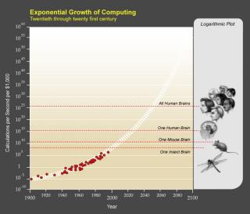The requirement of a humanlike computer program is a humanlike processing machine- and the human brain is an exceptionally powerful machine. Ray Kurzweil has estimated that the human brain is capable of processing 1016 (10 quadrillion) calculations per second (cps) (Kurzweil 2005). Right now, China’s Tianhe-2 supercomputer is able to surpass that number (Reuters 2015). However, the Tianhe-2 is a machine that is massive, expensive, and (unless you are a Chinese National Defense insider) inaccessible. In a 1965 report, NASA (allegedly) affectionately noted that “man is the lowest-cost, 150-pound, nonlinear, all-purpose computer system which can be mass- produced by unskilled labor” (McAfee and Brynjolfsson 2014). But humanlike processing capabilities may be arriving to the store soon.

If Moore’s law holds, which has accurately projected the exponential growth of processing capacity, a 1016 cps processor may be available by 2025. The extrapolated trend of computer processing capabilities can be found in Figure 2.

**Figure 2:** Exponential Growth

*Source: Kurzweil Technologies, Inc.*

Once a machine as powerful as the human brain is available to the masses, the community responsible for developing AGI will boom- from college undergrads to Google Directors. AGI development will likely be an integration of three strategic approaches: emulating the

methodology and physiology of the brain with software and hardware; using self-evaluating, self-improving algorithms to mimic the process of evolution; and programming machines to learn about AI and develop and improve their AI own architecture (Urban 2015). The development efforts will require creativity, coordination

and collaboration; fortunately, facilitation of this effort will be aided by the Internet.

It is important to note that human-level intelligence is merely a conceptualization for humans; that is, human-level intelligence is simply a benchmark of the current limitation of intelligence. But artificial intelligence has no limitations, and the capabilities of artificial intelligence may dramatically exceed that of man.

Once human-level AGI is obtained, an explosion of machine intelligence may happen (Good

1965). Shortly after human-level AGI is attained, AI systems may become the best AI developers. This may bring a scenario where a cohort of intelligent systems, smarter than the world’s top software engineers, are working tirelessly at improving their own intelligence. Provided adequate network capacity, improvements and breakthroughs can be shared across systems, and the capabilities of AI will be constantly expanding. This recursive improvement dynamic may bring accelerating returns to intelligence, creating a level of intelligence incomprehensible by man (Bostrom 2014). This powerful intelligence, labeled by the AI community as Artificial Super Intelligence (ASI), may arrive soon.

According to multiple panels of artificial intelligence experts, AGI may arrive by 2040, and the milestone of ASI may be reached by 2060 (Müller and Bostrom, 2013; Barrat 2013; Urban

2015). To illustrate how soon experts anticipate the ASI milestone to be obtained, consider that by

2060, the undergraduate author of this study will be at the current retirement age of 65.

ASI may exhibit a relationship greater than that afforded to man and the natural world. To contextualize, consider how man is supremely smarter than an ant. Man has GPS systems, the Hubble Telescope, and Bluetooth Christmas lights. Man is able to eradicate polio.

The smartest men have IQs upwards of 180. So what relationship will exist in the natural world if there is an entity with a rapidly growing IQ of 10,000?[14] What will ASI mean for man? And what will ASI mean for our economy?

**Artificial Intelligence and the Economy**

“Creative disruption”, a technology-driven change in the fundamental framework of an institution, is not a new phenomena for the economy. Consider the displacement of farmers with the advent of the gas powered tractor, or the hoard of trained secretaries whose skills were no longer needed when personal computers arrived. Historic sectoral shifts, such as when the economy transitioned from agriculture-centric to manufacturing, and then from manufacturing to services, create uncertainty about the prospect of employment. However, there is a simple figure to assuage said uncertainty: the historic long term unemployment rate of 5.5%.

The relatively stable long-term unemployment trend enforces a profoundly reassuring argument: as old jobs are displaced, new jobs are created. Labor-replacing technologies allow firms to increase output, lower prices, and improve the quality of their goods. Dually, new technologies exert pressure on the labor force to become trained with more advanced skills to improve their human capital and employability. This dynamic is the basis of creative disruption, which has brought about extreme improvements in household wealth and the standard of living.

From a future-oriented perspective, there are well-respected, yet dichotomous “bearish” and “bullish” outlooks on the implications technology may have on the economy. This paper will examine both views, and offer a synthesized outlook based on expert opinion.

**The “Bearish” Outlook**

In his seminal 2012 paper, Robert Gordon made a provocative claim: “the rapid progress made over the past 250 years could well turn out to be a unique episode in human history” (Gordon 2012). In “Is U.S. Economic Growth Over?”, Gordon argues that slowing technological advancement will be a bottleneck to economic growth.

Moreover, Gordon suggests that inventions from the “third industrial revolution”, which include the personal computer and the internet, will not have the same economic impact as technologies from prior revolutions.[15] By focusing on specific technologies from the most recent technological revolution, Gordon makes a compelling case, citing that “attention in the past decade has focused not on labor-saving

innovation, but rather on a succession of entertainment and communication devices that do the same things as we could do before, but now in smaller and more convenient packages” (Gordon 2012). By referencing average productivity growth in selected periods (Figure 3: Gordon’s Productivity), it may be reasonable to argue that accessing Twitter on an iPad may not improve productivity in a magnitude comparable to the productivity gains from electricity.

**Figure 3:** Gordon’s Productivity

*Source: NBER working paper (Title of chart modified from original version)*

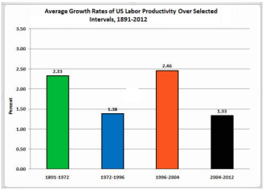

This bearish argument eventually concludes that the innovations from prior industrial revolutions may have provided a one-time boost to the American economy, and the economic benefits from future innovation will be more incremental- resulting in slower economic growth (Gordon 2012). Although this paper notes how the nature of labor changes with technological advancements, it may be reasonable to presume that Gordon (and experts who share similar opinions to Gordon) do not see Artificial Intelligence as an imminent

threat to the American labor force. Rather, this group likely believes that a modest path of creative disruption will continue to slowly improve the standard of living in America.

**The “Bullish” Outlook**

Karl Marx, a wide-eyed observer of the first two industrial revolutions, saw technology as the engine of capitalism. An era later, iconic economists John Maynard Keynes and Joseph Schumpeter developed theories emphasizing the economic and material gains that result from innovation. Contemporary scholars, like Erik Brynjolfsson and Andrew McAfee, continue to stress the economic potential of innovation.

These “bullish” academics distinguish between economic growth and employment growth. Although ongoing creative disruption has not disturbed the long-term employment trend, experts in the bullish group maintain a relative skepticism about the sustainability of employment growth. In Marx’s theory of history, technological growth was described not only as the engine of capitalism- but also as the force that would engulf the institution that it once drove. Marx speculated that technological advancements would bring workers to a point of revolution, where bargaining power and profit sharing would be demanded by the labor force, bringing society from capitalism to socialism. In a similar, yet less explicitly radical view, Brynjolfsson and McAfee envision a “labor-light” economy, where technology could decouple consumption and employment (in other words, workers would be able to maintain their appetite for consumption without working as much). Fortunately for humans, Brynjolfsson and McAfee note, “people can influence economic outcomes, such as wages and incomes, through the democratic process” (Brynjolfsson and McAfee, 2015).

In the bullish view, institutions are critical to mitigate the destructive potential of technology. If machines do replace the need for most human labor, people will need to control their destiny and assure that development, both human and technological, can occur in tandem.

**A Synthesized Outlook**

Technology is a sweeping force that is not ignored by economists. Although extreme views about the labor force implications of innovation are largely conflicting, the views expressed by both the “bear” and the “bull” camps have their merits.

Robert Gordon may rightfully anticipate slower economic growth as a result of slowing innovation. However, the slowing of innovation should not be treated as an isolated, singular force. Slowing innovation may occur, but will likely be a proxy effect of an aging demographic in frontier economies, and a lack of necessary skills to maintain historical levels of innovation.[16] If sufficient emphasis is placed on STEM training and education, economies may have a sufficient pool of human capital to mitigate an innovation slowdown.

If technology does substantially disrupt the labor force, Marx and McAfee may be overly optimistic about the potential for humans to intervene in their employment destiny. If the trend of wage inequality and the political clout of the elite class continues on the current trajectory, workers may not have sufficient bargaining power to prevent a dismal outcome. Firms employing labor saving technologies will have little incentive to end their practices, and without government intervention, creative disruption may transform to creative destruction where fewer and fewer workers are needed by firms.

There is one dynamic that is promising for the going concern of human labor- humans are social beings. Humans seek nurture, motivation, and camaraderie from other humans. Machines may be capable of child care, personal training, and education- however, machines may never be capable of being *humans*. The human element may be the most important asset to human destiny.

**EMPIRICAL ANALYSIS**

Robert Solow, with his revered economic wisdom, noted that “you can see the computer age everywhere but in the productivity statistics” (Solow, 1987). In light of Solow’s witty quip, this paper will attempt to illustrate the “macro-mosaic” of the American labor force, with its intricate composition, through empirical observations. This paper does not employ sophisticated panel regression techniques or bayesian analysis. Rather, a story will be weaved with data that is easy to interpret.[17]

The relationship between humans and machines is nicely illustrated by the investment decisions of firms. As shown in Figure 4, firms are employing an increasing amount of capital, while investment in labor inputs has remained relatively stable over the last 30 years.

**Figure 4:** Labor and Capital Input, Productivity

*Source: Bureau of Labor Statistics*

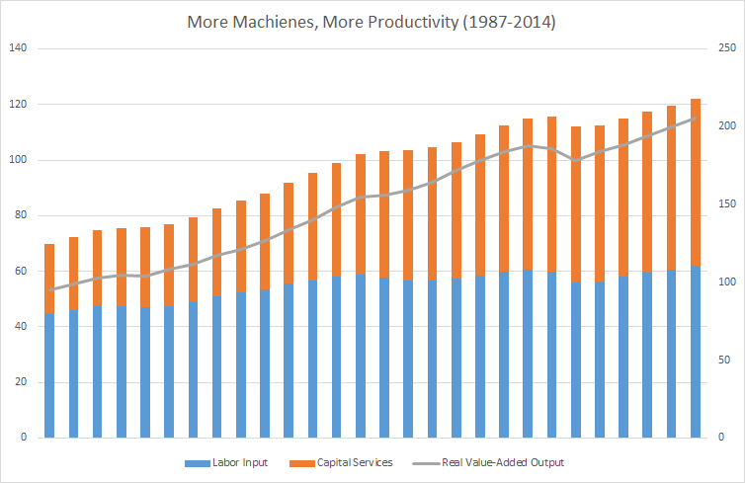

Provided this interpretation, it may be fair to conclude that increasing capital employment is driving productivity growth. As previously noted, this dynamic has been the foundation of an improved standard of living in the United States. More goods are able to be produced at a lower price, so consumption can increase- provided wage growth meets or exceeds productivity growth.

But as Figure 5 suggests, the American labor force has entered into a new era. In 2010, for the first time since wage and productivity data was collected, productivity growth surpassed wage growth in the United States. This represents a significant turning point in the dynamic of the American labor force. Prior to this divide, the economic assumption, supported by data, was that labor inputs were critical for firms, and workers were rewarded proportionately for increases in productivity. Now, as machines are becoming more capable of performing “human work”, workers are becoming less necessary for productivity gains- and their wages are following this diminishing demand.

**Figure 5:** GDP, Median Household Income, Corporate Profits

*Source: Federal Reserve Bank of St. Louis*

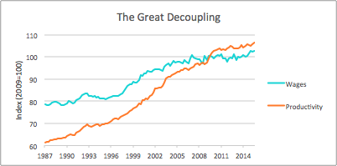

In light of the stagnant wage growth in post recession America, GDP, a barometer of standard of living, has continued to grow. As Figure 6 suggests, average households are not reaping the benefits of this increase in output.

**Figure 6:** Real GDP, Median Household Income, Corporate Profits

*Source: Federal Reserve Bank of St. Louis*

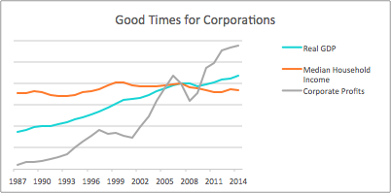

As GDP continues to grow, median household income has been descending. Meanwhile, corporate profits have followed an upward trajectory to historical highs. America, once home to the American dream, is now a nation with sluggish wage growth,

declining household income, and soaring corporate profits. The result has been

rampant inequality, where

the concept of “average” is no longer synonymous with “well off”. Government policy has done little to combat the issue of income inequality in the land of liberty, creating a dynamic where workers have little bargaining power, social welfare programs are moot and dwindling, and the elite class has disproportionate political clout (Desilver 2013).

Technology may compound the hurdles faced by the American labor force. As more jobs are subject to automation, the labor market is becoming polarized. Highly skilled workers are experiencing substantial wage gains and are easily finding employment, whereas less-skilled workers do not have the same prospects (Autor and Dorn, 2005).

Although the headline U3 unemployment rate is near historic lows (5.0% in October 2015), in-depth JOLTS and Dice-DFH indicators reinforce the suggestion that there is a bifurcation of the American labor force. In September of 2015, for the first time since the data was collected, job openings surpassed job hires. After examining recruiting intensity in key industries, it is apparent that firms are reluctant to hire job candidates with less-than-ideal skills sets. This may suggest that there is a “skills gap” in America, where necessary human capital is unavailable to employers, and employers are hesitant to invest in imperfect candidates. Why is there a skills gap? The answer may be technology. Computer scientist/ economist James Besson explains how new technologies frequently require specific new skills that schools don’t teach and that labor markets don’t supply. Since information technologies have radically changed much work over the last couple of decades, employers have had persistent difficulty finding workers who can make the most of these new technologies. (Besson 2014)Technology may be destroying the American labor market for workers without sufficient skills; meanwhile, workers with proper technical skills may have more prospects than ever.

New technologies are adapted at an increasing rate (see Figure 7), so future innovations such as AI may rapidly intensify the existing imbalances in the labor market. A Bank of America Merrill Lynch report cites that “the number of industrial robots is up 72% in the last 10 years, while the number of US manufacturing jobs is down 16%. The Boston Consulting Group recently predicted that machines, which now account for 10% of all manufacturing tasks, are likely to perform about 25% of them by 2025. More pertinently, in the future, machines will perform more and more tasks in banking, logistics, health care and other service sector industries.” (Hartnett et al. 2015)

**Figure 7:** Technology Adoption Rates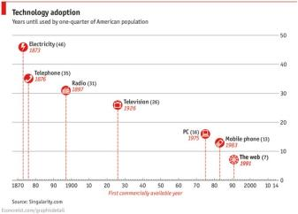

*Source: The Economist*

A growing global population, compounded with the exponential rate of technological innovation and adaption (shown in Figure 8), will require workers to be more skilled than ever before. Workers without sufficient skills may see their wages dwindle and government policy fail to safeguard their standard of living.

**Figure 8:** Technology Innovation Rate, Population Growth

*Source: Bank of America Merrill Lynch*

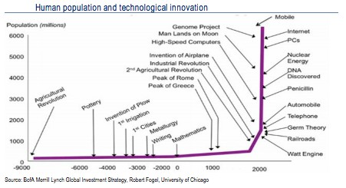

Eventually, with in developments nanotechnology and ASI, it is possible that human labor will no longer be *needed*.[18] Human labor will be something that

is sought not for productive potential, but for “human-ness”. Wealth, and the

strife associated with wealth, may become part of the historical zeitgeist. Until then, as technology advances, and the gaps within the American labor market widen, it is important for humans to prevent their obsolescence, value their “human-ness”, and promote legislative policy that is both “pro-human” and “pro-progress”.

**CONCLUSION**

The American economy is at a crossroads, with technology driving a divide in the labor force. As time progresses, technological innovation may further disrupt the economic mechanisms that once offered an improving life to American households. With the onslaught of new automated capabilities, workers are no longer needed in a traditional capacity. The dynamic of creative disruption is changing- and changing fast. Single industries, such as manufacturing or agriculture, are no longer subject to fundamental changes in their composition; rather, the economy as a whole is permeated by rapidly improving technologies.

A majority of these technologies may be considered forms of artificial intelligence. So far, the development of artificial intelligence technologies has been impressive, and specialized programs can markedly outperform humans at specific functions. If the trend of development continues, there may be dwindling need for human labor in any capacity. Eventually, human labor may no longer be needed for generating output whatsoever. Economic institutions will fundamentally change, and the current method of allocating resources

based on “luck, brains, and productivity” will seem archaic. However, if advancement in artificial intelligence begins to slow, and the landmark of artificial general intelligence is never reached, the bifurcation of the American labor force may continue. In this circumstance, average humans will be less needed, while properly skilled workers will be in great demand.

In consideration of the current trends in the American economy and the artificial intelligence development community, things may get worse for the average American before they get better. Innovative AI technologies may permanently displace workers in many industries, while new emerging industries will require high levels of human capital. The trend of exponential innovation, coupled with reduced adaptation periods, is already posing a difficult conundrum for policymakers. Right now, the average American household is falling behind, while corporations are making incredible strides. As the literature review and empirical analysis suggest, new innovations may be contributing to this divide.

However, technological advancement and economic prospect can coexist if mutually

beneficial relationships are established between firms, workers, and governments. Developing policy to establish proper safeguards for workers rights, encourage research and development of new technologies, and assure equitable access to education and training can assure a promising future for the American economy- and all of its participants.

The building blocks for new era of economics are largely in place. Constructing a bridge from the “old economy”, where humans were productive inputs, to the “new economy” where humans are *humans*, valued for their human-ness, can be an exciting process. Technology, and artificial intelligence in particular, can enable faster discoveries, create new business ecosystems, and afford humans more time to be *human.*

**REFERENCES:**

Artificial [Def. 1]. (2015). In *Oxford Dictionary*. Oxford, UK: Oxford University Press.

Autor, D. H., & Dorn, D. (2013). The Growth of Low-Skill Service Jobs and the Polarization of the US Labor Market. *American Economic Review, 103*(5), 1553-1597. doi:10.1257/aer.103.5.1553

Barrat, J. (2013). *Our Final Invention: Artificial Intelligence and the End of the Human Era*. New York, NY: Thomas Dunne Books.

Bessen, J. (2014, August 25). Employers Aren't Just Whining – The "Skills Gap" is Real. Retrieved November, 2015, from https://hbr.org/2014/08/employers-arent-just-whining-the-skills- gap-is-real/

Bostrom, N. (2014). *Superintelligence: Paths, Dangers, Strategies* (1st ed.). Oxford, UK: Oxford

University Press.

Brynjolfsson, E., & McAfee, A. (2015, September 03). Will Humans Go the Way of Horses? Retrieved from https://[www.foreignaffairs.com/articles/2015-06-16/will-humans-go-way-horses](http://www.foreignaffairs.com/articles/2015-06-16/will-humans-go-way-horses)

Bureau of Labor Statistics. (2015). *Job Openings and Labor Turnover Survey Highlights* (September

2015 ed., Issue brief). Washington, DC: Bureau of Labor Statistics.

Desilver, D. (2013, December 19). Global inequality: How the U.S. compares. Retrieved November,

2015, from <http://www.pewresearch.org/fact-tank/2013/12/19/global-inequality-how->the-u-s-compares/

DHI Group, Davis, S. J., & Durney, M. (2015). *Monthly Reports* (November 2015, Rep. No. 19). New

York, NY: Dice Holdings.

The Economist, & Singularity.com. (2014, March 12). Technology Adoption [Digital image].

Retrieved November, 2015, from [http://cdn.static-](http://cdn.static-/) economist.com/sites/default/files/imagecache/original- size/images/2014/03/blogs/graphic-detail/20140315_gdc502_1.png

Gordon, R. J. (2012). *Is U.S. Economic Growth Over? Faltering Innovation Confronts the Six Headwinds*

(Working paper No. 18315). Cambridge, MA: National Bureau of Economic Research.

Hartnett, M., Hodess, B., Hanson, M. S., Blanch, F., Nahal, S., & Roche, G. (2015). *Thematic Investing: Creative*

*Disruption* (Issue brief). New York, NY: Bank of America Merrill Kynch.

Hofstadter, D. R. (1999). *Gödel, Escher, Bach: An Eternal Golden Braid* (20th Aniv ed.). New York, NY: Basic Books.

Kurzweil, R., & Kurzweil Technologies, Inc. (2005, July 5). Exponential Growth of Computing. 20th to 21st Centuries. [Digital image]. Retrieved November, 2015, from https://upload.wikimedia.org/wikipedia/commons/thumb/d/df/PPTExponentialGrowthof

_Computing.jpg/800px-PPTExponentialGrowthof_Computing.jpg

Kurzweil, R. (2005). *The Singularity is Near: When Humans Transcend Biology*. New York: Viking. Marx, K., Engels, F., & Hobsbawm, E. J. (1998). *The Communist Manifesto: A Modern Edition*. London: Verso.

McCarthy, J. (2007, November 12). Basic Questions. Retrieved from [http://www-](http://www-/) formal.stanford.edu/jmc/whatisai/node1.html

Müller, V. C., & Bostrom, N. (2014). Future Progress in Artificial Intelligence: A Survey of Expert

Opinion. doi:10.1007/13748.2192-6360

Nair, A. S., & D'Souza, S. (2014, November 17). China's Tianhe-2 Retains Top Supercomputer Rank.

Retrieved from <http://www.reuters.com/article/2014/11/17/us-china-supercomputer-> idUSKCN0J11VV20141117

SEC. (2014). *Equity Market Structure Literature Review* (Part II) (United States of America, U.S.

Securities and Exchange Commission, Staff of the Division of Trading and Markets). Waschington, DC: Securities and Exchange Commission.

Solow, R. M. (1987, July 12). We'd Better Watch Out. *The New York Times*, pp. 35-36. Retrieved November, 2015, from <http://www.standupeconomist.com/pdf/misc/solow-computer->productivity.pdf

US. Bureau of Labor Statistics, Nonfarm Business Sector: Real Output Per Hour of All Persons [OPHNFB], retrieved from FRED, Federal Reserve Bank of St. Louis https://research.stlouisfed.org/fred2/series/OPHNFB/, November, 2015.

US. Bureau of Labor Statistics, Nonfarm Business Sector: Real Compensation Per Hour [COMPRNFB], retrieved from FRED, Federal Reserve Bank of St. Louis https://research.stlouisfed.org/fred2/series/COMPRNFB/, November, 2015.

US. Bureau of Labor Statistics, Net Multifactor Productivity and Costs, Private Business Sector, retrieved from Bureau of Labor Statistics [http://www.bls.gov/mfp/mprdload.htm,](http://www.bls.gov/mfp/mprdload.htm) November 2015.

US. Bureau of the Census, Real Median Household Income in the United States [MEHOINUSA672N], retrieved from FRED, Federal Reserve Bank of St. Louis https://research.stlouisfed.org/fred2/series/MEHOINUSA672N/, November, 2015.

US. Bureau of Economic Analysis, Corporate Profits with Inventory Valuation Adjustment (IVA) and Capital Consumption Adjustment (CCAdj) [CPROFIT], retrieved from FRED, Federal Reserve Bank of St. Louis https://research.stlouisfed.org/fred2/series/CPROFIT/, November, 2015.

US. Bureau of Economic Analysis, Real Gross Domestic Product [GDPC1], retrieved from FRED, Federal Reserve Bank of St. Louis https://research.stlouisfed.org/fred2/series/GDPC1/, November, 2015.

Urban, T. (2015, January 27). The AI Revolution: Our Immortality or Extinction.

**AN EVALUATION OF THE ALBANY COUNTRY COMMUNITY ACCOUNTABILITY BOARDS**

***Dylan Keyer, Siena College***

***Karen Kirker, Siena College***

***Dr. Ashley Provencher, Siena College***

***ACKNOWLEDGEMENTS***

This study was supported by the Albany County District Attorney’s Office, the Siena College Center for Academic Community Engagement, and the Damietta Cross-Cultural Center’s Cross- Cultural Solidarity Experience Grant. Any opinions, findings, conclusions or recommendations expressed in this publication are those of the authors and do not necessarily represent the official position or policies of the Albany County District Attorney’s Office or Siena College.For their assistance in making this research possible we would like to express our gratitude

to District Attorney Soares, Ms. Amanda Kyle-Sprague, Mr. Frankie Brito, Dr. Ruth Kassel, and Ms. Christa Grant.

We are grateful to staff at the Albany County District Attorney’s Office and the New York State Division of Criminal Justice Services (DCJS) for providing complete criminal record files on Community Accountability Board participants. The authors are solely responsible for the methodology used and results obtained with the DCJS data.

Finally, we would also like to extend our sincerest thanks to the numerous guest speakers who met with the class during the fall semester to inform our research methods, findings, and recommendations. Their contributions allowed us to more deeply understand criminal justice in the Capital District.

For correspondence, please contact Dr. Ashley Provencher, Siena College, Department of Economics, 515 Loudon Road, Loudonville, New York, 12211 ([aprovencher@siena.edu](mailto:aprovencher@siena.edu)).

**INTRODUCTION**

Since first emerging in the 1970s (Barnett, 1977; Eglash, 1977), restorative justice practices have increasingly supplemented or even replaced mainstream criminological practices (Braithwaite,

1989; Marshall, 1985; Umbreit, 1994). The restorative movement has been international, with practices being adopted in the United States, Canada, England, Scotland, Norway, Australia, New Zealand, and Japan (Hughes & Mossman, 2001). Still, the research is generally inconsistent about the effectiveness of restorative practices on

recidivism. Some research has linked practices to reductions in reoffending (Bonta, Law, & Hanson, 1998; Hayes & Daly, 2004; Luke & Lind, 2002; Maxwell & Morris, 2001; McGarrell & Hipple, 2007), while other studies failed to find significant reductions in recidivism (McCold & Wachtel, 1998; Niemeyer & Shichor, 1996; Roy, 1993; Umbreit, 1994). Meta-analytical studies (Bonta, Law, & Hanson, 1998; Bonta, Wallace-Capretta, & Rooney, 2002; Bradshaw & Roseborough, 2005; Latimer, Dowden, & Muise, 2005; Nugent, Williams, & Umbreit, 2003) have found a reduction in the reoffending rate of people who participated in programs with restorative features. Given the diversity of restorative practices, individual practices should be evaluated in order to assess their impact on a particular community.

With the support of the Albany County District Attorney's Office and Siena College, we collaborated on an evaluation of two community accountability boards (CABs) in Albany County, both in urban communities. Our framework enabled us to compare the experiences of an urban center to a more rural region. More importantly, our study enabled us to provide recommendations on how the program could be expanded thoughtfully.

**About this Evaluation**

Two administrative data sets were merged and analyzed in order to assess the recidivism patterns of people who participated in Albany or Cohoes CABs. The first data set includes case-level information as recorded by CAB board members. The second data set summarizes criminal histories of CAB participants in New York State. Data were provided by the New York State Division of Criminal Justice Services (DCJS).

The current study sought to answer three questions:

● What are the recidivism rates of people who participated in CAB?

● Do recidivism rates vary by the outcome of the CAB hearing?

● Are the demographic characteristics of CAB volunteers similar to those of the community?

This report is organized as follows: section two provides an overview of the restorative justice framework. The next section provides a profile of crime and criminal justice practices in Albany County during our survey period. The fourth section includes a descriptive profile of the board members. Section five presents findings related to the CAB participants, including their recidivism rates. The final sections present limitations of the study and recommendations for practice and further research.

**RESTORITIVE JUSTICE**

Restorative justice was originally developed in the 1970s (Barnett, 1977; Eglash, 1977) as a sentencing alternative that aims to help offenders acknowledge and repair the harms that were caused by their actions. In this framework, an offender, victim, and the community can collectively identify the harm created by an offense and restore the collective wellbeing. In contrast to a retributive system of justice, the goal of restorative justice is to acknowledge that harm was imposed on a victim and to attempt to repair that harm rather than simply punishing an offender for imposing the harm. Restorative justice views crime as a violation of people and relationships rather than just a violation of the law. Thus the goal of restorative justice is the restoration of both victims and offenders and to repair the harm done to the wider community.

Restorative justice aims to meet three pillars (Zehr, 2002). The first pillar is harms and needs. Harms are the crime that was committed and how it affected society and other people. While, needs seek to repair the harm caused by the offender both symbolically and concretely. It is also important to consider the need to be concerned about the harm experienced by offenders and communities (Zehr, 2002). The second pillar of restorative justice is the obligation to put right. This pillar focuses on the responsibility and accountability of the offender. Here, the offender is encouraged to understand the harm that was caused and understand the consequences behind that behavior. In addition, the offender must understand that they have a responsibility to make things right as much as possible (Zehr, 2002). The last pillar of restorative justice is engagement, or communication between stakeholders to help determine how to achieve justice.

In order for restorative justice practices to be effective, the offender must admit to committing a crime, and, in addition, must make amends for the harm that resulted from the offense through positive acts for the victim and the community. This general process has been adopted and amended for various program models but generally follows as such: in conference, the offender admits guilt and hears from the victim and the community about the harm experienced following the offense. The offender admits guilt and demonstrates a willingness to accept responsibility for the harm and to repair the harm. Community participation is strongly encouraged. The offender must listen to the other stakeholders to understand how their behavior has affected them. In this meeting, the offender must accept responsibility for the harm and apologize for the harm. Then, the offender must complete one or more reparative tasks to restore the victim and the community. The reparative tasks, repairing the harm and being accountable for imposing the harm, are jointly decided upon by all three parties (Zehr, 2002). Victim participation is important for both the offender and the victim’s restoration. The victims need to feel satisfied with the process and in addition, they must feel a sense of closure in order to restore justice.

**Restorative Practices**

Since first developed, restorative practices have evolved and been implemented in various contexts. Each practice consists of three primary elements: voluntariness, truth telling, and face-to- face encounters (Llewelly & Howse, 1998). The three main types of restorative justice practices are victim offender conferences, family group conferences, and circles. Victim offender conferences are meetings coordinated and led by a trained facilitator who helps guide the restorative process. Prior to the meeting, victims and offenders are worked with individually (Zehr, 2002). While family group conferences have primarily family members participate with some other individuals that are significant to both parties such as community members. This model tends to focus on supporting offenders to take responsibility and change their behavior. Circles allow equal participation from everyone. In circles, participants are arranged in a circle and they pass a talking piece around to assure that only one person speaks at a time. There is usually one or two circle keeper who facilitate the discussion. They allow equal participation from victims, offenders, and family and community members as well by using a talking piece. Community members are essential participants given their connection to both the offender and victim, who are members of the community (Zehr, 2002).

Studies of the effectiveness of restorative justice practices on recidivism have become more numerous since the 1980s but, given variations in the types of practices, are often not applicable to predicting the effectiveness of a particular practice in a local setting. Moreover, a study’s population may not be similar to the population served by a local program. Our study examines a program that targets low-risk, first-time, adult offenders[19] whereas many published evaluations assess restorative practices for juveniles. For instance, Latimer, Dowden, and Muise (2005) examined the effectiveness of restorative justice practices through a meta-analysis. This meta-analysis defined restorative justice as “a voluntary, community based response to criminal behavior that attempts to bring together the victim, the offender, and community, in an effort to address the harm caused by the criminal behavior,” (Latimer, Dowden, & Muise, 2005). This study investigated the effectiveness of 35 programs across 22 studies (Latimer, Dowden, & Muise, 2005). Most program participants were male (94 percent) or young (74 percent), though the definition of young was broadly defined (Latimer, Dowden, & Muise, 2005). Latimer, Dowden, and Muise (2005) found that participation in restorative justice programs resulted in a higher victim satisfaction rate (Latimer, Dowden, & Muise,

2005).

In addition, compared to the control group, offenders participating in restorative justice were significantly more likely to complete restitution agreements (Latimer, Dowden, & Muise, 2005) Restorative justice practices also yielded a large reduction in recidivism (Latimer, Dowden, & Muise, 2005).

In addition to meta-analytical work, researchers have documented the effectiveness of particular restorative practices. In one such study, using official court data, de Beus and Rodriguez (2007) conducted an evaluation of the Community Justice Committees in Maricopa County, Arizona. This is a diversionary program for juveniles that aimed to provide the youth with a sense of community. Similar to a family group conference model, juveniles participating in this program were required to take responsibility for and acknowledge their actions, participate in community service, and, or participate in a counseling, education, or rehabilitation program. de Beus and Rodriguez (2007) found that 20 percent of juveniles who participated in the Community Justice Committees recidivated compared to 32 percent of juveniles who did not participate. The type of crime committed and socioeconomic characteristics were also strong predictors of the effectiveness of the restorative practice. Juveniles who committed status or property offenses or who lived in communities with low levels of poverty were less likely to recidivate (de Beus & Rodriguez, 2007).

Another study examined the recidivism rates of juvenile offenders following their participation in restorative conferences (Sherman, Strang, & Woods, 2000). The authors controlled for four types of crime: drunk driving, juvenile property offenses, juvenile shoplifting offenses, and violent offenses (Sherman, Strang, & Woods, 2000). The restorative conferences were most effective at reducing the recidivism rate for people convicted of a violent offense; the conferences did not significantly affect the recidivism rates for people convicted of drunk driving, shoplifting, or

property crimes. Results from this study suggest that the effectiveness of a restorative practice is dependent on the type of crime committed. Thus, restorative practices should be targeted to particular offenders and recognize that some practices may be more effective for offenders of certain types of offenses.

Rojek, Coverdill, and Fors (2003) used a quasi-experimental design to examine the effectiveness of victim impact panels (VIPs), a type of restorative practice, on the new arrest rates of people who had been convicted of driving under the influence (DUI). The treatment group and comparison group each consisted of more than 400 people who were convicted of a DUI offense, though those people in the treatment group had participated in the VIP sessions. All DUI offenders in the treatment group had been required to attend VIP sessions following their conviction. Rojek, Coverdill, and Fors (2003) found that after 5 years, 16 percent of the offenders who attended VIPs were new arrested, compared to 34 percent of the offenders who did not attend. Further analyses revealed that the deterrent effect of the VIPs was strongest during the first 2 years and waned in the remaining 3 years. Interestingly, there was no evidence that the impact of the treatment varies by age, gender, race, or prior DUI conviction. While these findings are encouraging given that some CAB participants in this study may have been convicted of a DUI. VIPs actively engage the victim in the process whereas such engagement is not a requirement of CAB, yet is highly encouraged. If the success of these programs is specific to the active participation of the victim, then CAB might be relatively less effective at reducing recidivism in the presence of lower victim participation.

## COMMUNITY ACCOUNTABILITY BOARDS AS RESTORATIVE JUSTICE PRACTICES

The CAB serves as a diversionary restorative justice program. CAB, like any restorative justice program focuses on the harms and needs of the offender, the victim, and the community. Harms and needs are addressed during board meetings wherein all agents are encouraged to participate. A second goal of CAB programs is the obligation to make a situation right. This is done when an offender takes accountability for his actions during a meeting, and is given responsibilities in order to restore the harm imposed by the act. For a case to be diverted to CAB, the offender must take responsibility for the crime committed by pleading guilty to the offense. Restoration may be done through community service, awareness presentations, and apology letters for victims and community members. Lastly, CAB programs aim to engage the victim and the community in the restorative process. When victims participate, the offender gains a greater understanding of the harms imposed on the victim. Yet victim participation has been difficult to incite in many CABs. Crimes, such as petit larceny, against private individuals, may result in increased victim participation in CAB since the harm has been directly imposed on the individual. Yet, when petty larceny occurs against a large business, there is little incentive for the business to send a representative, a person indirectly harmed, to the CAB hearing. The victim also may refuse to participate in CAB if it is difficult for her/him to face the offender.

## SECTION THREE: CONTEXT FOR CAB IN ALBANY COUNTY

The Albany County District Attorney’s Office coordinates two CABs, which operate as community-based, alternative sentencing programs for nonviolent offenders. CABs focus on how an offender should repair harm done to the community as the result of their criminal act. One program, the oldest of the two, operates in Albany (hereafter referred to as Albany CAB) while the other operates in Cohoes (hereafter referred to as Cohoes CAB).

The first program began in 2002 under District Attorney Paul Clyne, and was then known as Albany’s Community Prosecution Initiative. At that time, the current District Attorney David Soares was an Assistant District Attorney, and he attended a conference on community prosecution in South Carolina where restorative justice and CABs were a central topic. Upon his return from the conference, the then Assistant District Attorney Soares established Albany CAB. Following his election in 2004, District Attorney Soares secured a state grant to fund Albany CAB; the program remains largely grant funded. The majority of cases for the Albany CAB have been diverted from Albany City Court though the program had targeted primarily cases from Arbor Hill in its early years. This was in part why the program was initially located in Arbor Hill (at the corner of Lark Street and Clinton Avenue).Cohoes CAB began in 2010 under the direction of Mr. Tom McGrath and Mr. John Frainer, and largely reviews cases that were diverted from Cohoes City Court.

In 2011, the Community Justice Outreach Center (CJOC) opened up on 155 Clinton Avenue

with a mission to oversee the community relations for the Albany County District Attorney’s Office as well as to coordinate both CABs. Albany CAB hearings are held at the CJOC or, on occasion, at the District Attorney’s Office. Cohoes CAB hearings are held at the Cohoes Community Center.

The two CABs differ only in their location yet the necessary involvement of the community in the restorative process and differences across the communities unsurprisingly results in program distinctions. For instance, all board members are volunteers but board members may serve on only one CAB, and there may be selection bias on which CAB board members choose to serve. Since volunteers play an important role during the case’s duration, it is likely that different volunteers might handle cases differently and this would influence whether or not an offender successfully completes the program or not. Moreover, the number of cases and type of offenses committed vary across cities. It is vital to recall the importance of police officers in educating offenders about CAB following their arrest, as well as the role of judges to divert cases to CAB intake. Given that the City of Albany and the City of Cohoes are different municipalities with different police departments and different judges, the propensity of one city’s officials to support CAB might differ from that of the other city. We therefore analyze separately Albany CAB and Cohoes CAB throughout this report. Below we discuss the demand for CAB in Albany and Cohoes as suggested by the crimes committed.

**Crime in Albany**

There were 9,762 crimes recorded in Albany in 2013 (“City of Albany, Albany County, NY”, 2015), more than half of the crime in Albany County (New York State Division of Criminal Justice Services (NYSDCJS), 10/20/2015). This is unsurprising given that Albany is the only metropolitan area within the county. Still, the higher rates of crime are not attributable to a larger population since the surrounding suburbs of Bethlehem, Colonie and Guilderland account for a population that is larger than the population of Albany income (U.S. Census Bureau, 2015). Economic factors are also worth considering given the great differences across the county; suburban towns have a median household income nearly double that in Albany (U.S. Census Bureau, 2015).

Most crimes committed in Albany are nonviolent, and most nonviolent crimes are property crimes. Property crimes have accounted for more 80 percent of all crimes each year since 1990 (NYSDCJS, 10/20/2015). These crime statistics suggest that many cases in Albany may be eligible for diversion to CAB.

**Crime in Cohoes**

Approximately three percent share of the Albany County crime occurs in Cohoes, the location of Albany County’s second CAB (NYSDCJS, 10/20/2015). There were 538 crimes recorded in 2013 in Cohoes ("City of Cohoes, Albany County, NY”, 2015). Nearly 90 percent of crimes are nonviolent, potentially suggesting a large number of CAB eligible cases (NYSDCJS, 10/20/2015).

## SECTION FOUR: ANALYSIS OF BOARD MEMBERS

One of the three pillars of restorative justice is the engagement of stakeholders (Zehr, 2002). Stakeholders include victims, offenders, criminal justice professionals, and community members, which are the volunteer board members for CAB. Community participation is necessary to address the needs of the victim, offender, and the community. This influx of knowledge, skills, and labor hours theoretically makes CAB more effective. Board members also have an important role in CAB because they are charged with the responsibility to help the offender acknowledge the wrong or injustice, restore the equity, and addressing future intentions (Zehr, 2002).

The motivation for volunteering as a board member may provide some insight into the relationships and interactions that could be had between the victim, the offender, and the community. Certainly volunteers may join given their interest in enhancing the safety of the community, a desire to ‘give back’ to the community by contributing relevant personal skills, or a belief in the obligation of all citizens to participate in community rehabilitation. An interesting phenomenon that could occur from successful utilization of volunteers is that prior offenders or victims will subsequently join CAB as a volunteer because of their prior experience with the program (Karp, Bazemore, & Chesire, 2004). Personal experiences with CAB may inform and subsequently result in successful future cases (Karp, Bazemore, & Chesire, 2004) in somewhat of a multiplier effect.

In order to sustain a pool of volunteers, volunteer motivations must be recognized by program organizers in order to meet the volunteers’ expectations thus impacting board member retention. Just as the victim and offender, the community has needs that must be met as part of the restorative process. These needs may be met by encouraging the offender to be accountable and repair the harm, but also working with the offender to improve future decision making so a future crime does not occur (Zehr, 2002). Understanding the motivation of volunteers may also help the Albany County District Attorney's Office to target ideal board members.

In many criminal justice practices, volunteers perform menial work and thus often feel underutilized (Karp, Bazemore, & Chesire, 2004); therefore, it is essential to also evaluate the satisfaction and experience of board members.

Ideally, restorative justice programs have board members whose demographics are representative of the community in which they serve. Board members should have a connection with the community in order to understand the needs of the offender, victim, and the community based on the harm committed. Zehr (2002) argues that the type of group conferencing used in CAB must maximize the offender's willingness to participate and acknowledge the harm. By offering an alternative process facilitated by invested and representative community members, offenders may be more likely to participate and to be accountable, ultimately resulting in an effective restorative justice program.

Both Albany CAB and Cohoes CAB are coordinated by one paid part-time staff member at the CJOC and facilitated by trained, volunteer board members. In this section, we discuss the motivation and demographics characteristics of Albany CAB board members to inform our evaluation of the effectiveness of CAB.

**Data Collection and Description**

Volunteer data was collected from the CJOC’s files of Albany CAB volunteer application forms. These forms were completed by the volunteers upon joining the board. Only current Albany CAB volunteers are included in the analysis here, consisting of 57 volunteers. We did not complete an evaluation of the volunteers in Cohoes, in part, due to small sample size. The data include seven variables for each volunteer: gender, age, referral source, city of residence, motivation for volunteering, employment status, and employment sector.

**Findings and Discussion**

In CAB, the board serves the role of the community in the restorative process. Specific to Albany CAB, the community is defined as Albany City since offenses were committed in Albany and then diverted to CAB from Albany City Court. We therefore compare the characteristics of theboard members to those of the adult population (people age 18 or older) in Albany. The adultpopulation best corresponds to the pool of people who are eligible to be a board member. Ideally, the demographics of these groups should be relatively similar so that the board is representative of the community, ensuring that an offender meets with representatives from the community. Indeed, most board members reside in the city of Albany, at 61 percent (see Table 1).

Of the adult population in Albany, 85 percent are between ages 18 and 64. The age distribution for board members was similar with approximately 93 percent of board members being adults who are younger than 65 years old (U.S. Census Bureau, 2015). Fewer adults are age 65 or older on the board (7 percent) or in the city (15 percent) (U.S. Census Bureau, 2015). There are also differences by gender since nearly 40 percent of board members are female compared to 54 percent of the adult population (U.S. Census Bureau, 2015).

It might also be worthwhile to establish a board that is similar in demographic characteristics to the offender. For instance, a large age gap between the community and the offender might result in social distance such that the agents do not understand each other (Karp, Bazemore, & Chesire, 2004). Indeed there is some cause for concern with Albany CAB. On average, an Albany CAB board member is 43 years old whereas the average age of an offender is 24 years old.[20]This suggests that recruitment of volunteers should target younger volunteers (people in their 20s) so that the age of board members is more comparable to the offenders.

On recruitment, we find that board members discover Albany CAB and the potential to volunteer in a variety of ways (see Table 1). For example, the data shows that there are a number of people who were introduced to CAB through neighborhood meetings, presentations at school, and even by email. What was surprising about this data was the amount of people who discovered CAB through their friends, or word-of-mouth. This discovery method accounts for nearly 30 percent of all methods, suggesting that there is opportunity to develop marketing to attract new (and younger) volunteers.

These data further suggest that there is some selection bias in who volunteers on the board. Most volunteers cited being active in the community (46 percent) as their motivation to volunteer (see Table 1). More than half of the volunteers (56 percent) are employed in the public sector, relatively high given the workforce in Albany. Future recruitment efforts should consider these selection biases and, perhaps, target new places so a more diverse pool of volunteers and subsequent board could better represent the community.

### ANALYSIS OF OFFENDERS

Although reducing re-convictions is not necessarily the aim of restorative justice programs, it is still a valuable measure for stakeholders to evaluate the efficacy of a program relative to any viable alternatives. As such, our analysis sought to calculate recidivism rates for individuals who have participated in either Albany CAB or Cohoes CAB. Rates were calculated separately for those who successfully completed a program and those who did not in order to discover any statistical difference in recidivism rates by program completion. Furthermore, the rates also allow for a comparison to be drawn between the extents to which restorative justice practices deter crime relative to traditional court processing. This is vital when considering that a reduction in reoffending would almost surely reduce the number of individuals that the criminal justice system would have to police, incarcerate or supervise through some sort of correctional programming. Such a reduction in recidivism would be cost-saving for the county given less expenditure on jails, prisons, probation officers, policing, and other criminal justice resources.

**Data Collection and Description**

In order to evaluate the CAB, the Albany County District Attorney’s office provided individual-level data for each of the cases that have been reviewed by Albany CAB or Cohoes CAB since their respective inception (hereafter referred to as the CAB dataset). Relevant information such as the unique case identification number, the case’s close date, and whether or not the offender successfully completed the program were included in this dataset. Moreover, the data also included demographic information such as gender, race, and age. In order for us to determine whether or not each individual offender recidivated following the completion of their CAB case, the New York Department of Criminal Justice Services (DCJS) provided us with arrest record data for each of the individuals who have participated in the CAB (hereafter referred to as the DCJS dataset). The dataset also included the same unique case identification number as in the CAB dataset, which allowed us to link an individual’s case data to their arrest history (hereafter referred to as the final dataset).

However, before we were able to merge the two datasets together, it was necessary to consider the structure and shortcomings present in the CAB dataset. Out of the initial 783 cases for which we had data, there were 19 identification numbers with duplicated values. To remedy this, the observation with the later appearance was dropped in order to arrive at a total of 764 unique cases.

Another issue that arose within the CAB dataset was missing values, which likely arose from the omission of certain information on the paper case documentation which was digitized to form the dataset. Nevertheless, any case that was missing either the case’s file close date or the completion status (i.e. successful or unsuccessful) were omitted prior to analysis. Furthermore, for the sake of this evaluation, the offenders whose cases were dismissed ‘without prejudice’ – meaning they opted to return to court rather than proceed within the CAB– were removed. Since our primary focus is on offenders who have partaken in the Albany and Cohoes CABs, any cases which were missing the court information or were from another court were removed. In total, this entire process to prepare the CAB dataset for analysis removes 121 cases, which brings the count of unique cases from 764 to

643.

Of these 643 individual offenders for whom we had sufficient case-level information, only 522 had corresponding arrest records in the dataset over the period of CAB’s existence, from 2005 to March 2015. This, however, is not due to missing data from DCJS. Rather, the difference between 643 and 522 of 121 represents the number of offenders who attended CAB as first time offenders, had their cases sealed by the court (the court result was an adjournment in contemplation of dismissal) after CAB, and were never new arrested. Simply put, there were 121 participants whose only arrest since 2005 resulted in their diversion to CAB, and since their case was sealed, their records have since been wiped clean and so they do not appear in the DCJS dataset. Since they had no additional records with DCJS, these 121 offenders did not recidivate, and so they were included

as non-re-offenders during our analysis.

Consistent with our earlier analysis, we present findings for Albany CAB and Cohoes CAB separately. As previously mentioned, the numerous differences between the cities and CAB participants make it inappropriate to perform analysis as if there is one large program. The 643 unique CAB cases were separated into 578 cases from Albany CAB and 65 cases from Cohoes CAB.

**Findings and Discussion**

Table 3 describes the percent of cases by outcome, year, and program. While the total amount of cases being referred to CAB varied significantly, the number of cases diverted to Albany CAB peaked in 2008 (119 cases) and again in 2011 (122 cases). There was a noticeable reduction in the number of cases diverted to Albany CAB in 2014, falling from 91 cases in the previous year to 40 cases. A similar cycle was observed in Cohoes CAB with a peak in 2012 of 22 cases and a noticeable reduction by 2014 at 6 cases.

Despite variation in the number of cases both CABs have steadily increased the percent of successful cases since 2010. A case is deemed successful in CAB when the participant completes all reparative tasks that were assigned and appeared at all necessary CAB hearings within the 60 day limit. In Albany CAB, the percent of cases that closed successfully was greater than the percent of cases that closed unsuccessfully for each year except 2007, 2008, and 2009. Since Cohoes CAB was not established until 2010, it is not possible to discern if these outcomes were the result of the program or a general trend in criminal justice outcomes. For instance, aside from the first year that Cohoes CAB existed, the percent of successful cases exceeded the percent of unsuccessful cases each year in Cohoes CAB. The percent of cases that closed successfully did not vary by program for each year from 2011 through 2013. This findings are promising since previous research has been found linked successful participation in restorative justice programs to reductions in recidivism (de Beus & Rodriguez, 2007).

The demographics of CAB participants are important to consider in its evaluation as a program. This is because an understanding of the demographics allows one to determine if the benefits of the CAB are seen across a variety of individual groups or are biased towards a specific group. The demographics are also a way to track which groups are represented more or less in the CABs of Albany and Cohoes relative to their representation in the general population of the two cities. The age breakdown for the 578 cases in Albany and the 65 cases from Cohoes is shown in Table 4. Of all cases that have been evaluated, the average age of participants is around 24 to 25 years old for Albany. In Cohoes, the average age of participants in the program was around 21 to 22 years old. Prior to 2011, the average age of offenders with an unsuccessful case was lower than the average age of offenders with a successful case in Albany CAB. Beginning in 2011 and through 2014, there was no statistical difference in the average age by case outcome in Albany CAB. The trend was less consistent over time in Cohoes CAB. In some years the average age of the offender was lower for unsuccessful cases (i.e. 2013), was higher for unsuccessful cases (2010), or did not vary by case outcome (i.e. 2011, 2012, and 2014). In general, young offenders are most likely to be impacted by the CAB, which is unsurprising since CAB targets first-time offenders, who are likely to be young. Though, on average, offenders were younger in Cohoes.

Across all years and programs, most of the offenders were male, at nearly two-thirds of all offenders. There was no statistical difference in the percent of cases that were successful and unsuccessful by sex. By race/ethnicity, most offenders were White (44 percent) or Black (48 percent)[21], yet a greater percent of White offenders successfully completed the program (69 percent) compared to the percent of Black offenders (45 percent) (see Table 5). Our findings by race are consistent with other studies (see de Beus and Rodriguez (2007)) that find that non-Whites were less likely to complete the program, again raising concerns of cultural competency which may be addressed through increased training for and diverse representation among board members.

Our research aims to investigate two questions related to the recidivism of people who participated in CAB. First, what are the recidivism rates of people who participated in CAB? Second, do recidivism rates vary by the outcome of the CAB hearing? As discussed above, we omitted cases that were diverted from courthouses other than Albany or Cohoes in order to focus our analysis solely on these two CABs. We investigate four definitions of recidivism following the closing of a CAB file: new arrest ever, new arrest within three years, new conviction ever, and new conviction within three years. We examine convictions in addition to new arrests to account for the fact that an arrest does not necessary imply that a criminal offense has occurred; a new arrest does impose a real cost on the criminal justice system.

Table 6 reports the recidivism rate by definition of recidivism, program, and case outcome. Recidivism rates were noticeably lower for people with a successful CAB case in both programs, regardless of the definition of recidivism. Indeed, the recidivism rate was nearly double for people whose CAB case closed unsuccessfully.

Thirty percent of offenders who participated in Albany CAB were arrested again following the close of their case compared to 58 percent for those whose case closed unsuccessfully (*p*<0.01). This gap was only slightly narrowed when constricting the time to just three years following the closure of the CAB case. Differences in recidivism between the CABs were not statistically significant. The recidivism rates for a new arrest were comparable for Cohoes CAB, with 33 percent of people with a successful CAB case being arrested again after their case was closed, or 31 percent within three years of the case’s closure. Nearly 61 percent of people with an unsuccessful case were rearrested at some point following their case’s closure or within three years following their arrest.[22]

Another way in which we can define recidivism that is a bit more constrained, is to say that a person has recidivated if they were convicted of a new offense. This alternative definition acknowledges that arrests are at the discretion of the police officer and do not necessarily imply that a criminal offense has occurred. As such, we also measure recidivism to be a re-conviction after the completion of a program.

Similar to the previous definition of recidivism, a smaller percent of people who successfully

completed CAB had a new conviction following the close of their file, regardless of program or time horizon. Twenty-one percent of people with a successful case in Albany had a new conviction compared to 47 percent of people with an unsuccessful case (*p*<0.01). In Cohoes, the respective rates were 29 percent for successful cases and 48 percent for unsuccessful cases, though these rates were not statistically different. The recidivism rates still were slightly lower if the observation period was constrained to the three years following the close of the CAB file. Among cases in Albany, the recidivism rate was 19 percent for successful cases and 42 percent for unsuccessful cases (*p*<0.01); in Cohoes, 26 percent of successful cases had a new conviction within three years and 48 percent for unsuccessful cases (*p*<0.10). Thus, the gap between recidivism rates by case outcome was slightly smaller for each program using a new conviction as the qualifying event compared to a new arrest.

The recidivism rate for people who successfully completed CAB was lower than the recidivism rate for those who were unsuccessful. This is important, but it is not very telling without more context. A DCJS analysis of 2009 offenders who were convicted of a penal law misdemeanor -- crimes similar to offenses that CAB participants often commit -- showed that 41 percent of the offenders had a new conviction within three years (NYSDCJS, 2015) (see Chart 1). This recidivism rate is precisely equal to the recidivism rate estimated for people who unsuccessfully completed Albany CAB using a new conviction as the qualifying event. The reduced recidivism for people successfully completing CAB therefore is quite promising and suggests that the restorative justice process might effectively reduce recidivism.

Another way in which we can gauge the CAB program’s reduction in recidivism is to compare the recidivism rates of its participants to those of other offenders who go through similar restorative programming nationwide. For reference, a meta-analysis of restorative programs’ effects on reducing recidivism by Bonta, Wallace-Capretta, and McAnoy (2002) found that, on average, restorative programs reduce recidivism by two to eight percent. For reference, we consider the recidivism rate of 41 percent in Albany County for all 2009 misdemeanants to be the control and the three-year recidivism rate of successful participants in the Albany and Cohoes programs of 19 percent and 26 percent to be the treatments. Relative to the reduction one would expect in recidivism pursuant to the meta-analysis (Bonta, Wallace-Capretta, & McAnoy, 2002), the actual observed reductions in both Albany and Cohoes are substantial at 22 percentage points in Albany and 15 percentage points in Cohoes; or, an average reduction of 45 percent.

There are significant cost-benefit implications to reducing recidivism. The NYS DCJS

estimates the marginal cost of incarceration at $51 per day for state prison and $69 per day for local jail, or $18,706 and $25,136 annually, respectively (Schabses, 2013 ) (see Table 7).[23] A sentence of supervision is less expensive than confinement at $7 per day for state parole and $8 per day for local probation; or, annually, $1,973 and $2,168, respectively. This represents the cost that New York would likely spend each year on any of the CAB offenders had they not been diverted to the program and instead, were sentenced to a period of incarceration or supervision. By reducing recidivism, CAB can actually produce marginal benefits by reducing the number of new convictions and avoiding these potential future costs.

More specifically, considering the recidivism rate of 41 percent for penal law misdemeanants in Albany County to be an adequate baseline for the CAB offender population, then of the 579 cases in Albany CAB, approximately 237 offenders would have a new conviction within three years if they had not participated in CAB, and thus impose a cost to the state. In Cohoes, an estimated 27 of the 65 offenders would have a new convicted within three years. However, the CABs have reduced these numbers to 163 people in Albany and 22 people in Cohoes. These reductions in recidivism would amount to an estimated, maximum annual cost-savings of $1,985,744 (see Table 7). This is likely an over-estimate since it assumes that the offenders would be convicted of a second offense and be sentenced to a local jail for one year. The general conclusion is clear: significant reductions in recidivism from participation in a CAB are noteworthy, and may result in large cost-saving for the state.[24]

**LIMITATIONS**

Our findings are limited in a few ways. A primary limitation of both the volunteer and program participant analyses is incomplete data. With regards to the volunteers, it would be ideal to capture more complete information about the volunteer’s race and ethnicity and socioeconomic status on the in-take forms. The volunteers that serve on a CAB should be representative of the community. Thus, board members should be as racially and socio-economically diverse as the community. The case files for program participants were also incomplete, and thus limited our analysis. In total, 121 cases were omitted. Data limitations prevent us from commenting on whether the exclusion of these cases bias our findings.

Secondly, it is difficult to contextualize the estimated recidivism rates here without a control group. Our best attempt to interpret our findings is to compare our estimated recidivism rate for program participants to the recidivism rate for people who committed a misdemeanor in Albany County, as provided by the NYS DCJS. Still, we were unable to compare the characteristics of program participants, such as gender or race, to those who committed a misdemeanor. An ideal control group would consist of people who could have been diverted to CAB but did not participate. The people who had exited CAB without prejudice could comprise a control group but the existing sample is too small to create a control group of adequate size. Indeed our analysis excludes the few cases that were closed without prejudice, focusing solely on successful and unsuccessful cases.

Finally, as with nearly every study of restorative justice practices, it is difficult to discern to what extent self-selection bias might influence the recidivism rate for those who participate in a restorative practice from the rate for those who did not participate. The voluntariness of restorative practices makes them particularly vulnerable to statistical error. People who would not have committed a new offense regardless of whether they participate in a restorative program may be the most likely to participate in such a program, while the people who are less likely to be diverted to a program are more likely to commit a new offense. The resulting estimated effect of a restorative practice will be bias without controlling for such selection bias.

##### **RECOMMENDATIONS**

The results from this analysis, though limited given the absence of a control group, do inform a few recommendations on how to improve program implementation and future evaluation.

* **Increase victim-offender engagement to improve effectiveness.** Restorative practices aim to include the offender, victim, and community in the process. Given the current low victim participation, we recommend efforts that will reverse this outcome. For instance, a trained facilitator could systematically contact the victim and encourage their engagement in the board meeting.During this call, the facilitator could underscore the importance of the victim’s participation in the restorative process.
* **Conduct public education and outreach regarding the impact of CAB on recidivism to better education the public on restorative justice and the purpose of the CAB program itself.** Some stakeholders, including judges, public defenders, private attorneys, local law enforcement, and community members, are unaware of and, or unfamiliar with CAB. As a result, relatively few of all eligible cases are diverted to CAB. The program could be marketed by sending regular (e.g. weekly or monthly) e-mails with information about CAB to stakeholders. These emails might include a data-drive fact about the program, such as the recidivism rate of program participants, or spotlight a successful participant. Such a mechanism would provide updates to stakeholders about outcomes of CAB cases to ensure they understand that their efforts make a difference. Another marketing technique could involve poster boards and pamphlets, which would be strategically placed in police stations, courthouses, and county public defender offices. Educating the public about CAB and restorative justice may support the increased use of CAB and encourage community members to join the board.
* **Improve collaboration with stakeholders.** Efforts should focus on general education and awareness, information-sharing and participating in CAB case diversion. Underscore the importance of judges and lawyers identifying both primary (e.g. person directly harmed) and secondary (e.g. person indirectly harmed) victims when diverting cases to CAB to allow for board members to contact and involve the greater number of people. Emphasize the primary purpose of CAB to clarify that it is not an effort to ‘go easy’ on offenders but rather to force them to be accountable for their actions and restore the harm imposed on the victim and community.

Stakeholders are critical in promoting CAB. Below we identify the key stakeholders:

* *Judges*. Cases are heard in CAB only following diversion from a judge. A case is more likely to be diverted to CAB if a judge is familiar with the program and its effectiveness.
* *Attorneys*. Cases also could be diverted if an attorney proposes CAB as diversion to a judge. Here, the attorney must be aware of and be willing to advocate for the offender’s diversion to the program. CAB may be well-received by offices with an interest in alternatives to incarceration, including the Albany County Public Defender’s Office.
* *Police officers.* Police officers are at the forefront of the CAB process, and often play a significant role in the restorative process. While police officers cannot refer cases to CAB directly, they may inform people who are arrested about the program. Community Police Officers also may advocate for CAB at neighborhood association meetings or other community-wide events.
* *Community organizations/associations.* The community is a major stakeholder in CAB given its central role in the restorative process. Indeed, the criminal act was performed, the arrest was made, the court diverted the case, and the restoration occurs in the community; the board members comprise the community. Community-based organizations, such as churches or neighborhood associations, are key stakeholders in the restorative process. They are uniquely positioned to reach a broad network of community members.
* *Elected officials.* Elected officials, such as city mayors and judges, as well as appointed officials, such as police chiefs, have a vested interested in the success of CAB. Given the term lengths of these positions, it is important that efforts are made to educate newly elected officials about the effectiveness of CAB.
* **Revise the process for collecting and analyzing data.** Taking into account the fact that more than 10 percent of all of the CAB cases had to be omitted solely on the basis that they were missing necessary data, it is vital that the Albany County D.A.’s Office continue improving its data collection and maintenance. Moving towards a more modernized database is a proper advance that might improve custodial practices, but staff must also do their best ability to assure that paper documentation is filled out entirely throughout the duration of each case so that future analyses do not have to exclude cases from the analysis.

Another recommendation would be to implement a database in order to electronically keep track of volunteer data. Data would ideally capture volunteers’ race, ethnicity, age (date of birth), gender, highest level of education, employment status, annual income, city of residence, length of time at residence, motivation for volunteering, length of volunteer service, and cases reviewed. This database may inform our understanding of who volunteers and how they impact the success of CAB.[25] By analyzing the change in the volunteer pool of CAB and volunteer turnover rates, conclusions may be made on volunteer satisfaction. It is further recommended that stakeholder surveys are conducted to gather testimonials from CAB participants, including offenders, victims, and board members and identify potential areas for improvement.

While CAB appears to be effective for people who complete the program, future research with this data set should examine whether the impact of the program is similar for different types of people and whether actual completion of the program further contributes to better outcomes. Specifically, examine whether recidivism rates differ for older and younger program participants, for males and females, and for participants with differing offenses. It would also be useful to examine whether progression through various stages of the program (e.g. signing the reparative agreement, conferencing) contribute to larger reductions in recidivism compared to simply the referral process.

## REFERENCES:

Barnett, R. (1977). Restitution: A new paradigm of criminal justice. *Ethics,* 87: 279-301.

Bonta, J., Law, M., & Hanson, R.K. (1998). The prediction of criminal and violent recidivism among mentally disordered offenders: A meta-analysis. *Psychological Bulletin*, 123, 123-142.

Bonta, J., Wallace-Capretta, S., and McAnoy, K. (2002). An Outcome Evaluation of a Restorative

Justice Alternative to Incarceration. *Contemporary Justice Review*, 5: 319-338.

Bonta, J., Wallace-Capretta, S., and Rooney, J. (1998). *Restorative justice: An evaluation of the Restorative* *Resolutions*

*Project. Ottawa: Solicitor General Canada.*

Bradshaw, B. and Roseborough, D. (2005). Restorative justice dialogue: The impact of mediation and conferencing on juvenile recidivism. *Federal Probation*, 69(2): 15-21.

Braithwaite, J. (1989). *Crime, shame and reintegration*. Cambridge, U.K.: Cambridge University Press.

"City of Albany, Albany County, NY." *Open Public Records*. Statistic Inc., 2015.

Web. [http://www.open-public-records.com/new_york/albany_data.htm.](http://www.open-public-records.com/new_york/albany_data.htm)

"City of Cohoes, Albany County, NY." *Open Public Records*. Statistico Inc., 2015.

Web. [http://www.open-public-records.com/new_york/cohoes_data.htm.](http://www.open-public-records.com/new_york/cohoes_data.htm)

de Beus, K., and N. Rodriguez. (2007). "Restorative Justice Practice: An Examination of Program Completion and

Recidivism." Journal of Criminal Justice, 35: 337-47.

Eglash, A. (1977). Beyond restitution: Creative restitution. In J. Hudson & B. Galaway (Eds.),

*Restitution in criminal justice* (pp. 91-129). Lexington, MA: D.C. Health.

Hayes, H. and Daly, K. (2004). Conferencing and re-offending in Queensland. *The Australian and*

*New Zealand Journal of Criminology*, 37(2): 167-191.

Hughes, P., and Mossman, M. J. (2001). *Re-thinking access to criminal justice in Canada: A critical review of needs and responses.* Ottawa: Research and Statistics Division, Department of Justice Canada.

Karp, D. R., Bazemore, G., and Chesire, J. D. (2004). The role and attitudes of restorative board members: A case study of volunteers in community justice. *Crime & Delinquency*, 50(4): 487-515.

Latimer, J., C. Dowden, and D. Muise. (2005). "The Effectiveness of Restorative Justice Practices: A Meta-Analysis." *The Prison Journal*, 85(2): 127-44.

Llewellyn, J., and Howse, R. (1998). Restorative justice: A conceptual framework. Ottawa: Law Commission of Canada.

Luke, G., & Lind, B. (2002). *Reducing juvenile crime: Conferencing versus cour*t (Crime and Justice Bulletin: Contemporary Issues in Crime and Justice No. 69). Sydney, New South Wales, Australia: New South Wales Bureau of Crime Statistics and Research.

Marshall, T. (1985). *Alternatives to criminal courts: The potential for non-judicial dispute resolution*. Brookfield, VT: Gower.

Maxwell, G., & Morris, A. (2001). Family group conferences and reoffending. In A. Morris & G. Maxwell

(Eds.), *Restorative justice for juveniles: Conferencing, mediation and circles*. Oxford: Hart Publishing.

McCold, P., and Wachtel, B. (1998). *Restorative policing experiment: The Bethlehem Police Family Group Conferencing* *Projec*t. Pipersville, PA: Community Service Foundation.

McGarrell, E. F., and Hipple, N. K. (2007). Family group conferencing and re-offending among first-time juvenile offenders: The Indianapolis experiment. *Justice Quarterly*, 24 (2): 221-246.

New York State Division of Criminal Justice Services. (2015). "2009 Albany County Penal Law

Misdemeanants: Time to Re‐Conviction." Office of Justice Research and Performance.

New York State Division of Criminal Justice Services. (2015, October 20). “Index Crimes by County and Agency: Beginning 1990." Available online at [https://data.ny.gov/Public- Safety/Index-Crimes-by-County-and-Agency-Beginning-1990/ca8h-8gjq.](https://data.ny.gov/Public-Safety/Index-Crimes-by-County-and-Agency-Beginning-1990/ca8h-8gjq)

Niemeyer, M. and Shichor, D. (1996). A preliminary study of a large victim/offender reconciliation program. *Federal Probation*, 60(3): 30-34.

Nugent, W. R., Williams, M., and Umbreit, M. S. (2003). Participation in victim-offender mediation and the prevalence and severity of subsequent delinquent behavior: A meta-analysis. *Utah Law Review*, 2003(1): 137-166.

Rojek, D. G., J. E. Coverdill, and S. W. Fors. (2003). “The Effect of Victim Impact Panels on DUI New arrest Rates: A Five-Year Follow-Up.” *Criminology*, 41(3): 1319–40.

Roy, S. (1993). Two types of juvenile restitution programs in two Midwestern counties: A comparative study. *Federal Probation*, 57: 48-53.

Schabses, M. (2013). Cost-benefit analysis for criminal justice. New York State Division of Criminal Justice Services. Criminal Justice Technical Report, CBA-1.

Sherman, L.W., H. Strang, and D.J. Woods. (2000). Recidivism patterns in the Canberra Reintegrative Shaming Experiments (RISE). Canberra, Australia: Centre for Restorative Justice, Research School of Social Sciences, Australian National University.

Umbreit, M. S. (1994). *Victim meets offender*: The impact of restorative justice and mediation. Monsey, NY: Criminal Justice Press.

United States Census Bureau. (2015). 2014 American Community Survey 1-Year Estimates.

Zehr, H. (2002). *The Little Book if Restorative Justice.* Intercourse, PA: Good Book.

**CHARTS**

Chart 1: 2009 Albany County Penal Law Misdemeanants

*Time to re-conviction for any felony or misdemeanor.*

60.00%

51.00%

50.00%

40.00%

30.00%

32.00%

41.00%

48.00%

20.00%

17.00%

10.00%

0.00%

Year 1 Year 2 Year 3 Year 4 Year 5

Note: In 2009, there were 1,856 people convicted and sentenced for penal law misdemeanants in

Albany County; 955 people reconvicted in New York within five years.

Source: NYSDCJS (2015).

## TABLES

Table 1: Representation of the Community, Percents

|  |  |  |  |  |
| --- | --- | --- | --- | --- |
|  | | Board Members | Offenders | Albany City Residents |
| Age | |  |  |  |
| Age 18 to 64 | | 92.98 | N/A | 85.29 |
| Age 65 or older | | 7.02 | N/A | 14.71 |
| Sex | |  |  |  |
| Male |  | 59.46 | 66.32 | 45.52 |
| Female |  | 40.54 | 32.99 | 54.48 |
|  | *N* | *57* | *579* | *83,910* |

Note: Estimates not reported for the age of CAB participants; denoted as “N/A.” The average age

was 42.53 year for CAB volunteers; and 24.23 years for CAB participants.

Source: Authors’ calculations for board members and offenders. Data for Albany city compiled from the U.S. Census Bureau (2015).

Table 2: Characteristics of Albany CAB volunteers

Number Percent

Motivation for joining

Active in community 26 45.61

Support for restorative justice 8 14.04

Interest in criminal justice 2 3.51

Experience at CAB 2 3.51

Other 14 24.56

Missing 5 8.77

Referral source

|  |  |  |
| --- | --- | --- |
| CAB member | 3 | 5.26 |
| Conference | 3 | 5.26 |
| E-mail | 2 | 3.51 |
| Family member | 1 | 1.75 |
| Friend | 17 | 29.82 |
| Internet | 3 | 5.26 |
| Internship | 1 | 1.75 |
| Neighborhood Association | 7 | 12.28 |
| Newsletter | 2 | 3.51 |
| School | 9 | 15.79 |
| Employer | 7 | 12.28 |
| Employment sector | | |
| Private | 25 | 43.86 |
| Public | 32 | 56.14 |
| Residence |  |  |
| Albany city | 35 | 61.40 |
| Other | 22 | 38.60 |

Note: *n* = 57 volunteers.

Table 3: CAB Cases by Year and Outcome

|  |  |  |  |  |  |  |  |
| --- | --- | --- | --- | --- | --- | --- | --- |
|  | | Albany |  |  |  | Cohoes |  |
| Year | Total | Successful | Unsuccessful |  | Total | Successful | Unsuccessful |
| 2005 | 11 | 90.91 | 9.09 |  | - | - | - |
| 2006 | 15 | 53.33 | 46.67 |  | - | - | - |
| 2007 | 1 | 0.00 | 100.00 |  | - | - | - |
| 2008 | 119 | 36.13 | 63.87 |  | - | - | - |
| 2009 | 24 | 95.83 | 4.17 |  | - | - | - |
| 2010 | 46 | 58.70 | 41.30 |  | 6 | 33.33 | 66.67 |
| 2011 | 122 | 56.56 | 43.44 |  | 18 | 55.56 | 44.44 |
| 2012 | 110 | 66.36 | 33.64 |  | 22 | 68.18 | 31.82 |
| 2013 | 91 | 65.93 | 34.07 |  | 13 | 69.23 | 30.77 |
| 2014 | 40 | 72.50 | 27.50 |  | 6 | 100.00 | 0.00 |

Note: 2010 was the first year that cases were diverted to CAB in Cohoes.

Table 4: Average Age of Offender by Case Outcome

Albany Cohoes

|  |  |  |  |  |  |
| --- | --- | --- | --- | --- | --- |
| Year | Successful | Unsuccessful |  | Successful | Unsuccessful |
| 2005 | 22.30 | 16.00 |  | - | - |
| 2006 | 24.63 | 22.00 |  | - | - |
| 2007 | N/A | 19.00 |  | - | - |
| 2008 | 29.21 | 27.49 |  | - | - |
| 2009 | 28.35 | 19.00 |  | - | - |
| 2010 | 30.81 | 26.47 |  | 17.50 | 22.00 |
| 2011 | 27.84 | 23.94 |  | 21.90 | 20.63 |
| 2012 | 26.70 | 27.32 |  | 20.00 | 20.86 |
| 2013 | 23.57 | 23.93 |  | 25.67 | 18.00 |
| 2014 | 21.45 | 20.45 |  | 20.50 | N/A |

Note: 2010 was the first year that cases were diverted to CAB in Cohoes. In 2014, all cases in

Cohoes were successful; “N/A” means the statistic could not be estimated.

Table 5: Race/Ethnicity of Offender by Case Outcome, All Years

Overall Successful Unsuccessful

|  |  |  |  |  |  |  |  |  |
| --- | --- | --- | --- | --- | --- | --- | --- | --- |
| Race/Ethnicity | Number | Percent |  | Number | Percent |  | Number | Percent |
| White | 278 | 43.92 |  | 193 | 69.42 |  | 85 | 30.58 |
| Black | 301 | 47.55 |  | 135 | 44.85 |  | 166 | 55.15 |
| Hispanic | 28 | 4.42 |  | 18 | 64.29 |  | 10 | 35.71 |
| Other | 26 | 4.11 |  | 15 | 57.69 |  | 11 | 42.31 |
| *Total* | 633 | 100.00 |  | 361 | 57.03 |  | 272 | 42.97 |

Table 6: Recidivism Rates by Program and Completion Status

Albany Cohoes

Successful Unsuccessful Successful Unsuccessful

Arrest

|  |  |  |  |  |  |  |
| --- | --- | --- | --- | --- | --- | --- |
| Ever | 30.41 | 58.47 | *** | 33.33 | 60.87 | ** |
| Within three years | 27.19 | 51.27 | *** | 30.95 | 60.87 | ** |
| Conviction | | | | | | |
| Ever | 21.05 | 47.46 | *** | 28.57 | 47.83 |  |
| Within three years | 19.01 | 41.53 | *** | 26.19 | 47.83 | * |

Notes: Statistical significance is reported at the ten (*), five (**), and one (***) percent levels. There was no statistical difference in the recidivism rates by completion status and recidivism measure

across programs (i.e. the recidivism rates using ever arrested for successful cases did not differ across

Albany and Cohoes).

Table 7: Estimated cost-savings from recidivism reduction

Marginal cost Costs avoided

|  |  |  |  |  |  |
| --- | --- | --- | --- | --- | --- |
| Sanction | Per day | Per year |  | Per day | Per year |
| Confinement |  |  |  |  |  |
| State prison | $51 | $18,706 |  | $5,451 | $1,477,774 |
| Local jail | 69 | 25,136 |  | 4,029 | 1,985,744 |
| Supervision |  |  |  |  |  |
| State parole | 7 | 1,973 |  | 553 | 155,867 |
| Local probation | 8 | 2,168 |  | 632 | 171,272 |

Source: Marginal cost estimates cited from Schabses (2013). Authors’ calculations for costs avoided

following participation in CAB

**HELPIR**

***Marlee Wacholder, Siena College***

***Peter Tasca, Siena College***

***Sage Stebbins, Siena College­­­­***

***Prof. Matthew Cusack, Siena College***

***EXECUTIVE SUMMARY***

*Helpir is made for people whose schedule is so busy they cannot get their small jobs and repairs done around the house. Helpir uses their web and app interface to build a community resource for residential maintenance and repairs. We are a service based company who provides customers with an easy solution for all their home repairs from major renovations to small fixes.*

*Our mission is to be the most reliable, effective, and convenient way for individuals to save time and obtain help and/or assistance for a wide variety of tasks and repairs. Helpir plans to become the web application for outsourcing, and for learning how to complete jobs such as minor repairs, installations, painting, landscaping, heating and cooling systems and more.*

*Helpir is modeled as a web-based market network application, constructed and designed similarly to well-known web based organizations such as Handy, TaskRabbit, and iCrack. The innovative idea behind Helpir is a channel for needs and problems to be satisfied and solved by local, capable, and willing individuals for an agreed upon price and scope of work. Helpir connects busy people (called ‘wantirs’) with local capable individuals and professionals (called ‘helpirs’) looking to help, at any price point. This allows skilled individuals looking for work to monetize their free time. Further, with our Pro Model, we offer vetted professional services for not just small repairs, but the larger jobs as well.*

*Helpir provides individuals with the opportunity to fulfill their entrepreneurial spirit and start building their ‘wantir’ clientele list. Helpir also provides busy individuals with the ability to become much more productive by having neighbors complete their jobs. Helpir**is the new innovative way of solving every little problem. Helpir enables people to prioritize, cherish time, and learn.*

*Helpir is a community resource for residential maintenance and repairs. As a service based company, we provide customers with an easy solution for all their home repairs from major renovations to small fixes. No matter what type of problem you may have, the Helpir platform is the place to go. We recruit local professionals and qualified individuals (“helpirs”) to complete all projects.*

*These helpirs undergo an aggressive vetting process before they can start completing projects. We as a company coordinate all projects and connect the customer with the best local helpir for the project. Helpir is a trusted online community marketplace for anyone to conveniently be connected with professionals and individuals in their town that can solve their problems and complete their tasks.*

*This concept allows people to outsource jobs that would typically be to small for a contactor, to now be completed by local capable individuals for a reduced cost, greater convenience, and increased productivity.*

*“You’re either in a problem, just left one, or heading towards one” – Les Brown. Everyone has problems and there is always someone who can solve them, it is just a matter of finding them. This is why everyone is encouraged to join Helpir. When users sign up on the Helpir website, they will be prompted to input their name, date of birth, and email address. Users are either considered to be wantirs, those looking to obtain help and knowledge, or helpirs, those providing help and information. All users looking to become helpirs must go through a vetting process before becoming helpirs. This includes an online training program with topics in both safety and values. A background check that includes an identity check and a national criminal check is conducted on all helpirs. This increases the safety and reliability for all users.*

*The web based platform strategically connects helpirs and wantirs quickly to solve problems. The tasks or jobs are submitted through the website and local helpirs in the area receive notifications regarding the specific job. Based on Helpir pricing suggestions for each service, wantirs name their own price for the quest they wish to have completed; however, a minimum hourly wage is (determined by the Helpir) is enforced for each service offered. ‘Helpirs’ in the areas will then receive a notification of the job and have the ability to review the job and accept it or decline it depending upon availability and scope of work. Helpirs will only receive notifications of jobs that relate to the skills listed on their personal Helpir profiles. Helpirs also have the ability to set an active GPS radius to the distance in which they only want to receive job notifications. This radius can be expanded or contracted for the preference of each user. If multiple helpirs accept the same quest, the wantir has the opportunity to select the helpir based on personal preference, ratings, and reviews. Both the helpir and the wantir are rated upon the completion of a job.*

*All payment transactions are conducted through the Helpir secure payment system. Transactions are processed upon the completion of a Quest.*

*The Company charges a minor fee (called the ‘Helpir Finder Fee’) for every Quest completed. The markup is 15 percent for all completed Quests. However, if the Quest is identified as extremely urgent, the Company has the ability to increase this markup to 20 percent. This markup is charged to the wantir on top of the initial price. This can be thought of as a tip provided to the company for providing the connection between the helpir and wantir. Therefore, the helpir will receive the full payment of the offer and the wantir’s initial offer will be marked up. The company also receives profit from user data information and from hosting various advertisements on the helpir website.*

*The Company’s growth strategy is to launch within the New York Capital District Area and continue to launch in higher populated cities such as New York City and Washington D.C. However, expansion is not limited by the cities the company launches in. Anyone can sign up and start Helpir in their own city or town. If an individual or group of individuals wish to start Helpir in their area; the Company has specific steps and procedures for doing so. With this strategy, Helpir has the ability to scale and grow at a much more rapid pace than its competitors.*

*Helpir provides individuals with the opportunity to fulfill their entrepreneurially spirit and start building their wantir clientele list. Helpir also provides busy individuals with the ability to become much more productive by having neighbors complete their jobs. Helpir**is the new innovative way of solving problems. Helpir allows society to prioritize, cherish time, and learn.*

**TEACHME**

***Jen Hogan, Siena College***

***Kevin Danaher, Siena College­­­­­***

***Prof. Matthew Cusack***

***EXECUTIVE SUMMARY***

*TeachMe is software that allows students in a highly disciplined training field, such as dance, to access training materials in a more flexible way. This motivates the user to practice, and eases the process of practicing itself, as well as increasing activity, productivity, and flexibility in their schedule. A big factor is inconvenience.*

*Missing practices is not as detrimental or difficult to recover from. With dance studio owners being the primary target customers, and dancer’s parents as the secondary target, there is a total market size stretching over 8,500 dance studios. The focus of distribution will be in New York, California and Florida. By partnering with dance competitions and conventions, as well as backend services and music legalities, TeachMe will be exposed across the country. In early distribution, TeachMe will be constructed on a web-based platform so the client base can grow as the app is constructed for Apple and Android.*

*Studios will use the app in exchange for teaching services by the Co-Founders of TeachMe, Jennifer Hogan and Kevin Danaher.*

*TeachMe features two different account types: administrator and student. The administrator account is tailored for use by the studio owner and the user account for all other users (Students and Parents). The administrator account is charged a yearly fee of $149.99 and the user account is charged a yearly fee of $29.99. Pricing varies depending on what services you want from the app, and is subject to pivoting.*

*Although students may not necessarily miss many classes, a majority of the time the thirty minute lesson is spent reviewing old choreography, which is equally as damaging as being absent.*

**

**SUNDIAL**

***Simon Bruno, Siena College***

***Julian Lavelle, Siena College­­­­­***

***Prof. Matthew Cusack***

***EXECUTIVE SUMMARY***

*The Problem:*

*The problem is simple yet two fold. In fact, the first problem we are looking to solve using the second problem. The first problem being the extreme lack of energy in impoverished countries. Underdeveloped countries do not have the capital or infrastructure to fully participate in the world’s economy. The second problem Sundial is attacking is within the wristwatch realm. Sundial looks to provide a timepiece unlike any that has come before it with extreme customizability, comfort and flexibility. With every purchase of this solar powered watch, Sundial will make a donation to a nonprofit that will fund solar energy projects in third world countries.*

*The Value Proposition:*

*While purchasing an object that tells time, the consumer is simultaneously giving time to those in need through means of solar panels. The consumer is buying much more than a watch, instead they are buying a connection to a much larger cause. As a bonus, the consumer is also receiving an environmentally conscious, stylish wristwatch that utilizes solar panels to gain its charge.*

*Alternatives:*

*While there are other solar powered watches, none of these companies focus solely on these pieces as their main product. There are also no other companies that use the band material Sundial will be using and certainly none with a social mission behind them. However, both regular watch companies and other 1 for 1 model companies pose a threat to the business.*

*Solution:*

*Sundial provides an opportunity for consumers to purchase a technologically advanced, stylish watch while having the ability to give back in an extremely relevant way. For each watch sold, 25 watt hours of energy is donated to a location in need, which gives individuals more time to live, learn and grow as a community rather than worrying about the things no one should have to worry about.*

*What’s it Worth?*

*Citizens of developing countries can benefit directly from American consumerism in a countless number of ways. It is worth it to people to know and understand the impact of their purchase. Simultaneously, Sundial hopes the design and style of the watch will provide its own value beyond the social mission.*

**FINEST TIDE OYSTERS**

***Robert Ewing, Siena College***

***Manimoy Paul, Siena College­­­­­***

***Prof. Matthew Cusack***

***EXECUTIVE SUMMARY***

*Finest Tide Oysters is going to be an oyster farm on the Chesapeake Bay. Finest Tide Oysters will be providing fresh, high-quality oysters at competitive prices to my customers. I have even come up with an effective new way to farm oysters that will give Finest Tide Oysters more control and access to its oysters than most oyster farms. When getting my first customers for Finest Tide Oysters, I will have free tasting events for potential commercial buyers so they can try my oysters before they sign on to purchase them to serve and sell. Finest Tide Oysters will keep close personal relationships with its customers. I plan to start small only selling oysters to local seafood restaurants, oyster bars, and the occasional curious tourist or local. Within the first harvest cycle, Finest Tide Oysters will be able to supply 4 large seafood restaurants with 1000 oysters a week for an entire year. After my farm has been established and growing for at least 5 years, I plan to expand to more restaurants and bars and hopefully find a seafood distributor who will be able to sell my oysters far and wide. If I am still interested and not too busy I will open the party and event section of my business once I feel that I can handle it. I plan to use my environmental studies background to keep Finest Tide Oysters a sustainable and environmentally responsible company on my way to the top of the oyster market.*

**Effect of cash conversion cycle on liquidity analysis**

***Senan Lonergan, Siena College***

***Dr. Jenny Zhao***

*Abstract*

*A reliable measure of a company’s liquidity is critical to gauging a company’s level of financial distress and risk of bankruptcy. While the most common indicators of liquidity are generally limited to the current and quick ratio, the cash conversion cycle (CCC) is a beneficial addition to these traditional measures, and is often a better indicator. This study provides a brief introduction of the CCC approach and compares two companies in the electronics retail industry, Best Buy and RadioShack. The data compiled in this research compares the financials of these companies over a 10 year span and supports the notion that the current and quick ratios do not tell the whole story. The results show that CCC indicators are often a better reflection of a company’s actual short-term debt-paying ability and liquidity, and is a valuable measure to consider when assessing a company’s liquidity.*

­­

**Introduction**

Liquidityis the ability of the company to satisfy its short-term obligations using assets that can be readily converted into cash. A weak liquidity position can pose a greater risk of financial distress and ultimately lead to bankruptcy. The most common indicators used to measure liquidity are the current and quick ratios. However, it is important to note that various industries may have sizable differences in these two ratios. For instance, a grocery store requires large investment in inventory, but an airline’s profitability is generated primarily from its investment in Property Plant & Equipment. Furthermore, these ratios measure liquidity at only one moment in time and can be quite difficult to interpret (Cagle et al.,2013). Richards and Laughlin (1980) pointed out that Cash Conversion Cycle (CCC) is a superior value added approach to evaluate corporate liquidity, when compared to these two traditional measures. CCC recognizes the dynamic nature of the circulating capital and facilities the analysis of its individual components. CCC becomes increasingly applicable as firms experience greater volatility in their sales revenue and, therefore, greater uncertainty in forecasting cash inflows and outflows as well as short-term financing need. Given the negative relationship between liquidity and CCC (Kim et al., 1998), a better working capital management policy aims for the reduction of CCC. This research study uses practical cases of Best Buy and RadioShack to show the advantage of CCC relative to the traditional assessment of a company’s liquidity (the use of the current ratio and quick ratio).

This paper is organized as follows: The following section is literature review. Data and Methodology is provided in the third section. Lastly, the results of the study are discussed in the concluding section of the paper.

**RELATED LITERATURE**

Cash conversion cycle (CCC), a liquidity approach that incorporates dynamic nature of the circulating capital, was first introduced by Richards and Laughlin (1980). The large body of literature examines the relationship between current assets and short term financing costs, discussed by authors such as Hoshi et al. (1991) and John (1993). Other authors focus on the working capital’s role in maintaining corporate liquidity; including Schilling (1996), Hillier et al, (2010), and Goel (2013). Further research conducted by Kim et al. (1998) and Muscettola (2014) examines the determinants of corporate liquidity. Cagle et al. (2013) pointed out the weakness of traditional liquidity measurements. They noted that the CCC is a useful complementary approach to evaluate firm’s liquidity and profitability. The data they used in their illustration is from 1998 to 2008. Since the global melt down in 2008, the concept of an efficient working capital has again assumed importance in the context of financial turbulence. Therefore, this study follows the approach of Cagle et al. (2013). This study compares a listed company, Best Buy, and a company that filed for bankruptcy because of financial risk and inadequate operations, RadioShack. The financial data of the two companies’ is taken from a span of 10 years, a period concluding with RadioShack’s bankruptcy filing.

**DATA AND THE CASH CONVERSION CYCLE METHOD**

Our data was collected via two sources: 1) Bloomberg terminals located in the Hickey Financial Technology Center; 2) Capital IQ in the Hickey Financial Technology Center.

**Variables:**

***Current Ratio = Current Assets/Current Liabilities (1)***

***Quick Ratio = = (Current Assets-Quick Ratio)/Current Liabilities (2)***

The relationship between CCC and inventory period, receivable period, and payable period is illustrated in the following Exhibit (Fundamentals of Corporate Finance*,* McGraw-Hill).

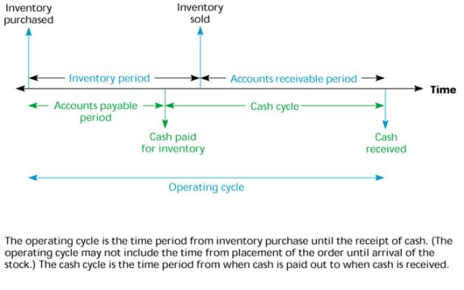

As mentioned earlier in the introduction, the cash conversion cycle is used as a measure in order to gauge profitability. This measure is described by the following equation:

***Cash Conversion Cycle = A/R Period+ Inventory Period – A/P period(3)***

In turn, the components of cash conversion cycle are given below:

***Account Receivable Period = Accounts Receivables/Sales*365 (4)***

***Inventory Period = Inventory/Cost of Goods Sold*365 (5)***

***Account Payable Period= Accounts Payables/Cost of Goods Sold*365 (6)***

Ratios (1) and (2), measure the relative sizes between current assets and current liabilities. Current assets specify assets that can be converted into cash within one year. Current assets include cash and cash equivalents, short-term investments, accounts and notes receivable, other accounts receivable, inventory, prepaid expenses and prepayments, and other current assets. Current liabilities are debts that need to be settled within one year, including short-term borrowings, commercial paper payable, accounts and notes payable, expenses payable, advance receipts, other accounts payable, income tax payable, current portion of long-term liabilities and other current liabilities. Inventory needs to be sold before converting into accounts receivable. Whether inventory is able to be sold cannot be controlled by the company. Prepaid expenses and prepayments (such as prepaid rent or insurance premium) belong to the company’s current assets, but mostly will not be converted into cash in the future; therefore, their ranking of liquidity is relatively low. The quick ratio deducts these items, including inventory, prepaid expenses and prepayments, from the current assets, to obtain quick assets, and then calculate the relative number between quick assets and current liabilities.

The main advantage of the current ratio and quick ratio is that it is easy to calculate, and gives an idea of a company’s operating cycle. However, the current ratio alone may not be sufficient to analyze the liquidity position of the company as it relies on the quantity of current assets instead of quality of the asset. In addition, the major weakness of the quick ratio is that it ignores timing of both cash received and cash paid out. Therefore the traditional liquidity measurements are unable to control for the liquidity that is changing with time. It is difficult to state whether higher values of these two ratios are good or bad. For example, higher current ratios and quick ratios, in general, are considered good. On the contrary, low current and quick ratios seem to be bad. However, such low ratios are probably the result of effective working capital attention (Cagle et al., 2013). Therefore, a ratio is really just one number divided over another number. While these numbers can be very meaningful starting points, further analysis is crucial to determining the true health of a firm. Any of these ratios need to be used in comparison/conjunction with other measures to interpret the short-term solvency/liquidity of the company.

Equations (3) through (6) are described as follows:

The inventory period depicts the average time to convert total inventory into sales. Generally, the shorter the inventory period, the better the company’s liquidity. A buildup of slow-moving inventory due to less sales or obsolete nature of the product would result in a less favorable CCC. On the other hand, the current ratio includes inventory in the calculation, which may lead to overestimation of the liquidity position in many cases. In such companies with an undesirable buildup in inventory; taking inventory under calculation may lead to displaying incorrect liquidity health of the company.

The receivable period measures the approximate amount of time that it takes for a business to receive payments owed. If a company relaxes its credit policies, the current and quick ratio will not reflect the fact that receivables become less liquid. With that said, an undesirable buildup of accounts receivable will be reflected in a less favorable CCC.

The payable period measures the number of days the firm is able to defer payment of its accounts payable without paying interest. The longer the timeframe a company is able to obtain interest-free financing through credit relationships with suppliers, the better the company’s working capital position; resulting in a shorter CCC. However, the traditional measurement of liquidity will have an unfavorable verdict to the company who maintains larger accounts payable balances.

Cash Conversion Cycle (CCC) indicates how fast a company can convert cash on hand into even more cash on hand. The CCC does this by following the cash as it is first converted into inventory and [accounts payable](http://www.investopedia.com/terms/a/accountspayable.asp) (AP), through sales and [accounts receivable](http://www.investopedia.com/terms/a/accountsreceivable.asp) (AR), and then back into cash.

Exhibit 2: Cash Conversion Cycle

Cash

Receivables

Raw materials

Inventory

Finished goods

Inventory

As you can see, a shorter CCC is favorable, and it is entirely possible to have a negative CCC. This would indicate that the company manages its working capital so well that it is, on average, able to purchase raw material inventory, sell inventory, and collect the resulting receivables before the corresponding payable from the inventory purchase becomes due (Cagle et al., 2013).

Example Illustration: BEST BUY VS. RADIOSHACK

Figure 1: The Comparison of Current Ratios between Best Buy and RadioShack

Figure 2: The Comparison of Quick Ratios between Best Buy and RadioShack

Figure 3: The Comparison of CCC between Best Buy and RadioShack

**CONCLUDING COMMENTS**

The data shows that during the period 2004 to 2013, RadioShack’s average current ratio during that time was 2.21, while Best Buy’s was 1.21. RadioShack’s current ratio was higher than that of Best Buy in every year for the entire 10 year span. Similarly, during this period, RadioShack’s quick ratios were higher than that of Best Buy except year 2005. Based on the traditional liquidity measurement, RadioShack’s liquidity is superior to that of Best Buy. However, Best Buy’s average CCC was 13 days, while RadioShack’s was 96 days. A further breakdown of each component of the cash cycle reveals more about each company’s working capital management position:

|  |  |  |  |
| --- | --- | --- | --- |
|  | Avg. Receivable Period | Avg. Inventory Period | Avg. Payable Period |
| Best Buy | 10.33 | 52.46 | 49.73 |
| RadioShack | 15.43 | 119.36 | 49.29 |

Best Buy’s average Account Receivable Period was 5 days shorter than RadioShack, and Best Buy’s inventory period was 67 days shorter. The two companies’ payable period were very similar. The CCC analysis reveals that RadioShack’s “better” liquidity ratios were made up of slower-moving inventories and longer collection time for receivables. This study exposes the weakness of the traditional liquidity measurements and demonstrates the value provided by CCC. The CCC approach allows an investor to gauge the company's overall health and is a useful tool for cross firm comparisons. In conclusion, the research results show that CCC indicators better reflect the company’s actual short-term debt-paying ability and liquidity and is a useful compliment to assessing a company’s liquidity.

**REFERENCES:**

Cagle, Corey S.; Campbell, Sharon N.; Jones, Keith T. (2013) Analyzing liquidity using the cash conversion cycle. Journal of Accountancy, 215(5), 44-48.

Hillier D, Ross S, Westerfield R, Jaffe J and Jordan B (2010), Cash Flows, Ratio Analysis and the W T Grant Company Bankruptcy*, Corporate Finance,* Berkshire: McGraw-Hill.7.

Hsieh,J.P. (2013), Fundamentals of Cororate Finance (Add. 4th Edition), Taipei: Best-wise publishing

Goel, Sandeep. (2013) Working Capital Management Efficiency and Firm Profitability: A Study of Indian Retail Industry. South Asian Journal of **Management**. 20 (3) 104-121.

### John, T.A. (1993), Accounting Measures of Corporate Liquidity, Leverage, and Cost of Financial Distress, Financial Management, 22 (3), 91-100.

### Kim, C.S.,Mauer, D.C., and Sherman, A.E. (1998), The Determinants of Corporate Liquidity: Theory and Evidence, *Journal of Financial and Quantitative Analysis*.33 (3), 335-359

Lazaridis, L.; Tryfonidis, D.(2006), Working Capital Management and Corporate Performance: Evidence from Iranian Companies. Journal of Financial ***Management*** & Analysis. 19 (1,) 26-35.

Muscettola, M. (2014), Cash Conversion Cycle and Firm’s Profitability: An Empirical

Analysis on a Sample of 4,226 Manufacturing SMEs of Italy, *International Journal of Business and Management*; 9(5), 25-35

Richards, V. and Laughlin, E. (1980), A Cash Conversion Cycle Approach to liquidity Analysis, Financial Management, 9(1), 32-38.

Schilling, G. (1996) Working Capital’s Role in Maintaining Corporate Liquidity, *Treasury Management Association*, 16, 4-8.

# **CORPORATE ACTIVISM: MARKETING IMPACT ON TODAY’S SOCIETY**

***Matthew Potts, Siena College***

***Michael Corcoran, Siena College***

***Michael Talarico, Siena College***

***Kenneth Newman, Siena College***

***Dr. Raj Devasagayam, Siena College***

**EXECUTIVE SUMMARY**

*Corporations have a certain level of social responsibility to the public. Our research asked: does corporate activism bear weight on the likelihood of a consumer to buy a specific product? We wanted to know if our surveyees either supported or did not support the campaigns we presented to them. We wanted to aid marketers and corporations as a whole to better identify and satisfy the needs and wants of consumers.*

*We conducted a literature review, which showed us that companies do look to activism in order to discover how this impacts their business. Our literature review showed that businesses are aware of how social media plays in their activism.*

*Our survey was designed to be both simple and repetitive for the purpose of consistency and ease to the surveyee. Once the respondent had agreed to consent, we moved them right into the psychographic portion of our survey. We asked questions about their willingness to change behavior for different people and situations, adjusting to new situations and their understanding of others emotions. We used seven anchors for these questions. We then asked respondents questions about different ad campaigns and how these campaigns affected their buying of a particular brand and its products.*

*Once we got our survey results, we carefully ran our data through OLS simple linear regression in SPSS, and observed eleven out of our forty hypotheses provided a non-significant result. Level of significance is represented by “p” and if the p value is lower than .1, then the results are significant. Although this proves almost half of our hypotheses to be non significant, we have to consider the large number of initial tests and how twenty-nine of our total hypotheses were redeemed significant. This allows us to interpret many relationships between variables and determine which ones to utilize to make meaningful recommendations.*

*We found that our most successful campaign that we conducted was Chick-Fil-A. We found that they gave us the highest R2 out of all of our other data. Our top 3 R2 values were .314, .240, and .218, all of which were taken from Chick-Fil-A. We were astonished by these results, and were pleased that our data results were significant.*

*In the future, we would like to increase our response rate to at least 1,000. We are proud of the work we have done, but gathering a larger sample size would improve the accuracy of our data. We would also be interested in putting another campaign into our survey, particularly one that makes the company look bad, like Chick-Fil-A. We would, of course, have to see if this increases the time it would take to complete the survey. However, it would be worth investigating.*

*Our recommendation would be that corporations should absolutely be involved in some form of corporate activism. Even the negative campaigns get people talking about a particular company. It is up to the management to be able to make sure that the campaigns will be well perceived by a majority of the public in order to help increase brand value, as a significant amount of people tend to have their buying habits affected by campaigns.*

**INTRODUCTION**

In the article: 22 Great Examples of Socially Responsible Businesses, it states that, “Many businesses recognize the importance of being socially and environmentally conscious, and will often advertise charitable initiatives, such as annual fundraisers for a cause, or a volunteer project their staff worked on. But companies that incorporate social responsibility into their business model prove that a dedication to these initiatives goes a long way, both for the cause and their reputation” (Fallon 2015). All Corporations bear a certain level of social responsibility to the public. Our research asked the question: does corporate activism bear any weight on the likelihood of a consumer to buy a specific product?

We also wanted to know whether or not the surveyees supported or did not support the campaigns we presented to them. For this survey we focused on four companies: Coca-Cola and its “Make it Happy” campaign designed to target and stop online bullying. Dawn and its oil spill campaign wherein Dawn would clean the animals with a combination of Dawn soap and oil. Starbucks and its “Race Together” campaign, which aimed to provide a space where race talks could begin. And lastly Chick-Fil-A and its gay marriage campaign that gave coupons to supporters of gay marriage after their CEO was found, “guilty as charged” when asked if he believed in a traditional marriage. The goal of this research was to aid marketers and corporations as a whole to better identify and satisfy the needs and wants of consumers. For this survey we did not focus one industry in particular (i.e. sport marketing, athlete endorsements, streaming entertainment, etc.)

##### **RESEARCH METHOD AND PROCEDURES**

**LITERATURE REVIEW**

We conducted a literature review as part of our preliminary analysis. The literature review showed us that companies do in fact look to activism in order to see how it will have an impact on their sales. Our literature review showed that corporations are aware of the role that social media plays in their activism. Social media makes it easier than ever for word of mouth to spread about a particular campaign.

In the article, “The New Face of Corporate Activism,” Gerald F. Davis and Christopher J. White relate Corporate Activism to the breakthrough of social media. They claim that these new technologies “allow activists to mobilize mass support for social change.” They write that social activists are putting companies in the spotlight towards social change. Davis and White claim that companies are actually being pressured to take on social issues rather than taking them on themselves. It is important to realize this because it shows that more and more corporations are going into an activist role.

In “The limits of corporate do-goodery.” Jason Kirby analyzes both successful and unsuccessful instances of corporate activism. He talks about Starbucks’ failed campaign and then moves on to highlight good examples such as Wal-Mart, Eli Lilly and Cummins (a diesel engine-maker) who fought against laws that discriminated against gay and lesbian individuals.

Kirby ends his discussion by saying that a company’s choice towards activism is to “improve their bottom lines.” Kirby finds that corporate activism is not an ethical responsibility as much as it is to establish a brand-value benefit that comes from “championing” popular causes (Kirby, 2015).

Information that we gathered from the literature review helped us validate our topic. Through this research we were able to see that there is a correlation to consumers and the way a corporation using activism. Corporations know that they can use social media and things to their advantage to push campaigns based around activism. A corporation wants to use activism to their advantage and to have a positive influence on the consumer, this isn’t always the case and it can backfire which transitions can have negative effects on consumers. This type of information was valuable and helped us further design our survey and advance further into our topic.

**RESEARCH DESIGN AND SAMPLING (See Appendix 5 for Full Scale Conceptual Model)**

###### **HYPOTHESES**

###### 

##### **H1 Demographics**

H1a Age has an impact on likelihood to buy.

H1b Ethnicity has an impact on likelihood to buy.

H1c Education has an impact on likelihood to buy.

H1d → the specific year in college you are in has an impact on likelihood to buy.

H1e Martial status has an impact on likelihood to buy.

H1f Gender Identity has an impact on likelihood to buy.

##### **H2 Psychographics**

H2a Having trouble changing behavior to suit people has an impact on campaign support.

H2b Having trouble changing behavior to suit situations has an impact on campaign support.

H2c One’s ease to adjust actions accordingly has an impact on campaign support.

H2d A good intuition when it comes to understanding people’s emotions has an impact on campaign support.

##### **H3 Starbucks**

H3a: Supporting the Starbucks campaign has an impact on likelihood to buy.

H3b: Being a coffee drinker has an impact on likelihood to buy.

H3c: Being a typical consumer of Starbucks products has an impact on likelihood to buy.

H3d: How the Starbucks campaign makes one feel has an impact on likelihood to buy.

##### **H4 Dawn**

H4a: Supporting Dawn’s campaign has an impact on likelihood to buy.

H4b: Being aware of Dawn has an impact on likelihood to buy.

H4c: How Dawn’s campaign makes one feel has an impact on likelihood to buy.

H4d: Being fully aware of which dish soap you use has an impact on likelihood to buy.

##### **H5 Coca Cola**

H5a: Supporting the Coca Cola campaign has an impact on likelihood to buy.

H5b: Being a consumer of Coca Cola products has an impact on likelihood to buy.

H5c: Being a typical consumer of soda has an impact on likelihood to buy.

H5d: How the Coca Cola campaign makes one feel has an impact on likelihood to buy.

##### **H6 Chick-Fil-A**

H6a: Supporting Chick-Fil-A’s campaign has an impact on likelihood to buy.

H6b: Typically consuming Chick-Fil-A has an impact on likelihood to buy.

H6c: Being a consumer of fast food has an impact on likelihood to buy.

H6d: How the Chick-Fil-A campaign makes one feel has an impact on likelihood to buy.

**SCALES AND VALIDATION**

|  |  |  |  |
| --- | --- | --- | --- |
| **Original Scale** | **Our Adaptation** | **Mean** | **Standard Deviation** |
| “Handbook of Marketing Scales: Multi-item measures for marketing and consumer behavior research” | Psychographics: Non-significant | 4.223 | Suit different people: 1.604  Suit different situations: 1.325  Easy to adjust my actions accordingly: 1.425  Good intuition to understand emotions: 1.293 |
| Cronbach Alpha: 0.75 | Starbucks Support and Makes One Feel: .626  Other Starbucks Cronbach Alpha’s were Non-significant. | 3.474 | Support: 4.09  More likely To Buy: 2.65  Less Likely To Buy: 2.90  Typically Consume Coffee: 3.39  Coffee Drinker: 4.74  Makes Me Feel: 3.07 |
|  | Dawn Cronbach Alpha’s are all Non-significant. | 4.876 | Support: 6.33  More likely To Buy: 4.89  Less Likely To Buy: 1.82  Aware of Dish Soap: 6.67  Aware Soap I Use: 5.61  Makes Me Feel: 3.94 |
|  | Coca Cola I am a soda drinker and typically consume Coke: .759 | 3.606 | Support: 5.51  More Likely To Buy: 3.14 Less Likely To Buy: 2.24  Typically Consumer Soda: 3.65  Soda Drinker: 3.59  Makes Me Feel: 3.50 |
|  | Chick-Fil-A Support and Makes One Feel: .615 | 3.183 | Support: 1.969  More likely to go to Chick-Fil-A 1.900  Less likely 1.965  Typically consume Chick-Fil-A 1.688  Fast food consumer: 1.987  Makes me feel: .809 |
|  | Demographics: Non-significant | 1.774 | Age: 1.585  Ethnicity: 1.756  Education completed: 1.266  Year in College: 1.045  Marital Status: .551  Gender Identity: .581 |

**SURVEY DESIGN AND IMPLEMENTATION**

Our survey design was meant to be simple and repetitive in order to make it as fluid as possible. Once the respondent had agreed that they were over the age of 18 we asked them four psychographic questions. We asked questions about their willingness to change behavior for different people and situations, adjusting to new situations and their understanding of others emotions. We used seven anchors for these questions. We then asked respondents questions about different ad campaigns and how these campaigns affected their buying of a particular brand and its products. We asked them about a Starbucks “#RaceTogether” campaign. We asked about a Dawn campaign that involved cleaning animals affected by the Gulf Oil Spill in 2010. We asked about Coca Cola’s #MakeItHappy campaign and a Chick Fil A campaign on the company’s stance on gay marriage. Once we had asked the respondents all the campaign questions we asked them a series of demographic questions. We left the demographic section until the end in case a respondent decided to leave the survey before completing; there was a chance of still getting valuable data about the campaigns. The survey was distributed to mainly members of the Siena College community. This included faculty, students, and alumni. We received approximately 272 responses.

**SAMPLE PROFILE**

###### Sample Profile (n=272)

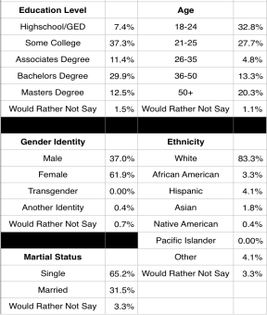

Our sample consisted of 272 participants. Of these participants 37% were male and 61.9% were female, .4% identified as another identity and .7% preferred to not say. At 37.3 % the majority of respondents had completed some level of college. 53.3% had some sort of college degree with most having a bachelors at 29.9%. The vast majority of respondents were Caucasian/white (83.3%), and 60.5% were between the ages of 18-25. This comes as no surprise considering the survey was distributed to mainly college students.

**DATA ANALYSIS AND FINDINGS**

**In descending order based on our R2 value. See Appendix 8 for our entire dataset.

|  |  |
| --- | --- |
| **Hypothesis** | **Result** |
| Supporting Chick-Fil-A’s campaign has an impact on more likely to buy. | **Confirmed**  (p:0.0001; F: 122.851; R2: .314) |
| How the Chick-Fil-A campaign makes one feel has an impact on more likely to buy. | **Confirmed**  (p:0.0001; F: 84.831; R2: .240) |
| Supporting Chick-Fil-A’s campaign has an impact on less likely to buy. | **Confirmed**  (p:0.0001; F: 74.823; R2: .218) |
| Supporting the Starbucks campaign has an impact on less likely to buy. | **Confirmed**  (p:0.0001; F: 69.959;R2: .206) |
| Supporting the Starbucks campaign has an impact on more likely to buy. | **Confirmed** (p:0.0001; F: 68.924; R2: .203) |
| How the Starbucks campaign makes one feel has an impact on more likely to buy. | **Confirmed**  (p:0.0001; F: 60.326; R2: .183) |
| How Dawn’s campaign makes one feel has an impact on more likely to buy. | **Confirmed**  (p:0.0001; F: 58.221; R2: .177) |

As a group, we underestimated the amount of alternate hypotheses we would need to test until we completed our conceptual model (Appendix 5). This diagram put into perspective what we should be testing to provide us with meaningful results. We had a total of four different campaigns we were researching and within each, we were asking an average of seven questions. We realized a customer’s likelihood to buy was the dependent variable and how participants responded to each question would accurately represent this relationship. The first category of questions we tested was psychographics and we hypothesized that they did have an influence on an individual’s support for every campaign. Along with each campaign, we believed the responses to our specific demographic questions would have an impact on likelihood to buy a related product. We prepared precisely forty hypotheses and conducted a level of significance test for all the independent variables.

After we carefully ran our data through OLS simple linear regression in SPSS, we observed eleven out of our forty hypotheses provided a non-significant result (less than .1). Although this proves almost half of our hypotheses to be incorrect, we have to consider the large number of initial tests and how twenty-five of our total hypotheses were redeemed true. This allows us to interpret many relationships between variables and determine which ones to utilize to make meaningful recommendations. In order to suggest ideas or changes, how to interpret the data must be understood. There are three letters that represent the impact from one variable to another. As previously mentioned, level of significance is represented by the p value and if it is lower than .1, then the results are significant. Most of our data displayed values so low, they were not visible in our chart. This consistency is extremely important because it represents the quality of our survey results.

The level of impact was also measured by the “R2”. As shown above, our first 7 R2 values ranged from 17.7% to 31.4%. We were extremely proud of these results, as producing a percentage this high proves strong reliability of our data. We achieved great success in our survey, and these numbers support that conclusion. We also noticed that how a campaign makes one feel and supporting the campaign are the 2 independent variables that drive the dependent variable for all 7 of these R2 values. Clearly, these were proven to be our most reliable independent variables in our data.

We had one primary independent variable that demonstrated greater significance than others based on the corresponding values. The independent variable support of Chick-Fil-A’s campaign does drive our dependent variable at a significant level. The amount of impact is displayed through the highest R-square value in our data of 31.4%. Also, the p value is much less than .1 and our calculated mean values are higher than 4.3, which is shockingly similar for male and female. This data is interesting because the company’s reasoning behind the campaign was to cover their mistakes. The results indicated that supporting Chick-Fil-A’s campaign statistically significantly drives the respondents likelihood to buy.

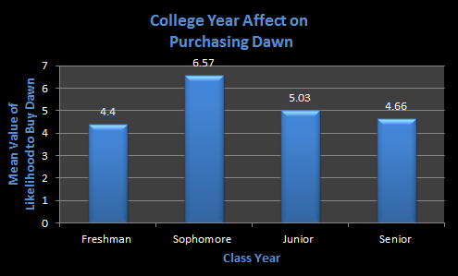

This graph represents the impact of class year on each respondent’s likelihood to buy Dawn products. We predicted the senior class to have the highest mean because we figured they are older, living in townhouses and more likely to actually use the product. To our surprise, sophomore year students responded with the highest mean value, which indicates they felt the strongest about the campaign.

**CONCLUSIONS AND RECCOMENDATIONS**

Our theory was that every independent variable would have an impact on respondents’ likelihood to buy. We had some fail, but they were still reliable in terms of proving our final decisions. We found that our data was very conclusive, and we are proud of our results. We planned on Starbucks giving us the best results considering it was our most recognizable brand. However, it was Chick-Fil-A that people felt most strongly about. Upon analyzation, we found that Chick-Fil-A’s campaign made people feel strongly due to the fact that, while their gay rights campaign was for a good cause, the reasons behind it was to cover up their CEO’s mistake. We analyzed that people felt that they were either in support of Chick-Fil-A’s campaign, or were strongly disliked it because of their faulty actions of covering up their campaign.

**Latent Driver Analysis**

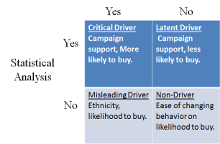

**COMMON PERCEPTION**

We found that a Critical Driver for our project was Campaign support, and its impact on more likely to buy. Considering it makes logical sense that supporting a campaign would influence more likely to buy, this is a critical driver because our statistical analysis proved this as well. In the case of Chick-Fil-A, supporting Chick-Fil-A’s campaign has an impact on *more* likely to buy gave us a p value of 0.0001 and an r squared value of .314.

We found the Latent driver to be that campaign support has an impact on less likely to buy. While most wouldn’t think this to be the case, “Supporting Chick-Fil-A’s campaign has an impact on less likely to buy” had a p value of 0.0001 and an r squared value of .218, proving it significant.

Our Misleading Driver was ethnicity. We suspected that ethnicity would have an impact on buying behavior, however this was not the case.

Our Non-Driver was ease of changing behavior based on likelihood to buy. We expected

that this would not have a significant statistical impact based on likelihood to buy, and we were correct in this assumption.

The regression results show us that campaigns do have an effect on a consumer’s willingness to buy or not buy a product of a certain company. If a campaign has a positive impact or influence on a person they may have a tendency to think of that company when shopping and may directly or indirectly support them more. In addition, the campaigns that have a negative influence on people may steer people away from that particular company’s products.

Our recommendation would be that corporations need to be involved in corporate activism. However, companies need to make sure that the campaigns they run think about people on all ends of the spectrum. Obviously you cannot make everyone happy, but these campaigns should be well thought out. Take for instance the Starbucks #RaceTogether campaign. This campaign was more of a reaction to current events. The company did not take into serious consideration how it could be perceived negatively from the public and ultimately it was a failure. Similarly, the Coca Cola campaign was also a failure. However, this was an ad campaign that had been planned months in advance as it was launched during the Super Bowl. This goes to show that even the well thought out campaigns can fall short of expectations. One thing that all these campaigns do well is get people talking about a particular company, they get you noticed. It is up to the company’s management to ensure that they are talked about for the right reasons as they can have a significant impact on a consumer’s buying habits.

##### **MANAGERIAL IMPLICATIONS**

After studying the impact that social activism has on society, we wanted to take it a step further and analyze this from a corporate marketing perspective. We wanted to see how corporate activism impacts consumer and buying habits. After Dr. Raj brought the Starbucks “Race Together” campaign to our attention, we were amazed at how consumers were on 2 ends of the spectrum. Some loved the idea of baristas discussing racial issues with consumers while others felt they were out of place. We realized that these different responses would make for an incredible project. We can take this project into so many different directions by analyzing which campaigns spark consumers to buy, not to buy, and which campaigns lead consumers to indifference.

**LIMITATIONS**

We received a few limitations throughout our research, however these limitations did not cause us to have incomplete or faulty data, they were simply minor setbacks. Let us also make clear that these limitations were uncontrollable, and our team pulled through given the circumstances.

→ Limitation 1. Project Completion Time.

This was our team’s biggest limitation by far. Given more time, our team would have been able to work at a more comfortable pace. We felt rushed to get the project done on time, and this caused us to make minor mistakes that would not have happened otherwise. Also, if given the time, we would have been able to meet more frequently and fully gather our thoughts and ideas along every step of the way.

**→** Limitation 2. Survey Time Limitation.

Corporate activism is a broad topic, there were so many different ways we could have taken it. We found at least thirty campaign instances in which corporations were initializing campaigns and consumers responded to them. However, given the fact that we wanted our survey to take five minutes or less, we were forced to limit the amount of campaigns to 4.

→ Limitation 3. Survey Response Number.

Our team was looking to get a response number of at least 800. While this number seems unrealistic given the week we had the survey up and running, our expectations were high. While we are proud of our response rate of 272, which is much higher than the minimum of 217, we find this number to be a limitation.

##### **FUTURE RESEARCH**

In the future, we would like to increase our response rate to at least 1,000. We are proud of the work we have done, but gathering a larger sample size would improve the accuracy of our data. We would also be interested in putting another campaign into our survey, particularly one that makes the company look bad, like Chick-Fil-A. We would, of course, have to see if this makes the survey take too long. However, it would be worth investigating.

##### **\**

##### **REFERENCES:**

Bearden, W., & Netemeyer, R. (1999). Handbook of marketing scales: Multi-item measures for marketing and consumer behavior research (2nd ed.). Thousand Oaks, Calif.: Sage Publications. Coyhen, B. (2015, April 30). Dawn Dishwashing Used to Clean Animals. Retrieved from: <http://www.mnn.com/earth-matters/wilderness-resources/stories/dawn-dishwashing-liquid-being-used-to-clean-animals>

Fallon Taylor, Nicole. (2015, July 21). 22 Great Examples of Socially Responsible Businesses. Retrieved from: <http://www.businessnewsdaily.com/5499-examples-socially-responsible-businesses.html#sthash.RqYXUWgy.dpuf>

O’Reilly, L. (2015, February 5). Coca Cola Suspends “Make it Happy”. Retrieved from: <http://news.nationalpost.com/news/coca-cola-suspends-makeithappy-twitter-campaign-after-gawker-tricked-it-into-quoting-parts-of-mein-kampf>

Sciullo, M. (2015, March 19). StarBucks “Race Together”. Retrieved from: <http://www.post-gazette.com/business/pittsburgh-company-news/2015/03/19/Starbucks-Race-Together-campaign-causing-a-stir/stories/201503190057>

<http://nteb.mudflowermedia.netdna-cdn.com/wp-content/uploads/chick-fil-a-says-no-to-gay-marriage.jpg>

##### **APPENDIX 1: SURVEY WITH CITATION**

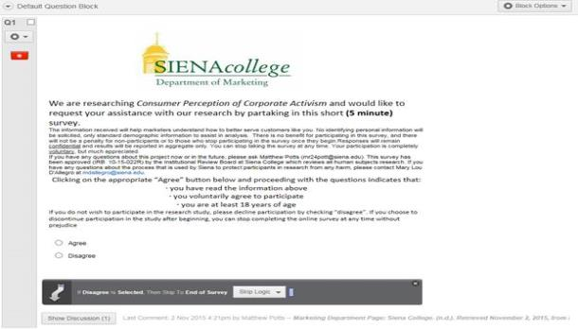

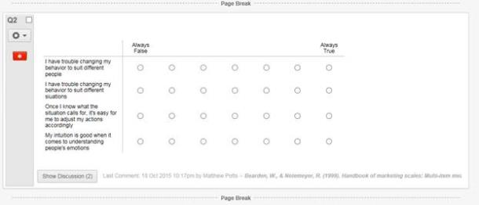

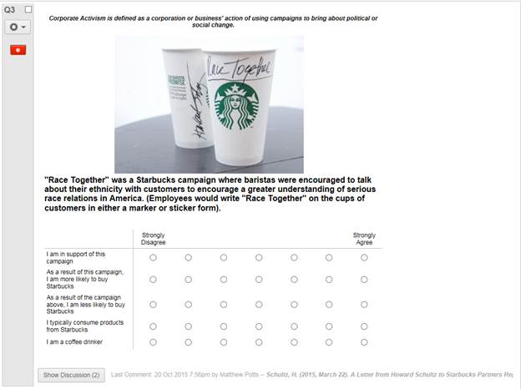

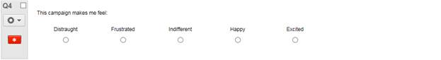

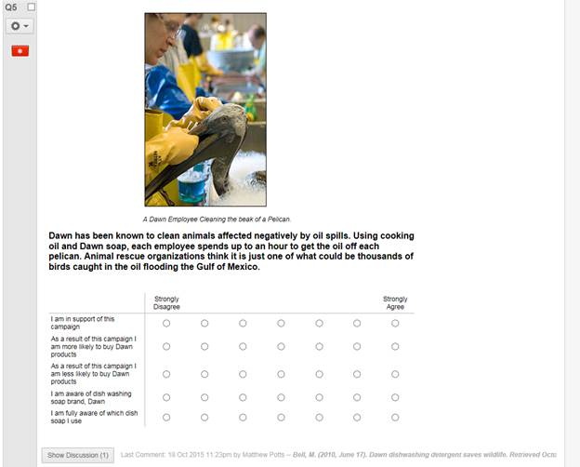

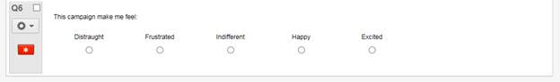

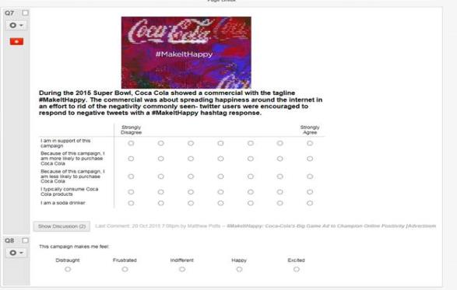

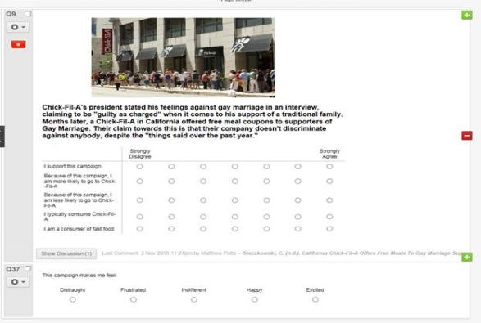

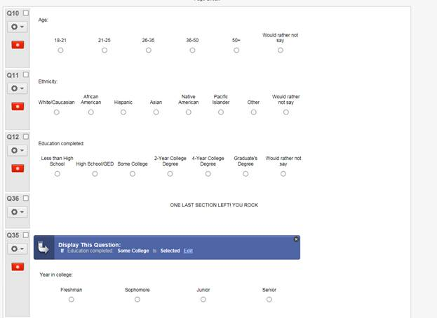

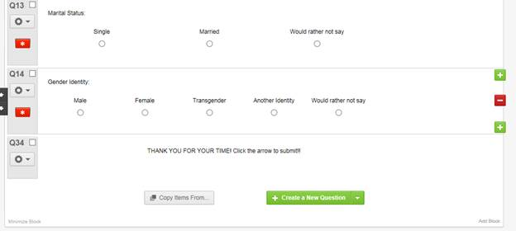

##### **APPENDIX 2: RB APPROVAL LETTER**



**APPENDIX 3: PERMISSION TO LAUNCH**

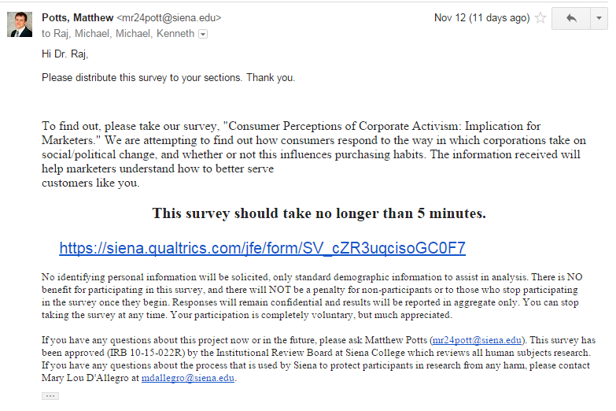



###### **APPENDIX 4: POWERPOINT**

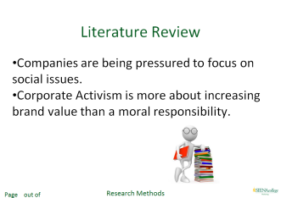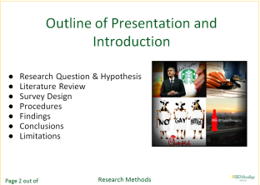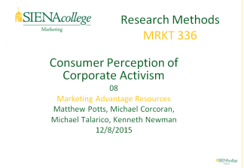

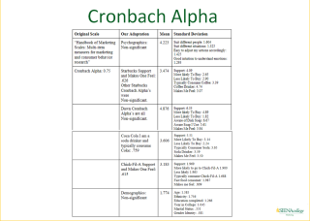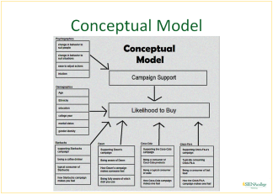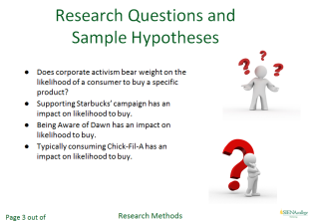

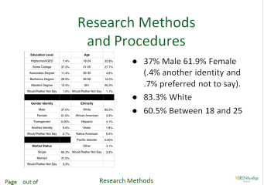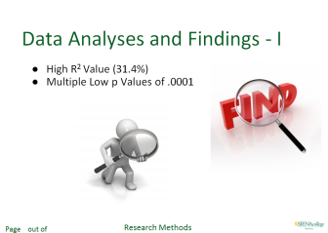

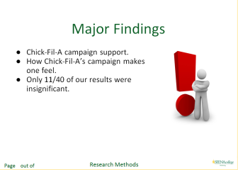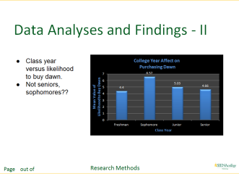

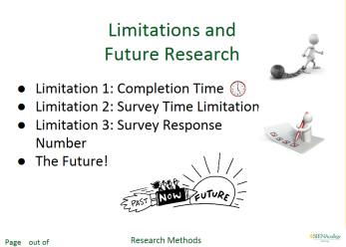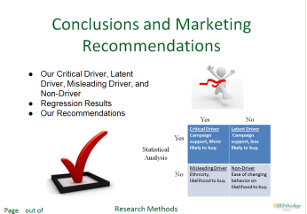

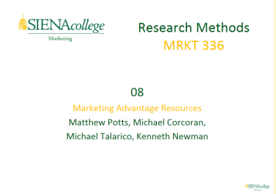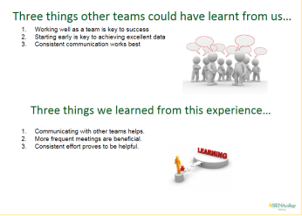

**APPENDIX 5: CONCEPTUAL MODEL**

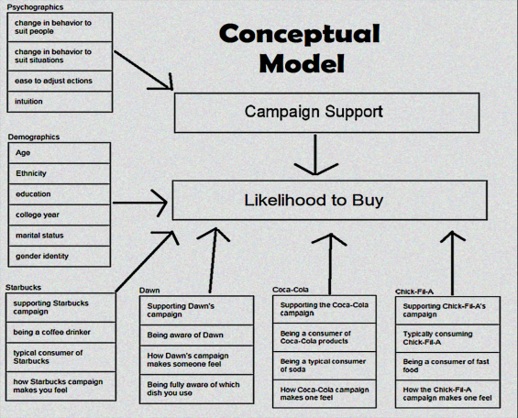

##### **APPENDIX 6: DATA ANALYSIS**

|  |  |
| --- | --- |
| **Hypothesis** | **Result** |
| Supporting Chick-Fil-A’s campaign has an impact on more likely to buy. | **Confirmed**  (p:0.0001; F: 122.851; R2: .314) |
| How the Chick-Fil-A campaign makes one feel has an impact on more likely to buy. | **Confirmed**  (p:0.0001; F: 84.831; R2: .240) |
| Supporting Chick-Fil-A’s campaign has an impact on less likely to buy. | **Confirmed**  (p:0.0001; F: 74.823; R2: .218) |
| Supporting the Starbucks campaign has an impact on less likely to buy. | **Confirmed**  (p:0.0001; F: 69.959;R2: .206) |
| Supporting the Starbucks campaign has an impact on more likely to buy. | **Confirmed** (p:0.0001; F: 68.924; R2: .203) |
| How the Starbucks campaign makes one feel has an impact on more likely to buy. | **Confirmed**  (p:0.0001; F: 60.326; R2: .183) |
| How Dawn’s campaign makes one feel has an impact on more likely to buy. | **Confirmed**  (p:0.0001; F: 58.221; R2: .177) |
| Being a consumer of Coca Cola products has an impact on more likely to buy. | **Confirmed**  (p:0.0001; F: 51.878; R2: .161) |
| How the Chick-Fil-A campaign makes one feel has an impact on less likely to buy. | **Confirmed**  (p:0.0001; F: 49.175; R2: .155) |
| How the Starbucks campaign makes one feel has an impact on less likely to buy. | **Confirmed**  (p:0.0001; F: 44.082; R2: .140) |
| Supporting Dawn’s campaign has an impact on more likely to buy. | **Confirmed**  (p:0.0001; F: 38.920; R2: .126) |
| Being a typical consumer of Starbucks products has an impact on more likely to buy. | **Confirmed**  (p: 0.0001; F: 32.710;R2: .108) |
| Supporting Coca Cola’s campaign has an impact on more likely to buy. | **Confirmed**  (p:0.0001; F: 29.028; R2: .097) |
| Typically consuming Chick-Fil-A has an impact on more likely to buy. | **Confirmed**  (p:0.0001; F: 28.713; R2: .096) |
| Being fully aware of which dish soap one uses has an impact on more likely to buy. | **Confirmed**  (p:0.0001; F: 28.331; R2: .095) |
| Being aware of Dawn has an impact on less likely to buy. | **Confirmed**  (p:0.0001; F: 27.288; R2: .092) |
| How the Coca Cola campaign makes one feel has an impact on more likely to buy. | **Confirmed**  (p:0.0001; F: 22.950; R2: .078) |
| Supporting Dawn’s campaign has an impact on less likely to buy. | **Confirmed**  (p:0.0001; F: 21.020; R2: .072) |
| Being a typical consumer of soda has an impact on more likely to buy. | **Confirmed**  (p:0.0001; F: 16.032; R2: .056) |
| Education has an impact on less likely to purchase Coca | **Confirmed** (p:0.002; F: 9.372; R2: .034) |
| Age has an impact on more likely to buy Coca Cola. | **Confirmed** (p:0.004; F: 8.481; R2: .031) |
| Gender Identity has an impact on the likelihood to buy Starbucks. | **Confirmed** (p:0.004; F: 8.598; R2: .031) |
| Being aware of Dawn has an impact on more likely to buy. | **Confirmed**  (p:0.005; F: 7.989; R2: .029) |
| Being a typical consumer of Starbucks products has an impact on less likely to buy. | **Confirmed**  (p:0.005; F: 8.125; R2: .029) |
| Supporting Coca Cola’s campaign has an impact on less likely to buy. | **Confirmed**  (p:0.006; F: 7.643; R2: .028) |
| How the Coca Cola campaign makes one feel has an impact on less likely to buy. | **Confirmed**  (p:0.033; F: 4.603; R2: .017) |
| Being fully aware of which dish soap one uses has an impact on less likely to buy. | **Confirmed**  (p:0.063; F: 3.476; R2: .013) |
| How Dawn’s campaign makes one feel has an impact on less likely to buy. | **Confirmed**  (p:0.074; F: 3.221; R2: .012) |
| Having trouble changing behavior to suit situations has an impact on campaign support. | **Results not significant** |
| Being a consumer of Coca Cola products has an impact on less likely to buy. | **Results not significant** |
| Marital Status has an impact on likelihood to buy for all campaigns. | **Results not significant** |
| Being a typical consumer of soda has an impact on less likely to buy. | **Results not significant** |
| A good intuition when it comes to understanding people’s emotions has an impact on campaign support. | **Results not significant** |
| Having trouble changing behavior to suit people has an impact on campaign support. | **Results not significant** |
| Being a coffee drinker has an impact on more *OR* less likely to buy. | **Results not significant** |
| Typically consuming Chick-Fil-A has an impact on less likely to buy. | **Results not significant** |
| Being a consumer of fast food has an impact on likelihood to buy. | **Results not significant** |
| Ethnicity has an impact on likelihood to buy for all campaigns. | **Results not significant** |
| One’s ease to adjust actions accordingly has an impact on campaign support. | **Results not significant** |

**APPENDIX 7: LETTER OF INTENT TO WORK ON PROJECT FOR CONFERENCE**

Dr. Raj,

We enjoyed the process of creating our research project and doing the data analysis. All four of us are interested in working with you on getting our project to the next point to where it can be featured at a conference and published.

Michael Talarico

Michael Corcoran

Matthew Potts

Kenneth Newman

**EMOTIONAL BRANDING AND SOCIAL MEDIA USAGE: TOWARDS AND UNDERSTANDING OF THE “*SCHOOL OF BUSINESS”* BRAND**

***Heather Leo, Siena College***

***Dr. Cheryl Buff, Siena College***

***ABSTRACT***

*Brands are all around us, from the products we use to the services we consume. Thus, what constitutes a brand? A brand is a “name, term, sign, symbol, or design, or a combination of them, intended to identify the goods and services of one seller or group of sellers and to differentiate them from those of competition.” [26]Many managers view the term more broadly, suggesting that a brand is something that creates a certain amount of awareness, reputation, and prominence; in fact, brands have value, convey meaning, cause emotional responses and reactions, and they must be effectively managed to help an organization reach its overarching goals. [27] There are a number of branding strategies including conventional, viral, cultural, and emotional branding.[28] Higher education institutions, such as Siena College, are brands that are comprised of multiple facets. These include, the School of Business, the School of Liberal Arts, the School of Science, Community Living, dining services, and student organizations. The School of Business not only contributes to the Siena College brand but is a brand within itself. Over the past year, the School of Business has undertaken a number of initiatives to build awareness of the School of Business brand. This includes communication initiatives serving as a link between students and the School of Business. The current research will study current attitudes and perceptions of the Siena College School of Business brand. Specifically, we seek to assess the current attitudes and perceptions of the brand, emotional connection and loyalty to the brand, as well as communications platforms usage and engagement. A focus will be on students’ consumption of social media platforms such as Facebook, Twitter, Instagram, and LinkedIn. It is important to note that the adoption rate for social media for those with a college degree is 76% of which 90% of young adults today from the ages 18-29 engaged with social media.[29] Data will be collected using an electronic survey sent from the Dean of the School of Business to the School of Business student email list, as well as through the Student Digest. Prior to this, a pretest of the survey in paper and pencil format will be conducted. Results will be analyzed utilizing SPSS.*

*From our findings, it is our intent to fully assess the School of Business brand. To this end, there will be an assessment of current brand awareness, brand attachment, and* *communications initiatives. We plan to evaluate the effectiveness of current branding initiatives and to make strategic recommendations about possible new branding and communications initiatives for Siena College’s School of Business.*

*_____________________________________________________________________________________________*

**REFERENCES:**

Keller, K.L. (2013). *Strategic Brand Management:* *Building, Measuring, and Managing Brand Equity*, 4e. (Upper Saddle River, NJ: Pearson).

Diana Plantic Tadic and Sandra Suca (2015). Comparative Analysis of the Emotional and Cultural Branding Modelsi (Zagreb, Croatia: International Proceedings of Social and Behavioral Sciences)

PewResearch Center, Social Media Usage: 2005- 2015, http://www.pewinternet.org/2015/10/08/social-networking-usage-2005-2015/, (2015)

**THE LINK: PARENT COMPANIES AND THEIR PRODUCT LINES**

***Heather Leo, Siena College***

***Chandler Gibbons , Siena College***

***Neill Dickenson, Siena College***

***Julia Jobin, Siena College***

***Dr. Raj Devasagayam, Siena College***

**_____________________________________________________________________________________________**

**EXECUTIVE SUMMARY**

*Our research objective was to investigate if a consumer's view on a parent company had an impact on the view of their product lines. As a team we chose three parent companies and six product lines to evaluate. Our main focus was first determining if such a connection existed between the parent company and their product lines. Then with this information we sought to determine if a consumer would favor a product line more or less once the consumer became aware that one parent company owns multiple product lines.*

*Prior to conducting our research we examined secondary scholarly articles that focused on our research topic. We then began to design our research questions and utilized the Handbook of Marketing Scales as a reference for our survey design. In creating our survey we selected a descriptive research design with a 7-point Likert Scale that had anchors ranging from “Strongly Agree” to “Strongly Disagree”. Before launching our survey we asked four subjects to pretest our survey and provide feedback regarding clarity and any issues that may impede their ability to understand the question. Once the survey was refined, we sought approval to launch from our professor, Dr. Raj. Our team launched the survey using various social media platforms such as Facebook, LinkedIn, and Reddit. Additionally, we emailed friends, family, colleagues, and fellow peers needing at least 217 respondents to satisfy our population of about 3,000 students here at Siena. After closing the survey, we had a total of 332 completed responses. To analyze all of the collected data our team used SPSS to run simple linear regressions with individual attributes, regressions with composites, and Cronbach’s Alpha.**After running our Cronbach’s Alpha, we discovered that our psychographics was rather low at .460. But, the section regarding brand perception attributes was rather high at 0.911 resulting in reliable data.*

*In regards to our regression analyses, the results from running the composites of the parent companies against the composites of the product lines and running the composites of the parent companies against our factoring questions; all resulted in having an influence on each product line. Specifically for one of our parent companies, Johnson & Johnson, we discovered that the perception of Johnson & Johnson has a 16.70% impact on Clean & Clear and a 21.20% impact on Neutrogena. Afterwards we examined if providing the respondent with the knowledge of the parent company’s ownership of particular product lines had an impact on whether the consumer favors the product line. In the case of Johnson & Johnson, the acknowledgement of the parent company’s ownership had 19.30% influence on Clean & Clear and a 20.80% influence on Neutrogena. In running simple linear regressions for each individual attribute of the parent companies and product lines there were driving attributes that stood out. First and foremost, it is important to notice that based on the percentages we received attributes either had a really strong or really weak influence on the product lines with very little in between. Secondly, it was very surprising to see that how “cool” the product lines were perceived to be had the largest influence when examining skin care brands. It was also very intriguing that across the board for almost all parent companies and their product lines “outdated” was the least influential factor.*

*Overall we confirmed all of our hypotheses, which were 1) the perception of the parent company has an influence on the perception of the product lines. 2) the perception of the parent company has an influence on consumers favoring the product line. From our findings we formulated recommendations for the parent companies, PepsiCo, Johnson & Johnson, and KraftHeinz. There is room for further investigation into our research topic, which will guide marketing managers to take the appropriate actions when building brands and brand awareness.*

*_____________________________________________________________________________________________*

**INTRODUCTION**

We conducted research to test brand awareness among consumers to examine if the perceptions of a parent company had any impact on a consumer’s view of their product lines. We have developed research questions to provide a framework for our project:

1. What is the link between parent companies and how consumers view their product lines?
2. If consumers are unaware that a parent company owns particular product lines, does knowing this information cause the consumer to favor the product line more or less?
3. How do consumers perceive individual product lines and parent companies?

As a team in researching products, we discovered that many product lines are owned by a few big parent companies. This discovery sparked the question, do consumers know that some of their favorite products are actually owned by one major company. Beyond this realization, consumers tend to have favorite brands or products that they prefer over others. Meanwhile many brands actually do share the same parent company. Understanding that consumers may not know this link, as researchers we wanted to determine if a consumer became aware of parent companies would this knowledge influence their attitude or view towards a product line.

Our research findings would enable marketing decision makers to use this knowledge to not only understand the extent of a consumer’s brand awareness but also have insights into a consumer’s thought process when selecting a product. This research will allow marketing decision makers to see if the reputation of the corporate or “parent” brand will affect their many product lines. If this is true, decision makers can take precaution to ensure that the parent company remains in good standing with the consumers. Therefore in the future, should a problem arise decision makers can understand the magnitude that the situation can reach. This understanding will help them see how it will affect their product lines, allowing decision makers to work towards protecting their brands.  Also, if consumers view the product lines as its own entity then decision makers can alter their marketing mix to ensure that consumers continue to view them separately. This will allow for brands to remain unscathed should a situation arise within the parent company.

**RESEARCH METHODS AND PROCEDURES**

**Literature Review**

Brand recognition and association psychologically play a big role in what we as a research firm are trying to explain. Keller’s seminal paper conceptualizes the connection between brand association and recognition. On Page 9 of Keller’s Customer-Based Brand Equity paper, he writes about choosing brand identities and how it can affect brand equity. He also speaks about Alba and Hutchinson who spark a discussion of psychological principles. One of which is understanding how a name choice affects the recognition process. He also discusses how simple, familiar and distinctive a brand name should be (Keller 1993). This goes along with our companies’ names, similar to how Pepsi-Cola went to PepsiCo once merging with Frito-Lay, which was once just the Frito Company and Lay Company.

Brand recognition also plays a role in how companies sell their product and its success. For example, when selling a product a company may put its parent company logo on the package to make it more identifiable for consumers. Berens goes into more detail on how this occurs. His studies have shown that associations with a company’s corporate ability and corporate social responsibility play a huge role in product evaluations. On page 44 of his “Corporate Associations and Consumer Product Responses” study, he goes into the depth of his study how the two variables in different levels can influence consumer opinions (Berens, 2005). This has a significant role into the opinions of customers and their opinions on products and what emotions they associate with each company.

When it comes to branding, most researchers focus on a consumer’s associations and believed attributes of a brand. But, researcher L.L. Berry examined branding in regards to customer service and determined that a brand’s “meaning” is determined by their experience (Berry, 2000). Thus, in this case our parent companies can have a great influence on a consumer’s experience and view of the product. Berry continues to suggest that a parent company is actually the primary brand and not just a product. Ergo, a company’s reputation has an especially acute effect on the consumer buying process, but a slightly different influence on each individual brand image (Berry, 2000).

**RESEARCH DESIGN AND SAMPLING**

Our study was created to reflect a quantitative, descriptive research design. This design allowed us to collect data on the independent variables of respondents’ awareness/ perceptions, demographics, and psychographics. Our study was conducted through an online questionnaire utilized nonprobability sampling. Due to a low Cronbach’s Alpha value for psychographics our team elected to focus the majority of our analysis on respondent awareness and perceptions. Ergo, our independent variables were our parent companies PepsiCo, Johnson & Johnson, and KraftHeinz. Our dependent variables included: Doritos, Lay’s, Clean & Clear, Neutrogena, CapriSun, and Kool-Aid.

**Conceptual Model: *\**** *For larger image please see Appendix A.*

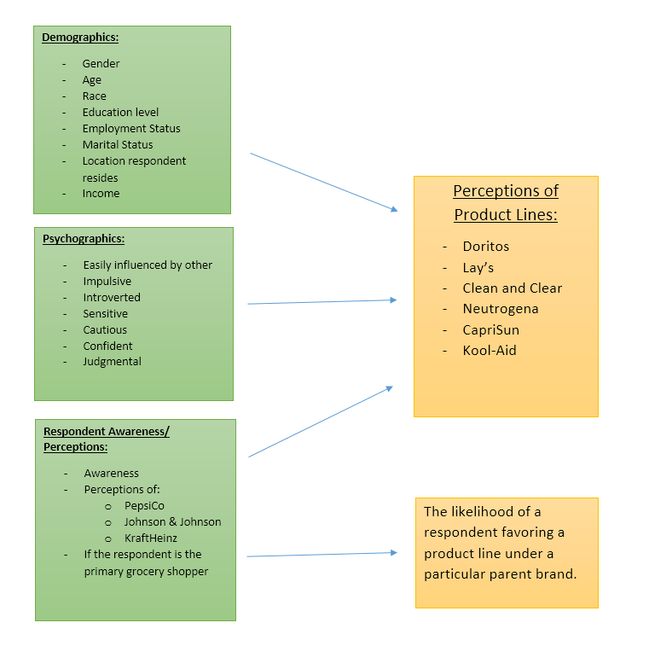

**HYPOTHESES**

H1: Perception of the parent company influences the perception of product line for the following:

1. Doritos
2. Lay’s
3. Clean and Clear
4. Neutrogena
5. CapriSun
6. Kool-Aid

H2: Perception of the parent company influences consumers favoring the product line for the following:

1. Doritos
2. Lay’s
3. Clean and Clear
4. Neutrogena
5. CapriSun
6. Kool-Aid

**SCALES AND VALIDATION**

Our survey asked how a consumer feels about each parent company and product line using select attributes on a Likert scale that we pulled from the *Handbook of Marketing Scales: Multi-item Measures for Marketing and Consumer Behavior Research*. For example, "Please indicate how you feel about Johnson and Johnson?" with the feeling attributes being “Honest, Cool, Reliable, Out-dated and Successful”. On a scale of 1 to 7, we had each participant rate their feelings about the product with 1 being rated “Strongly Disagree” and 7 being “Strongly agree”. We used this scale for all three parent companies and then for all six product lines.

|  |  |  |
| --- | --- | --- |
| **Original Scale** | **Cronbach’s Alpha** | **Our Adaptation to the Scale Cronbach’s Alpha** |
| **Psychographics** | .60-.84 | .460 |
| **Feel Section: (the only feelings that the scale provided a Cronbach’s Alpha for are the examples below)** |  | .911 |
| Sincerity | 2.72 (.99) | --- |
| Excitement | 2.79 (1.05) | --- |
| Competence | 3.17 (1.02) | --- |
| Sophistication | 2.66 (1.02) | --- |
| Ruggedness | 2.49 (1.08) | --- |
| Awareness | --- | .909 |
| Owned | --- | .846 |
| Demographics | --- | --- |

**SURVEY DESIGN AND IMPLEMENTATION**

For our study, our team chose to implement an online survey. An online survey design was selected for several reasons. First, using the software Qualtrics through Siena allowed us to conduct our survey without any costs. Also, in application online surveys are far less expensive compared to other survey methods. Secondly, the use of an online survey allows for all respondents to remain anonymous. Additionally, Qualtrics allows for researchers to force each question. By having the software force each question, there is a reduction in error and ensures completed surveys have all the information needed for analysis. Lastly, an online survey method allows for easy distribution. This will be discussed more in detail later.

When designing the survey our team was strategic in creating questions that would provide insights to our hypothesis. Our survey began with one screening question asking the respondent if they were 18 years of age or older. Once confirmed, the survey opened with a series of simple psychographic questions regarding personality traits and habits. This section was concluded by asking respondents if they were the primary grocery shopper for themselves. The question of if the respondent is the primary grocery shopper assisted in developing a deeper understanding of the level of exposure a respondent may or may not have to some of the parent companies and their product lines.

Following the brief psychographic section, respondents were asked about their awareness of each parent company and their product lines. To measure this response we selected matrix type questions incorporating a 7-point Likert scale. On the scale were two anchors with “1” all the way on the left representing “Not Aware” and “7” on the far right representing “Very Aware”. The following section asked respondents their feelings toward each parent company and product line on a 7-point Likert scale with five attributes. These attributes included: “honest”, “cool”, “reliable”, “outdated”, and “successful”. The attributes allowed us to gather the opinions of each parent company and product lines to gain insights into the perceptions respondents hold.

The next section revealed to respondents that the parent companies own particular product lines. We utilized another 7-point Likert scale with “1” on the far left representing “I Favor This Product More” and “7” on the far right representing “I Favor This Product Less”. This question was to test if the respondent’s perceptions of each product line had changed now that they became aware of the link between the parent companies and their product lines. With this question, we were able to see the influence the parent companies have on their product lines. The survey concluded with a few demographic questions.

In order to implement this survey, our team went through a series of steps. We came up with a research topic and then possible hypotheses. Once Dr. Raj approved our topic, we focused our energy on gathering secondary data to review previous research in this area. In the midst of collecting this information all team members became NIH certified. Our team then developed a series of questions for our survey and filled out an application for the Institutional Review Board (IRB). Once our study was approved, our team condensed the survey and pretested it to

ensure that it would not surpass 5 minutes. Upon completing this step we sought Dr. Raj’s approval and launched the survey.

The use of an online survey allowed for easy distribution to our target population of 18 years or older. Team members sent emails to friends, family, colleagues, and professors on Siena College’s campus containing the survey and asked them to forward it to others. Ergo, utilizing the non probability sampling technique of “snowballing” (Devasagayam, 139). As a team, we relied on this non probability technique of asking respondents to pass along our survey otherwise known as “referral sampling” (Devasagayam, 137). We also posted the survey to many social media platforms (i.e.: Twitter, Facebook, Reddit. LinkedIn, etc.) to help us get a broader response from many respondents in our target population.

**SAMPLE PROFILE**

Overall, our sample consisted of 332 participants, of which 38.9% were men and 60.5% were women. Additionally, our 67.5% of our sample were respondents between the ages of 18-25 years old. 69.3% of our sample had some form of employment either part time or full time employment. Lastly, 87.0% of our sample had some form of higher education.

\**For larger image see Appendix B.*

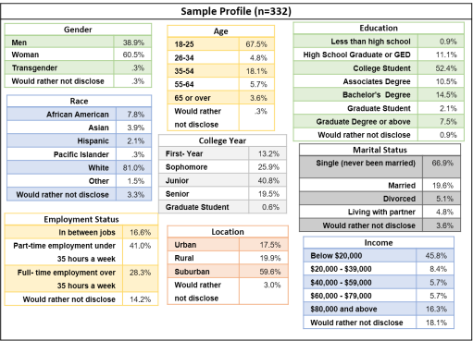

**DATA ANALYSIS AND FINDINGS**

|  |  |  |  |  |
| --- | --- | --- | --- | --- |
| **Hypothesis:** | **Results:** | | | |
| **H1: Perception of the parent company influences the perception of product line for the following: (composite parent companies)** | R2 | F | p | Conclusion |
| **1.** **Doritos** | 21.60% | 90.784 | 0.0001 | Confirmed |
| **2.** **Lays** | 19.20% | 78.248 | 0.0001 | Confirmed |
| **3.** **Clean and Clear** | 16.70% | 66.183 | 0.0001 | Confirmed |
| **4.** **Neutrogena** | 21.20% | 88.775 | 0.0001 | Confirmed |
| **5.** **CapriSun** | 20.40% | 84.686 | 0.0001 | Confirmed |
| **6.** **Kool- Aid** | 22.30% | 94.468 | 0.0001 | Confirmed |
| **H2: Perception of the parent company influences consumers favoring the product line for the following:** |  |  |  |  |
| **1.** **Doritos** | 7.40% | 26.2034 | 0.0001 | Confirmed |
| **2.** **Lays** | 7.70% | 27.406 | 0.0001 | Confirmed |
| **3.** **Clean and Clear** | 19.30% | 78.914 | 0.0001 | Confirmed |
| **4.** **Neutrogena** | 20.80% | 78.914 | 0.0001 | Confirmed |
| **5.** **CapriSun** | 4.70% | 16.272 | 0.003 | Confirmed |
| **6.** **Kool- Aid** | 4.40% | 15.153 | 0.003 | Confirmed |

After collecting all of our data we utilized our results from Qualtrics and downloaded the output to SPSS. We analyzed our data using a significance level of p ≤ 0.10 and R2 range of +1.00 and -1.00, which determines the influence our independent variable has on our dependent variable. Above is a summary of all of our results for reference. To analyze our data we ran simple linear regressions to test our hypotheses. In our survey, we asked each respondent to evaluate five attributes for each parent company and product line. The attributes were the following: “honest”, “cool”, “reliable”, “outdated”, and “successful”. When running our regressions the parent company was our independent variable and our product line was our dependent variable. For our first set of linear regressions, we looked at one single attribute of parent company and one single attribute of a product line.

When analyzing our individual attribute regressions the p-value of all of our results indicated that the perception of all of the parent companies have an influence on the perception of the product lines. Specifically, when looking at the perception of PepsiCo on Doritos “honest” was the feeling attribute that held the greatest influence. PepsiCo had 27.20% influences on the perception of Doritos. We also discovered that PepsiCo had 9.20% influence on the perception of Doritos when analyzing the attribute “outdated”. This attribute held the least influence on the perception of the product lines. Specifically, when looking at the perception of PepsiCo on Lay’s “honest” was the feeling attribute that held the greatest influence. PepsiCo had 25.90% influences on the perception of Lay’s. We also discovered that PepsiCo had 9.60% influence on the perception of Lay’s when analyzing the attribute “outdated”. This attribute also held the least influence on the perception of the product lines. We also analyzed our regressions for Johnson & Johnson and their product Clean and Clear. Specifically, when looking at the perception of Johnson & Johnson on Clean and Clear “cool” was the feeling attribute that held the greatest influence. Johnson & Johnson had 25.50% influences on the perception of Clean and Clear. We also discovered that Johnson & Johnson had 10.60% influences on the perception of Clean and Clear when analyzing the attribute “outdated”. This attribute held the least influence on the perception of the product lines. Specifically, when looking at the perception of Johnson & Johnson on Neutrogena “cool” was the feeling attribute that held the greatest influence. Johnson & Johnson had 27.90% influences on the perception of Neutrogena. We also discovered that Johnson & Johnson had 14.70% influences on the perception of Neutrogena when analyzing the attribute “reliable”. This attribute held the least influence on the perception of the product lines. Specifically, when looking at the perception of KraftHeinz on Kool-Aid “honest” was the feeling attribute that held the greatest influence. KraftHeinz had 29.60% influences on the perception of Kool-Aid. We also discovered that KraftHeinz had 6.0% influences on the perception of Kool-Aid when analyzing the attribute “outdated”. This attribute held the least influence on the perception of the product lines. Finally, when looking at the perception of KraftHeinz on CapriSun “honest” was the feeling attribute that held the greatest influence. KraftHeinz had 27.20% influences on the perception of CapriSun. We also discovered that KraftHeinz had 7.30% influence on the perception of CapriSun when analyzing the attribute “outdated”. This attribute held the least influence on the perception of the product lines.\**See Appendix C for summary table of individual attribute regression outputs.*

Upon completion of our individual attribute regressions, we decided to create composites of all our individual parent companies and product lines. The p-value of our results indicated that all of the parent companies have a degree of influence on their product lines. Specifically for our first regression, we ran the composite of PepsiCo and the composite of PepsiCo’s product line, Doritos. The result was that the perception of PepsiCo has 21.10% influences on Doritos. We then ran an identical regression of PepsiCo against a composite of its other product line, Lay’s. Our results indicated that PepsiCo has a 19.20% influence on Lay’s.

After we ran the composite of PepsiCo, we then ran regressions to compare the composite of Johnson & Johnson against its product lines. The perception of Johnson & Johnson has 21.20% influences on Neutrogena. Likewise, we ran a similar regression with the composite of Johnson & Johnson on Neutrogena’s counterpart, Clean & Clear. From this, we discovered that the perception of Johnson & Johnson has 16.70% influences on Clean & Clear.

Lastly, we ran regressions with the composite of the parent company, KraftHeinz, against the composites of their two product lines. The perception of KraftHeinz has 20.40% impact on CapriSun. We ran a final regression of KraftHeinz against its product line Kool-Aid. The results indicated that the perception of KraftHeinz had 22.30% impact on Kool-Aid.

In our research we wanted to explore if respondents would favor a product line more or less if they became aware that a particular product line was owned by a select parent company. To analyze this concept we provided the respondents with the knowledge of each ownership. We then ran regressions using the composite of all of the attributes of the parent company as the independent variable and the respondents’ selection on our favoring question as the dependent variable. The p-value of our results all indicated that there was some level of significance between perceptions of the parent company and if a respondent would favor the product line.

We then ran regressions with the composite of PepsiCo against the favoring question regarding the product line, Doritos. From this, we discovered that a consumer’s perception of PepsiCo along with the knowledge of ownership had a 7.40% influence that the consumer would favor Doritos. Likewise, we ran the same composite of PepsiCo with its other product line, Lay’s. We discovered that the perception of PepsiCo with the knowledge of ownership had a 7.70% influence that the customer would favor Lay’s.

Along with PepsiCo, we ran regressions for the composite of Johnson & Johnson against the favoring question of its product lines. In this case, we discovered that perception of Johnson & Johnson with the knowledge of ownership of Clean & Clear had a 19.30% influence that the consumer would favor the product. Similarly, the perception of Johnson & Johnson and knowledge of ownership of Neutrogena had a 20.80% influence that a customer would favor the product.

Finally, we ran the same composite as we have done in the past with KraftHeinz and its two product lines, CapriSun and Kool-Aid. When running this, we discovered that the perception of KraftHeinz with the knowledge of ownership of CapriSun had a 4.70% influence on the customer favoring the product. The perception of KraftHeniz with the knowledge of ownership of Kool-Aid had a 4.40% influence the customer favoring the product.

As a team we decided to run a simple regression for our psychographic questions. We identified our psychographic questions as our independent variables and the composites of each of our product lines as our dependent variables. After running our regressions, we came to a find that most psychographic attributes were not significant and if an attribute was significant, it had a very small R2 value. For example, when we ran “judgmental” against the composite of “CapriSun” we found it was one of the few attributes that were significant. It is significant at .001, the F value is 12.114 and the R2 is 3.5%. This shows that if there is an influence, it is very small and needs no further exploration for this project.

**CONCLUSIONS AND RECOMMENDATIONS**

In conclusion there is a link between parent companies and their product lines. After analyzing all of the data, we confirmed our hypotheses, which were that the perception of the parent company has an influence on its product lines and whether or not the consumer favors the product. Of our confirmed hypotheses, there were particular links between the parent company and product line that stood out. Most notably, we discovered that the perception of Johnson & Johnson had the greatest influence on its product lines and if the consumer favors the product line more. Johnson & Johnson had a 16.70% impact on Clean & Clear and 21.20% impact on Neutrogena. This already high percentage of influence was also reflective in our results of our favoring the product line question. Specifically, Clean & Clear was favored 19.30% while Neutrogena was favored 20.8%. These results express that the skincare industry can appeal to consumers by emphasizing the connection their products have to the parent company.

On the opposite end of the spectrum, KraftHeinz resulted in relatively low influence on its product lines compared to Johnson & Johnson and PepsiCo. The perception of KraftHeinz had 20.40% impact on CapriSun and 22.30% impact on Kool-Aid. Our percentages dropped when we examined the perception of KraftHeinz on consumers favoring their product lines. CapriSun was favored 4.70% while Kool-Aid was favored 4.40%. These percentages show that consumers knowing that KraftHeinz owns CapriSun and Kool-Aid have very little influence on their product lines.

In regards to our psychographic questions, our Cronbach’s Alpha suggests rather low reliability. When running our regressions many of our results came back as having very little impact on the perception. But, the few that came back significant had less than 3.00% influence. From this we discovered that psychographics had little to do with the perception of the parent companies and product lines.

When conducting this study, we discovered that our main demographic was white, single women, who live in the suburbs, ranging from 18-25. This may be a result of having a majority of Siena students taking our survey. Siena boasts a 52% female to 48% male population (siena.edu). Given this data, out sample profile was reflective of our target population.

Based upon the end results of our study, we have several recommendations for the parent companies. PepsiCo should continue with their current marketing strategies, since their product lines reflect similar percentages of favoring. Johnson & Johnson should alter their marketing strategies to bring awareness to the fact that they own Clean & Clear and Neutrogena. In regards to KraftHeniz, they should not emphasize their parent brand name with their product lines as it has very little impact on favoring their products.

**MANAGERIAL IMPLICATIONS, LIMITATIONS AND FUTURE RESEARCH**

There are several managerial implications that can be drawn from our results. First, our results indicate to marketing managers that the perception of a parent company does have an influence on a product line. Therefore, marketing managers can become aware of the strategies they utilize when building the parent company’s brand. Also, our information brings insights to marketing managers of the possible negative impact a parent company could have on their product lines should an issue arise for the parent company. Lastly, for select industries such as the skincare industry advertising the parent company’s association with product lines leads to more favorable perceptions.

Our limitations included time constraints; we only had a limited amount of time to create the survey, gather and analyze the data, and produce a cohesive report. A limited sample size also proved to be one of our limitations. With a larger sample size, we could gather more insightful information, which ties back to our time restraint. Along with a limited sample size, our sample consisted of mostly Siena College students, possibly creating a bias. While analyzing our data, we found our psychographic questions to be unreliable. Looking at our Cronbach’s Alpha, you can see that it is very low at .460. Ergo, when conducting regressions for psychographics, the results may not be accurate or reliable. During our data analysis, we overlooked the scale for our PepsiCo question, providing only six points instead of seven. Another limitation proved to be the disparity in some of our demographics. For example, we had an uneven split in our gender distribution, with women making up 60.5% and men making up 38.9% (Siena College 2015). We could have corrected this by using quota sampling, but our type of research does not allow this. Finally, we were unable to provide incentives to respondents and had to conduct the research with no budget.

The research topic of parent companies influence on product lines has plenty for room for further research in the area of brand awareness and brand building. Within certain industries “how simple, familiar and distinctive a brand name should be” can be determined by the level of influence that the parent company provides on a product line (Keller 1993). The results we obtained from our study can be furthered by examining different and more reliable psychographics to determine if there is an underlying impact. Researchers may also want to further our study by examining other parent companies and product lines. This can be for the United States or abroad. Lastly, branding techniques can be altered and tested specifically for brands that can prosper from parent company association. Overall, there is many avenues for further exploration of our topic.

**REFERENCES:**

Barksdale, Hiram C., and William R. Darden. (1972) “Consumer Attitudes Toward Marketing and Consumerism” *Journal of Marketing, 36,* 28-35 1972 by the American Marketing Association. Scale items and responses taken from Tables 1-7 (pp. 29-33) Reprinted with permission.

Bearden, William O., and Richard G. Netemeyer. "Chapter 2: Traits and Individual Perception Variables Difference. Impulsiveness Buying Tendencies." Handbook of Marketing Scales: Multi-item Measures for Marketing and Consumer Behavior Research. Thousand Oaks, CA: Sage Publications, 1999. 57. Print.

Bearden, William O., and Richard G. Netemeyer. "Chapter 6: Attitudes About the Performance of Business Firms, Satisfaction, and Post-Purchase Behavior, Social Agencies, and the Marketplace." Handbook of Marketing Scales: Multi-item Measures for Marketing and Consumer Behavior Research. Thousand Oaks, CA: Sage Publications, 1999. 315-318. Print.

Berens, G (2005). Corporate Associations and Consumer Product Responses: The Moderating Role of Corporate Brand Dominance. *Journal of Marketing 69*(3) 35, 44-35, 44

Berry, L. L. "Cultivating Service Brand Equity." *- Springer*. 3. Journal of the Academy of Marketing Science, 28 Jan. 2000. Web. 30 Sept. 2015.

Keller, K.L. (1993), "Conceptualizing, measuring, and managing customer-based brand equity", Journal of Marketing, Vol. 57 No. 1, pp. 1-22

Siena College. 2015. *Fast Facts.* Accessed December 6, 2015.

**APPENDIX A**



**APPENDIX B**

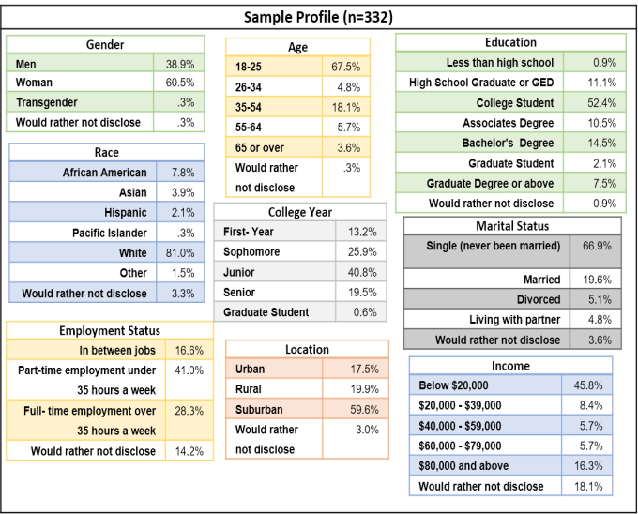

**APPENDIX C**

|  |  |  |  |
| --- | --- | --- | --- |
| **Hypothesis:** | **Results:** | | |
| **H1: Perception of the parent company influences the perception of the product line for the following (individually)** | **R2** | **F** | **p** |
| **Honest Doritos, PepsiCo** | **27.2%** | **123.326** | **.0001** |
| **Honest Lays, PepsiCo** | **25.9%** | **115.204** | **.0001** |
| **Cool Doritos, PepsiCo** | **21.9%** | **92.447** | **.0001** |
| **Cool Lays, PepsiCo** | **23.7%** | **102.448** | **.0001** |
| **Reliable Doritos, PepsiCo** | **18.8%** | **77.804** | **.0001** |
| **Reliable Lays, PepsiCo** | **21.1%** | **88.516** | **.0001** |
| **Out-Dated Doritos, PepsiCo** | **9.2%** | **33.299** | **.0001** |
| **Out-Dated Lays, PepsiCo** | **9.6%** | **35.144** | **.0001** |
| **Successful Doritos, PepsiCo** | **21.9%** | **92.647** | **.0001** |
| **Successful Lays, PepsiCo** | **15.9%** | **62.331** | **.0001** |
| **Honest C&C, J&J** | **21.5%** | **90.282** | **.0001** |
| **Honest Neutrogena, J&J** | **25.3%** | **111.534** | **.0001** |
| **Cool C&C, J&J** | **25.5%** | **104.171** | **.0001** |
| **Cool Neutrogena, J&J** | **27.9%** | **127.955** | **.0001** |
| **Reliable C&C, J&J** | **13.0%** | **49.404** | **.0001** |
| **Reliable Neutrogena, J&J** | **14.7%** | **56.941** | **.0001** |
| **Out-Dated C&C, J&J** | **10.6%** | **39.199** | **.0001** |
| **Out-Dated Neutrogena, J&J** | **14.8%** | **57.474** | **.0001** |
| **Successful C&C, J&J** | **12.4%** | **46.571** | **.0001** |
| **Successful Neutrogena, J&J** | **20.7%** | **86.157** | **.0001** |
| **Honest Kool-Aid, KraftHeinz** | **29.6%** | **139.005** | **.0001** |
| **Honest CapriSun, KraftHeinz** | **27.2%** | **123.142** | **.0001** |
| **Cool Kool-Aid, KraftHeinz** | **18.1%** | **72.797** | **.0001** |
| **Cool CapriSun, KraftHeinz** | **26.8%** | **120.644** | **.0001** |
| **Reliable Kool-Aid, KraftHeinz** | **22.9%** | **98.039** | **.0001** |
| **Reliable CapriSun, KraftHeinz** | **21%** | **87.984** | **.0001** |
| **Out-Dated Kool-Aid, KraftHeinz** | **6%** | **21.022** | **.0001** |
| **Out-Dated CapriSun, KraftHeinz** | **7.3%** | **26.085** | **.0001** |
| **Successful Kool-Aid, KraftHeinz** | **20.8%** | **86.805** | **.0001** |
| **Successful CapriSun, KraftHeinz** | **17.8%** | **71.561** | **.0001** |

**UNDERSTANDING HOARDING BEHAVIOR: A MARKETING PERSPECTIVE**

***Jennifer DeMaria, Siena College***

***Diana King, Siena College***

***Dr. Raj Devasagayam, Siena College***

**INTRODUCTION**

Our principal research objective in this study was to investigate the preconditions that drive hoarding behaviors when consumers perceive a shortage in supply and are faced with other marketing factors. We seek to further understand the lifestyle of consumers, and the impact that instilling urgent needs in advertising and pricing strategies have on hoarding behaviors. The main focal point of this research was to collect information for decision-makers in order to discover the preconditions of hoarding behaviors, and decide the proper advertising, price, and supply in the marketplace.

Prior to conducting research, we created hypotheses based on what we believed about hoarding behaviors. We then searched for secondary sources that focused on our topic in scholarly journals. Our principal reference for our scales came from the *Handbook of Marketing Scales.* This textbook was used to obtain our questions and assist us in designing our own questions based on what was given. We chose to use a descriptive research design with a 7-point Likert type scale, ranging from “Strongly Disagree” to “Strongly Agree” and pretested our survey before distributing it via email, text message, Facebook, and Twitter to members of Siena College, as well as our own friends and family. A total of 348 surveys were received, where 297 of those were fully completed. Data Analysis was performed utilizing SPSS and Cronbach Alphas were run, which measured levels of internal consistency, and found that our range was between 0.735 and 0.768, where a level of over .7 is acceptable. We ran One-Way ANOVA’s to test the significance levels of the variables included in our survey. Additionally, regressions were run to see if positive and/or negative relationships were present.

Our findings indicate that the uncertainty of future supply or perceived shortages have an impact on hoarding behaviors. Consumers with high levels of hoarding behaviors contain the symptoms: difficulty-discarding possessions, carrying “just in case” items, and having a large percentage of unused items. These consumers contain sensitivity to advertisements that portray uncertainty of future items and will produce a higher purchase rate in times of visible shortage. Conclusions that stemmed from our survey involve a greater understanding of the existent relationship between individuals containing levels of uncertainty, and carrying “just in case items”, with 17.7% of consumers who exhibit hoarding behavior of carrying “just in case items” will have a higher purchase rate due to uncertainty of the future. Other key variables that we found related to hoarding were emotional attachment to items, feelings based upon advertising, and perceived scarcity. Specific personalities, including indecisiveness, are more prone to exhibit hoarding behaviors compared to others. In each case women are more likely than men to exhibit hoarding behaviors.

With some patterns and preconditions that elicit hoarding uncovered, the marketing manager can begin to understand the signals that influence hoarding and begin to adjust the marketing strategy. Consumption may be short-run if the perceived shortage is temporary, or it can be a long-run consumption rate if uncertainty of future inventory is perceived as long-term. When the consumer withdraws, the marketing channel will cut back on production of those items. Once the consumer re-enters the marketplace, they will again perceive uncertainty of future supply and begin to hoard. Marketing managers can gain knowledge from this research to determine purchase motives, plan for inventory supply and adjust pricing, and send the correct messages through the marketing channel. Further research is needed to find additional conditions, causes and implications of hoarding behaviors to further acknowledge the differences and similarities between hoarding and other disorders in consumers. Other areas of further research recommended include the effect of individuals who hoard on their families directly, and the effect of this family impact in the marketplace. The participants of this study are limited to the college community, and in order to understand hoarding behaviors from a global standpoint, future research examining the extent of hoarding in other countries would be an excellent area to start.

**CONCEPTUAL BACKGROUND**

We tested hoarding behaviors among consumers to examine what factors lead people to hoard items, and how different personality types affect people’s habits to hoard. We designed research questions to guide our project to focus on hoarding behaviors. The research questions include:

1. What patterns and preconditions exist that formulate hoarding, such as sensitivity to scarcity and consumer expectations of inventory?
2. Will higher levels of urgency in advertising increase hoarding behaviors in consumers?
3. Do high levels of uncertainty within individuals drive higher levels of hoarding?
4. How do visual supply shortages produce hoarding behaviors in consumers that have certain personalities such as indecisiveness?

As a team we were interested in understanding what items people refuse to let go of and why they tend to keep the items that they do. Based upon research, individuals tend to hold onto “just in case items”; they choose to save these items to avoid choosing whether or not to get rid of them. We also found that emotional attachment is involved in hoarding objects.

Hoarding and consumption are related topics, where mass media, inter-personal communication, and the ability to observe price and retail ability are signals under the control of marketing managers. An importance of studying hoarding behaviors lies in the disorderly market dynamics that result from such behaviors. With between 2% and 5% of the population experiencing symptoms of compulsive hoarding, it is not something that should be disregarded. Families of individuals who hoard are significantly affected in regards to health and well-being, which also has an effect on the market. Marketing managers must analyze the threats and opportunities in the uncontrollable market dynamics resulted from hoarding, where both defensive and offensive marketing strategies are required (Stiff 1975). In order to do so, they need to stay attune to the results of advertising on individuals with certain characteristics.

Our research findings are beneficial to the general population as an opportunity to understand how advertisements affect the purchase a product amongst individuals with symptoms of hoarding. Certain demographics, psychographics, and lifestyles are more prone to hoarding than others. Indecisiveness and emotional attachment are associated with hoarding, which our study further examines along with the areas of doubt and uncertainty. When marketing mix decisions recognize this, advertisements that portray an emotional need or urgency to buy the product can be used, which may result in more purchases. Our research findings strengthen previous hypotheses made by past studies in terms of the attitudes and personalities of individuals with hoarding behaviors, along with the symptoms that they demonstrate. We targeted the population between the ages of 18-60 and used a sample to fully better understand the consumer population.

Within the past decade, the rights and interests of the consumer in both the public and private sectors have been an increasing concern. Within the area of attitudes of consumers toward marketing, research holds room to grow; yet the consumer focused approach requires answers (Barksdale, Darden 1972). Hoarding behaviors exist due to the acknowledgement of the scarcity of items that previously had been in excess. Consequently, the consumer’s response to this scarcity is to hoard these items. The industry involves different advertisements and strategies that result in consumers purchasing excess goods of one specific item, these advertisements specifically focus on the area of portraying an urgent need. Advertising for hoarded products could lead to short-run increases in profits. Within the topics of hoarding, media attention and also consumer behavior focused research focuses on the “irrational hoarding”, which is more extreme and overwhelming than lower amounts of hoarding. Certain expectations that stuff is exceptional or unworldly is contributed to media construction itself, and the “normal daily experience with the state and placement of objects” (Maycroft 2009). Our study examines the correlation between psychological and demographic aspects of the symptoms of hoarding themselves amongst various levels of extremes.

**Figure 1**

**Conceptual Model**

**Demographics**

**Psychographics**

**Lifestyle** **Habits**

IV1

IV2

IV3

**Attitudes toward Advertising**

**Independent Variables**

**Gender**

**Age**

**Location**

**Education**

**Employment**

**Marital Status**

**Annual Income**

**Risk aversion**

**Worrisome**

**Indecisiveness**

**Doubtful**

**Highly influenced by others**

**Emotional attachment to possessions**

**Control over possessions**

**Increased actions based on past**

**High buying rates during expected shortages**

**High belief in advertising**

**Purchases made from feelings from advertising**

**High levels of urgency in advertising**

**Uncertainty of the future leads to increased** **purchases**

**Difficulty discarding possession**

**Large percentage of unused items**

**Carry “just in case” items**

**Dependent Variables**

**Hoarding Behavior**

**RESEARCH**

IV4

Hoarding exists when the consumer’s current inventory of an item exceeds the inventory for previous periods, while consumption rate stays the same. Hoarding Disorder is referred to as acquisition and failure to discard a large number of possessions, where it has direct effects on financial planners, therapy, and health (Canale 2013). At different levels, hoarding can be problematic and can “cause clinically significant impairment.” Modeling, pertaining to the family vulnerability to regarding the observation of hoarding behaviors, demonstrates that those who hoard may do so due to an external influence (Canale 2013). Dangerous and unhealthy living conditions, including physical and mental illness and debt, are present in families who hoard (Busher 2013). Symptoms of distress are due to retaining items to avoid the possible negative side effects of discarding the item. Options to further develop research may include the individual influencers on hoarders themselves; a complex relationship between ecological, cognitive, and executive functioning variables contributing to difficulty discarding, clutter, and acquiring. Hoarding specifically involves emotions of fear, anxiety, and distress. It is a sizable desire for hoarders to avoid negative emotions (Timpano 2014). This explanation relates to a similar issue of hoarders “avoiding the harmful consequences of throwing things away” (Frost 1995). The responsibility of harm in throwing an item away involves negative feelings to a point where the individual just avoids the action entirely, and retains the item. However, empirical research in hoarding is still in its infancy, and can further be developed.

Advertisements reach the vulnerability of individuals who hoard. Specific personalities are affected by hoarding differently when the urgency of situations increases (Frost 1995). In fact, theories of hoarding lead to marketing implications involving distribution pricing, advertising and public relation positions, for “hoarding develops as a result of emotional responses to various thoughts and beliefs”(Canale 2013). Sociologists place a greater role on mass media and interpersonal communications as signals for hoarding, as well as the direct observation of both retail ability and purchase behavior of other consumers. Advertising would increase generic product design leading to competitor’s stock outs, which produces brand switching, and increases the long and short-term market share (Stiff 1975). Understanding advertising’s role in hoarding behaviors is essential to establish efficient advertisements based upon findings.

Hoarding develops as a result of “conditional emotional responses to various thoughts and beliefs” (Canale 2013). Hoarders are more likely to experience traumatic life events, which lead to higher severity of hoarding (Canale 2013). Hoarders also think about the future uncertainties and the chance that the items are needed in the near term. Difficulty discarding, acquisition problems, clutter, and interference/distress were identified as symptoms of hoarding (Coles 2003). After a self-report, findings that indecisiveness, maladaptive evaluative concerns, and OCD symptoms associate with hoarding. This study also found that the main sources of compulsive hoarding include information-processing deficits, problems in forming emotional attachments, behavioral avoidance, and erroneous beliefs about the nature of possessions. Individuals who are hoarders carry more “just in case” items, and also carry possessions in order to avoid making the decision to discard them, thus indicating indecisiveness.

“Possessions are imbued with importance far in excess of their true value” (Frost 1995). Beliefs about possessions, emotional distress, and avoidance result in manifestations of hoarding. Symptoms are defined as saving unless the items contain little or no sentimental value, which is distinguished from items that they find “interesting and valuable” (Frost 1995). Extreme levels of clutter are where hoarding becomes pathological. This relates to our study, for we are seeking to discover the levels of items that individuals face, in relation to the amount of emotional attachment that they hold. When possessions provide feelings of safety, there are higher levels of emotional attachment. In fact, “impaired mental growth, checking and doubting” were highly correlated with hoarding (Frost 1995).

Symptoms relating to compulsive hoarding involve acquisition and buying. Hoarding Disorder is a psychological disorder and also a money-management disorder. Hoarding of low-priced consumer goods are based on expectations of short-run instability of supply (Stiff 1975). Goods with high intrinsic value involve collections based on long-run scarcity. “The degree of hoarding is based off of the ratio of current inventory to previous inventory.” A necessary condition for hoarding is that the present cost is less than the future cost, which can be indicated in the prices of goods themselves. The future cost would include the future expected price of goods. An increase in prices may increase demand. A company is more likely to increase its short-run profits by raising prices during hoarding. In fact, increases in higher prices may trigger increased hoarding levels. Money itself can be hoarded, which should be taken into account. When money is viewed as sacred, as shown with the analytical personality type, bargain hunting, indecisiveness and saving in case of unarmed threats occurs (Canale 2013). This leads to under spending. “Collections are based on assumptions of long-term scarcity of the collected goods, which are often of high intrinsic value” (Stiff, 1975). The uncertainty of scarcity motivates individuals to hoard at higher levels.

**METHODOLGY**

The type of study that we conducted was a quantitative, descriptive research design. This design is adequate to use to summarize demographics, attitudes and beliefs. We utilized types of secondary data from past studies including journal articles and scales from the *Handbook of Marketing Scales*. We used an online questionnaire using a nonprobability sample that was based on four independent variable categories: demographics, psychographics, lifestyle habits and attitudes towards advertising. We measured the dependent variables of hoarding behaviors such as difficulty discarding possessions, having a large percentage of items not used, and carry “just in case” items.

**HYPOTHESES**

For research purposes, we created a variety of hypotheses to test. The hypotheses are as follows:

1. A higher level of urgency within advertising increases hoarding behavior in consumers.

2. Patterns and preconditions such as emotional attachment lead to hoarding behavior

3. Visual supply shortages lead to hoarding behavior in consumers with specific personalities particular to hoarding.

4. High levels of indecisiveness leads consumers to have difficulty discarding possessions, relating to hoarding behaviors.

5. A high level of uncertainty in individuals drives higher levels of hoarding.

**SCALES AND VALIDATION**

The scales used were taken from three sources: The *Handbook of Marketing Scales: Multi-item Measures for Marketing and Consumer Behavior Research, Third Edition* as well as *The Hoarding Rating Scale,* Tolin, D.F., Frost, R.O., & Steketee, G. (2010), and the *Big Five Factors Personality Model,* Paul Sinclair.

Below are the original scales we used from The *Handbook of Marketing Scales* and the Hoarding Rating Scale with the corresponding Cronbach’s Alpha’s. All of our adaptations to the scales were 0.70 and above, which indicates a high correlation and good internal consistency.

**Table 1**

**Cronbach’s Alpha**

|  |  |  |
| --- | --- | --- |
| **Original Scale** | **Cronbach’s Alpha** | **Our Adaptation to Scale Cronbach’s Alpha** |
| Psychographics | 0.80 | 0.751 |
| Possession Satisfaction | 0.80 | 0.764 |
| Attachment to Possessions | 0.80 | 0.735 |
| Compulsive Buying Scale | 0.884 | used 1 item from scale - no CA |
| Price Perception | .78 - .90 | 0.747 |
| Consumer Attitudes Toward Marketing | .69 -.76 | 0.768 |
| The Hoarding Rating Scale | .77 -.91 | 0.735 |

**SURVERY DESIGN AND IMPLEMATION**

We decided on an online survey method to implement our study. Several aspects were included in this form of survey. One aspect was that the respondent was able to stay anonymous. Second of all, online surveys are a less expensive compared to other survey methods, and held no cost in our study. Lastly, respondents were forced to answer every question in order to complete the survey. This was advantageous to reduce error. To distribute the survey we used snowballing, where the survey was sent to family and friends, and then passed along from there; this is also called “referral sampling” (Devasagayam 2014). This nonprobability strategy cannot be used to generalize the population. We did not use screening questions, except for the initial over the age of 18 previous to the survey.

Our goal was to sample 300 respondents for our survey with the target population of individuals aged 18 years and older. We ended up with 348 respondents, with 297 who fully completed the survey. We used structured, matrix type questions. In regards to scale measurement, we chose to use an interval 7-point Likert-type scale order to measure absolute differences between scale points. (Devasagayam 2014). The two anchors, ranging from “Strongly Disagree” on the left as “1” and “Strongly Agree” on the right as “7.” Since each question was structured, the respondent had to choose from predetermined responses. The survey was kept under 5 minutes to reduce fatigue within the survey, and to launch an unpaid survey that respondents would fully complete. Our questions were broken up by category.

We had to undergo various steps to implement our survey. After we came up with the topic that we wanted to focus on, the hypotheses were formed. We located secondary data that related to hoarding behaviors among consumers to confirm we had enough information to support our research. We began to develop questions that we believed would work well with our survey, and the developed our sample frame. We pretested our survey and revised

it to reduce the number of items, make sure they were in the correct order, and word our questions in order to get interval level data. We chose to put psychographic questions in the beginning of the survey, survey questions relating to first lifestyles then advertising, and then questions of hoarding, followed by demographic questions at the end. After doing this, we pretested the data to see if any changes needed to be made. We finalized our questionnaire and then launched it to collect data.

Sample Profile



Our Sample consisted of 297 participants. Out of these participants, 67% of the population were female, while 32% were male, the remaining 1% consisted of transgender and other identities. In analysis, we measured the comparison between the top two genders, and removed the one percent. Just above half (53.9%) of participants are single, where 21.1% are in a relationship; 24.9% are married either with or without children. A majority of participants live in a suburban area. The largest income level is less than $20,000 with 40.1%. A majority of our survey included participants with some college education while 58.6% of the sample was between the ages of 17-25 years.

**FINDINGS**

|  |  |  |
| --- | --- | --- |
| **Hypotheses: ANOVA** |  | **Results** |
| H0 There is no difference between gender (males and females) for having a large percentage of items not recently used. |  | Reject null  (F= 6.680, p:0.010) |
| H0 There is no difference between uncertainty levels and carrying just in case items.  H0 There is no difference between uncertainty levels and having a large percentage of items not recently used.  H0 There is no difference between uncertainty levels and difficulty discarding possessions. |  | Reject null [all]  (F= 11.195, p:0.0001)  (F= 8.416, p:0.0001)  (F= 6.119, p: 0.0001) |
| **Hypotheses: Regression** |  | **Results** |
| H1 Higher levels of certain personalities (composite) will lead to  consumers having a difficulty discarding possessions. |  | Confirmed  (F=26.999, p:0.0001, R2=.084) |
| H2 Higher levels of indecisiveness will lead to consumers with a difficulty discarding possessions. |  | Confirmed  (F=68.406, p:0.0001, R2=0.188) |
| H3 Consumer attitudes toward urgency in advertising will lead to large percentage of items not recently used. |  | Confirmed  (F=25.036, p:0.0001, R2=0.078) |
| H4 Consumer attitudes that purchases made due to feelings from advertisements will lead to large percentages of items not recently used. |  | Confirmed  (F=27.843, p: 0.0001, R2 = 0.086) |
| H5 Consumers who have high levels of purchases due to shortages will have a large percentage of not recently used items. |  | Confirmed  (F=46.037, p: 0.0001, R2=0.135) |
| H6 Consumers that are uncertain of the future will have high levels of purchases and will carry just in case items. |  | Confirmed  (F= 63.389, p:0.0001, R2 0.177) |
| H7 Consumers with high levels of emotional attachment to possessions will have difficulty discarding possessions. |  | Confirmed  (F=51.719, p:0.0001, R2=0.149) |

Data analysis was performed using SPSS to run the data extracted from our online survey results on Qualtrics. A summary of the results can be found above that compare the independent variables of demographics, personality, lifestyle habits, and attitudes towards advertising against the dependent variables of the three hoarding levels which are difficulty discarding possessions (x25), have a large percentage of items not recently used (x27), and carry “just in case” items (x28). The significance level was set at p<0.10 or below and an R2 of -1.00 - +1.00, which indicates that the independent variable and dependent variable have a strong relationship. We rejected the null hypotheses that states that there is no relationship between the variables.

In order to test if our hypotheses were true, we ran several variables together in One Way ANOVA tests to find if the data was significant. In our first ANOVA test, we used the variables “gender” with “large percentage of items not recently used”. With an F value of 6.680, and a significance level of 0.01, there is a significant difference; gender has a statistically significant impact on having a large percentage of items not recently used. This means that we reject the null hypothesis since there is a relationship between these variables. When the F value is larger, it represents a greater difference between means in the variables.

For the second ANOVA, we ran “uncertainty of the future”, with all three of the reliable dependent variables (x25, x27, and x28). We chose to include all three, for in each of the three cases there were significant differences between the means. With a significance of 0.001 for each variable, and F values of 11.195, 8.416, and 6.119 respectively, we can reject our null hypotheses. There is a difference between the levels of future uncertainty based upon the dependent variables.

After completing ANOVA tests, we ran linear regression tests to further understand the relationships in the data that we collected. We used a composite of psychographics combining the variables indecisiveness, worrisome, a risk avoider, doubtful, impulsive, easily influenced by others, introverted and sensitive and found it to be significant as a composite. This lead us to look deeper into individual psychographic variables, such as indecisiveness, which was in the composite, and found its significance at 0.0001, a high F value of 68.406 and a high R2 value of 0.188. This R2 value demonstrates that 18.8% of consumers with higher levels of difficulty discarding possessions is explained by indecisiveness. This is a high number, and is similar to our literature review, where levels of indecisiveness were associated with hoarding. The Pearson’s correlation coefficient, which measures the strength of the association between variables, is .434. This represents a moderate strength between indecisiveness and difficulty discarding possessions, which is also positive. Indecisiveness holds the highest F value amongst all of our selected hypotheses above, indicating that more variance in hoarding levels that is associated with indecisiveness.

We tested consumer attitudes toward urgency in advertising (x23) as well as purchases made due to feelings from advertisements (x22) against our dependent hoarding variables. We found them to be significant, but were surprised to find they had a low result with F values of 25.036 and 27.843 and R2values of 0.078 and 0.086 respectively. Between these two variables, feelings from advertisements have a larger coefficient of determination, which indicates a stronger linear relationship. It was believed these variables would have a strong relationship and believe further study would be helpful. Whether there was error in the wording or interpretation of the question, a deeper analysis in this area would further discover urgency in association with hoarding.

The last three hypotheses included regression results with R2 values that were relatively higher than the other hypotheses. The variables “higher levels of purchases due to shortages”, “uncertainty of the future”, and “emotional attachment to possessions” contained R2 values of .135, .177, and .149 respectively. The highest, 17.7% of the variance in hoarding is associated with uncertainty of the future. Uncertainty is a large factor to hoarding, with an R value of .421 which indicates that the strength in the association is moderate. Emotional attachment to possessions as well as uncertainty levels relate to prior research, and remain significant in this case.

**CONCLUSIONS AND RECOMMENDATIONS**

After running data analysis, we found that women had a higher difficulty discarding possessions, large percentages of unused items, and large amounts of “just in case” items compared to men. It is important to note that our survey consisted of 73% of participants who were female. However, in each variable of hoarding behavior, females ranked higher than males. Connecting our results to our first hypothesis, we can agree with past studies that a higher level of urgency from advertisements increases the hoarding behaviors in consumers. When we analyzed the results of consumer’s attitudes to the responses given by males and females, our hypothesis was validated.

For our second hypothesis, we were interested in knowing if patterns and preconditions, such as emotional attachment, lead to hoarding behaviors. Our data showed that females held a higher mean in this area than men, displaying that women have more of an emotional attachment to items. We found that there is a 14.9% impact on consumers with high levels of emotional attachment to possessions will display hoarding behaviors.

The third hypothesis was that visual supply shortages lead to hoarding behaviors in consumers that have specific personality’s particular to hoarding. In order to test this we needed to see how often there are shortages of specific items that result in consumers purchasing so much at just one time. The marketing scales gave us a value that resembled a good level of consistency at 0.884. We only used one item from the compulsive buying scale because it was the only item significant to hoarding behaviors among consumers. Our data showed that there is a 13.5% impact on consumers who make a purchase very often due to shortages will display personality’s specific to hoarding. Also, uncertainty of future supply and perceived shortages stands out, as shown in our literature review.

The fourth hypothesis that we had was that high levels of indecisiveness will lead consumers to have difficulty discarding possessions relating to hoarding behaviors. Our data showed that there is an 18.8% of the customer impact regarding discarding possessions is explained by indecisiveness. Indecisive individuals have a hard time discarding items. We ran an ANOVA to determine if there was a relationship between difficulty discarding items due to indecisiveness, and there was a relationship.

Our last hypothesis was that a high level of uncertainty in individuals drives higher levels of hoarding. Our results showed us that 17.7% of people who are uncertain would express higher levels of hoarding behaviors. When we ran ANOVA tests we focused predominantly on males and females with our variables.

We tested demographics, psychographics, lifestyle habits, and attitudes towards advertising against the three hoarding levels. The hoarding levels include difficulty discarding possession, large percentage of items not used, and large amounts of “just in case” items held. We have a fourth dependent variable, emotional distress because of clutter, but we chose not to use this variable because our Cronbach’s Alpha with this variable came out to be 0.683, which is a low score. When we removed this variable our Cronbach’s Alpha increased to 0.754, which is considered to be good. Consumers revealed that they are statistically influenced by the four independent variables to have difficulty discarding possessions, hold a large percentage of unused items, and hold a large amount of “just in case” items. With statistically significant data, conclusions that emerged included a relationship to exist between uncertainty and all three symptoms of hoarding, as well as relationships of indecisiveness, certain personalities, as well as feelings from advertisements related to hoarding behaviors suggest that hoarding behaviors stem from a combination of areas. Personality characteristics, certain demographics, mindsets, and exposure to aspects of the media are preconditions along with many others that relate to hoarding behavior.

**MANGERIAL IMPLICATIONS, LIMITATIONS AND FUTURE RESEARCH**

From this research, managers can determine what causes hoarding in terms of marketing strategies, such as advertising. In terms of adjusting prices, companies need to be aware of the levels of price changes in addition to how important the items are portrayed. With significant levels found between hoarding and specifically chosen characteristics, as well as a significance in regards to indicated shortages, managers must stay attune to these factors in terms of marketing strategies, such as advertising.

One of the critical limitations that we came across while conducting our research is that the majority of our respondents were students at Siena College. Since Siena does consist of a small community, the responses that we received could possibly have been biased due to these interviewees responding to the questions in a comparable way. Another limitation was the amount of time that we were given to have respondents complete our survey. We had to send out our survey link in a timely manner and receive our responses within a short time span. We did not have the opportunity to send out our survey to as many people as we would have hoped. Since we were restricted to an online survey, we were unable to conduct in-depth interviews to receive detailed responses.

Another limitation of this study is that we are focusing on the total household income of each respondent, but we are unsure if their attitudes towards purchasing items that they would possibly hoard might differ if individual income was focused on as well. In regards to employment status, we do not know if people in unpaid internships selected “unemployed,” “full-time,” or “part-time” as their response. However, we also neglected to include a “retired” section for employment status. We only sampled respondent’s aged 18 and over, so we do not know if younger children hoard items that hold a strong meaning to them. Demographics regarding age in this study included mostly college students, even though we did have a few people 65 years old and up. Consumer’s ability to hoard is not influenced by income level, as the largest income level is $20,000, which are college students.

Another limitation is that we did not include specific geographic region, so we do not know if participants were international versus national. This brings up an area of further study, including hoarding behaviors in different cultures. With numerous areas containing various priorities, accepted behaviors, as well as other cultural and economic differences, there are areas to discover various other triggers of hoarding behaviors. Different markets and marketing plans amongst companies internationally utilize various techniques; to look deeper into the effects of cultural aspects on hoarding is an understudied area.

There is room to further discover the area regarding hoarding and the topic of finance, for individuals may hoard money itself. Hoarding disorder, as a money disorder has a “direct effect on financial planners”, and also “the financial health of clients” (Canale 2013). Knowing this information would further analyze the money aspect of hoarding, which may have a large impact on the market, for hoarding can affect many aspects of individuals’ lives thus affecting the market in multiple ways. Understanding the impact of members related to, or in the same household as an individual who hoards is also another area for future study. Hoarding behaviors may rub off on close individuals, and may have a large impact on the behavior and formed habits of other members. Do children of individuals with hoarding symptoms grow up and resemble similar habits? These areas of further research have yet to be determined.

Future research can be done on retailers who intentionally limit supply and availability causing the consumer to perceive the items as perishable and scarce (Byun, Sternquist 2008). Understanding how consumers perceive perishability and scarcity of items will help marketing managers develop the appropriate retail strategies to accelerate purchase rates. (Bulow 1986). The Commodity Theory, Endowment Effect, and Prospect Theory distinguish how consumer’s value commodities that are scarce, have an attachment to possessions, and respond to a loss aversion. Further exploring these theories as they relate to hoarding behaviors may give insight into behavioral responses to the tactics of perceived perishability and scarcity of consumer goods.

**REFERENCES:**

Barksdale, Hiram C., and William R. Darden. "Consumer Attitudes toward Marketing and Consumerism." *Journal of Marketing* 36.4 (1972): 28. Web.

Bearden, William O., and Richard G. Netemeyer. *Handbook of Marketing Scales: Multi-item Measures for Marketing and Consumer Behavior Research*. Thousand Oaks, CA: Sage Publications, 1999. Print.

“Big Five Model of Personality.” *Encyclopedia of Quality of Life and Well-Being Research,* 2014, 394. Web.

Bulow, Jeremy. "An Economic Theory of Planned Obsolescence." *The Quarterly Journal of Economics* 101.4 (1986): 729. Web.

Büscher, T. P., Dyson, J. and Cowdell, F. “The Effects of Hoarding Disorder on Families: An Integrative Review.” Journal of Psychiatric and Mental Health Nursing, 21.6 (2013): 491–498.

Byun, Sang-Eun, and Brenda Sternquist. "The Antecedents of In-store Hoarding: Measurement and Application in the Fast Fashion Retail Environment." *The International Review of Retail, Distribution and Consumer Research* 18.2 (2008): 133-47. Web.

Canale, Anthony, and Bradley Klontz. "Hoarding Disorder: It’s More Than Just an Obsession - Implications for Financial Therapists and Planners." *Journal of Financial Therapy* 4.2 (2013): 42-63. Web.

Cherrier, Hélène, and Tresa Ponnor. "A Study of Hoarding Behavior and Attachment to Material Possessions." *Qualitative Market Research: An International Journal* 13, no. 1 (2010): 8-23. Web.

Coles, Meredith E., Randy O. Frost, Richard G. Heimberg, and Gail Steketee. "Hoarding Behaviors in a Large College Sample." *Behaviour Research and Therapy* 41.2 (2003): 179-94. Web.

Devasagayam, Raj. *Research Methods*. United States of America: McGraw-Hill Education, 2014.

Frost, Randy O., Tamara L. Hartl, Rebecca Christian, and Nicole Williams. "The Value of Possessions in Compulsive Hoarding: Patterns of Use and Attachment." *Behavior Research Therapy* 33.8 (1995): 897-902. Web.

Maycroft, Neil. "Not Moving Things Along: Hoarding, Clutter and Other Ambiguous Matter." *Journal of Consumer Behaviour* 8.6 (2009): 354-64. Web.

McKinnon, Gary; Smith, Milton E; Hunt, H Keith. “Hoarding Behavior among Consumers: Conceptualization and Marketing Implications.” *Journal of the Academy of Marketing Science,* 13.1-2 (1985): 340-351. Web.

Stiff, Ronald, Johnson, Keith, and Tourk, Khairy Ahmed, “Scarcity and Hoarding: Economic and Social Explanations and Marketing Implications,” in NA- Advances in Consumer Research Volume 02 (1975), eds. Mary Jane Schlinger, Ann Abor, MI: Association for Consumer Research, Pages: 203-216.

Timpano, Kiara R., Ashley M. Shaw, Jesse R. Cougle, and Kristin E. Fitch. "A Multifaceted Assessment of Emotional Tolerance and Intensity in Hoarding." *Behavior Therapy* 45.5 (2014): 690-99. Web.

Tolin, D.F., Frost, R.O., & Steketee, G. “A Brief Interview for Assessing Compulsive Hoarding: The Hoarding Rating Scale-Interview”, Psychiatry Research, 178.1. (2010). 147-152.

**Factors AFFECTING RETENTION AT**

**SIENA COLLEGE**

***Kyle Aberasturi, Siena College***

***Haleigh Topetro, Siena College***

***Dr. Manimoy Paul, Siena College***

*Abstract*

*The retention of students’ year over year has become a major focus and challenge for all colleges. It is a primary factor in forecasting a college’s budget and future investment expenditure. Maintaining a high retention rate affords a college greater stability, which directly affects future growth. A more reliable and steady stream of tuition revenue can be projected as a result of higher student retention. This study was conducted in accordance with Siena College’s great reputation for sustaining high annual retention rates. Our research focuses on the probability a freshmen student enrolled at Siena College will be retained for the next semester. The factors used to conduct this study were GPA, location, school of study, and number of on campus activities participated in. By utilizing these results, Siena College can structure policies focusing on those individuals with the lowest probability of being retained.*

**INTRODUCTION**

Every year, colleges receive new students looking to further their education.  These new students have done their research to determine which college will be the best fit for them.  One major criteria of the research that they do involves the college’s retention rate.  No student wants to enter a college with a retention rate of less than 50 percent.  If the college has a poor retention rate, students may believe that there could be something wrong with that specific college.

              Two-year colleges have a variety of students that continue on to four-year colleges, whilst some graduates choose to enter the workforce after two years.  The retention of these students are low if their GPA is low.  They also have a poor retention rate if the community college is more than 50 miles away from a four year institution (Kelly and Crellin, 2012). These two year institutions have a higher retention rate for students that are younger, have a higher GPA, and that receive more financial assistance.

              Another study tested the correlation between higher quality schools (based on tuition, of which higher costs were associated with a better education), retention and job benefits.  Higher quality schools proved to create better outcomes for students looking for jobs once they graduate.  They had more success finding higher paying jobs. These colleges, of which a study was done on Clemson University, have a higher retention rate because they are a higher quality institution (Dills and Hernandez-Julian, 2006).

               Siena College is looking to determine the factors that contribute to retention rates.  They are trying to increase retention rates to make the college more successful.  The factors being tested are GPA (above or below a 2.5 GPA), location (inside or outside the capital region), number activities involved in (0 or >1), and which school they belong to (business, science, liberal arts).

These factors are being used to determine how strongly they can be deemed predictors of retention. Once this is determined, the college can use the findings to improve certain aspects of their current process as to hold on to a greater number of students moving forward.

**DATA DESCRIPTION AND SOURCE**

Data collected for this study was gathered from Siena’s Office of Institutional Research. In order to attain more reliable results, we observed a sample size of 2209 freshman, covering a three year span; 2012, 2013 and 2014. The dependent variable (y), was simply retained or not. However, because being retained is a non-numerical variable, either yes or no, our team had to make it a ‘dummy’ variable (See Table 1). Essentially, this is designating non-numerical variables a numerical index. Additionally, excel does not have the ability to calculate a proper regression when the dependent variable is a ‘dummy’ variable. A Probit regression was conducted as a result of its ability to process ‘dummy’ variables as its dependent variable.

Regarding the independent variables (x) used in this research, our team focused on four coefficients. Location was broken down into either living within the Capital Region or living outside the Capital Region. Again, we had to employ a ‘dummy’ variable for this factor (See Table 1). Data focusing on location was important for this research due to Siena College’s ability to attract both local and non-local students. The three schools of study offered at Siena College; School of Business, School of Science, and School of Liberal Arts, was the next factor. Data regarding the two highest budgeted schools, Business and Science, was crucial due to the different levels of work, complexity, and professors offered. This coefficient was further transformed into a ‘dummy’ variable (See Table 1). GPA was broken down into two different brackets; either less than 2.5 or greater than or equal to 2.5. A ‘dummy’ variable was again utilized for this variable (See Table 1). The final variable we included for the study was the number of on campus activities a Siena freshmen become involved in; either zero or at least one. This coefficient was also required to be transformed into a ‘dummy’ variable (See Table 1).

|  |  |  |
| --- | --- | --- |
| **Table 1** | | |
| **Retention:** |  |  |
|  | Not retained: | 0 |
|  | Retained: | 1 |
| **Location:** |  |  |
|  | Outside Capital Region: | 0 |
|  | Inside Capital Region: | 1 |
| **School:** |  |  |
|  | Science: |  |
|  | No: | 0 |
|  | Yes | 1 |
|  | Business: |  |
|  | No: | 0 |
|  | Yes: | 1 |
| **GPA:** |  |  |
|  | Less than 2.5: | 0 |
|  | Greater than or Equal to 2.5 | 1 |
| **Activities:** |  |  |
|  | At least one activity: | 0 |
|  | Zero activities | 1 |

**DATA ANALYSIS METHOD AND RESULTS**

In determining whether location, GPA, activity involvement, or school of study had an influence on Siena’s retention rate, our team constructed various pivot tables and ran regression on the four coefficients. Pivot tables were created to highlight the percentage of retained students within each category. This served as a viable starting point for our team to get a more comprehensive picture. By running a Probit regression using retained as the dependent variable (y), and location, GPA, number of activities, school of business, and school of science as the independent variable (x), our team was able to determine which variables contributed towards the retention rate, thereby allowing us to create an equation to analyze the probability of a student being retained or not.

Pivot tables were formed first, to show an overview of the statistical results. A table was constructed for each variable affecting the retention rate. The four variables were; 1) location, home being inside or outside the capital region. 2) School of study; business, science, or arts. 3) GPA, less than 2.5 or greater than or equal to 2.5. 4) Activities, number of different school activities participated in. With the four pivot tables (See Table 2) our team analyzed the effects each variable had on retention rate. The results identified GPA as the most influential variable. These pivot tables gave our team a more complete understanding before running the regression.

**Table 2**

|  |  |  |  |  |
| --- | --- | --- | --- | --- |
| **Location (permanent address)** | |  |  |  |
| **Count** | **Retained:** |  |  | **Retention** |
| **Location** | **No** | **Yes** | **Total** | **rate** |
| **Inside Capital region** | **77** | **537** | **614** | **87.5%** |
| **Outside Capital region** | **185** | **1409** | **1594** | **88.4%** |
| **Total** | **262** | **1946** | **2208** | **88.1%** |
| **School** |  |  |  |  |
| **Count** | **Retained:** |  |  | **Retention** |
| **School** | **No** | **Yes** | **Total** | **rate** |
| **Arts** | **99** | **650** | **749** | **86.8%** |
| **Business** | **102** | **643** | **745** | **86.3%** |
| **Science** | **61** | **653** | **714** | **91.5%** |
| **Total** | **262** | **1946** | **2208** | **88.1%** |
| **Cumulative GPA** |  |  |  |  |
| **Count** | **Retained:** |  |  | **Retention** |
| **GPA** | **No** | **Yes** | **Total** | **rate** |
| **<2.5** | **110** | **262** | **372** | **70.4%** |
| **>=2.5** | **138** | **1684** | **1822** | **92.4%** |
| **Total** | **248** | **1946** | **2194** | **88.7%** |
| **Number of student activities** |  |  |  |  |
| **Count** | **Retained:** |  |  | **Retention** |
| **Activities** | **No** | **Yes** | **Total** | **rate** |
| **0** | **152** | **941** | **1093** | **86.1%** |
| **1** | **71** | **530** | **601** | **88.2%** |
| **2** | **23** | **260** | **283** | **91.9%** |
| **3** | **6** | **134** | **140** | **95.7%** |
| **4** | **7** | **45** | **52** | **86.5%** |
| **5** | **1** | **20** | **21** | **95.2%** |
| **6** | **2** | **8** | **10** | **80.0%** |
| **7** |  | **6** | **6** | **100.0%** |
| **13** |  | **1** | **1** | **100.0%** |
| **15** |  | **1** | **1** | **100.0%** |
| **Total** | **262** | **1946** | **2208** | **88.1%** |
| **1 or more** | **110** | **1005** | **1115** | **90.1%** |
| **2 or more** | **39** | **475** | **514** | **92.4%** |

The regression resulted in the following equation regarding the probability Siena College retains a freshmen:

**RETAIN = 1-@CNORM(-(0.9244375072 - 0.0709790474*LOC + 0.6580619746*GPA - 0.0552453879*SOB + 0.25226691*SOS - 0.3103856725*Z_ACTV))**

With this equation, Siena College can predict the probability of retaining a freshman based upon the student's location, school of study, GPA, and activity involvement. Additionally, the Probit regression showed the greatest significance in the variables GPA, Z-stat = 4.4187, and involvement in a school activity, Z-stat = -2.2625. Highlighted below are the scenarios that result in the lowest and highest chance of retaining a Siena College freshmen student:

**Lowest Probability** = 68.72%: Living inside the capital region, having a GPA less than 2.5, studying in the School of Business, and not being involved in any on campus activities.

**Highest Probability** = 96.67%:  Living outside the capital region, having a GPA greater than a 2.5, studying in the School of Science, and being involved in at least one activity

**CONCLUSION**

This research provides answers to several important questions surrounding Siena College’s retention rate. Based on the aforementioned results, it identifies GPA and on campus activity involvement as the most significant factors in determining whether a freshmen is retained. Additionally, it suggests Siena College’s School of Science is better suited in retaining students as compared to the School of Business. Employees and Trustees at Siena College should use this information to provide increased policy focus within these areas. A few policy proposals that may arise from this research include introducing a mandatory program that first year students must join a club related to their major or interests, creating more effective extra help programs to support students struggling with their GPA, and also allocating more funds towards the School of Business. Further data should also be retrieved and analyzed such as individual families income, transfer opportunities, high school GPA, and students overall productivity and determination. A college’s retention rate can be one of its greatest assets in determining the future success of its student body.

**REFERENCES:**

DeBerard, Scott M., Glen I. Spielmans, and Deana L. Julka. "Predictors of Academic Achievement and Retention among College Freshmen: A Longitudinal Study." *ERIC*. Mar. 2014. Web. 14 Nov. 2015. <http://eric.ed.gov/?id=EJ701984>.

Dills, Angela K., and Rey Hernández-Julián. "Transfer College Quality and Student Performance." *Eastern Economic Journal* 34 (2009): 172-89. *Business Source Premiere*. Web. 14 Nov. 2015. <http://web.a.ebscohost.com/ehost/pdfviewer/pdfviewer?sid=df5228b5-8a6d-4948-925b58b147162a44%40sessionmgr4001&vid=4&hid=4106>.

Kelly, Patrick J., and Matthew A. Crellin. "Retention and Transfer in Colorado's Public Colleges and Universities." *National Center for Higher Education Management Systems*. N.p., Oct. 2012. Web. 14 Nov. 2015. <http://www.nchems.org/pubs/docs/CO%20NCHEMS%20Retention%20and%20Transfe r%20in%20Colorado%20Final_2012.pdf>.

**LEGO CASE STUDY**

***Michael O’Connell, Siena College***

***Dr. John O’Neill, Siena College***

**INTRODUCTION**

The LEGO Group has sustained growth and profitability over the past eleven years, as a result of a switch in management, strategy, and philosophy. To continue this trend of profitability and growth, the LEGO Group must rethink their current strategy. A future strategy must focus on ways to decrease expenses because the potential for increased market share based solely on the LEGO brick is dwindling. With this in mind, there are both risk factors that can be mitigated and opportunities that can be taken advantage of if LEGO wants to maintain its successful reputation. The LEGO Group needs to recognize the risk of currency exchange rates to their global sales. The volatility of currencies against the krone have been increasing, which will decrease the potential for maximum profit. Related to this is that the price of petroleum is highly volatile which can add unpredictable expenses. Furthermore, the LEGO stores and related marketing techniques do not provide enough revenue to effectively benefit the corporation. As for lost opportunities, the LEGO Group is not utilizing their manufacturing space to its fullest potential. Subletting manufacturing equipment and space during low-production quarters would provide new revenue streams for increased profitability. In addition, licensing is an area that the LEGO Group can further take advantage of. Finally, the LEGO Group must be careful with how they innovate in the future. Historically, expansion into different toy markets has hurt the company. This is due to the fact that the LEGO Group invested in high-cost projects that did not bring back the return that was expected.

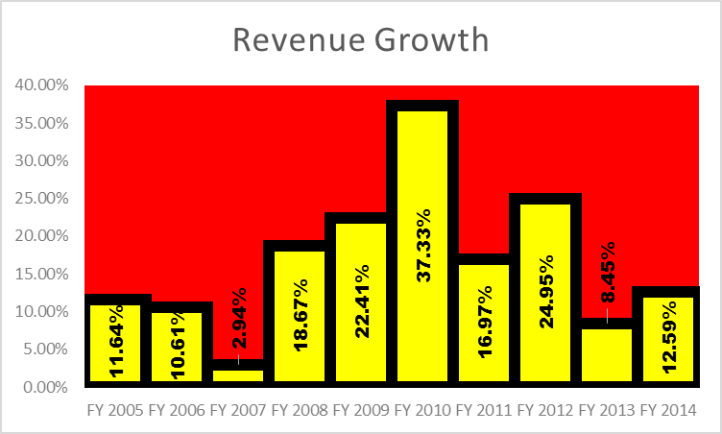The LEGO Group is a consistent giant in the toy industry and the consumer discretionary sector as a whole. With encouraging and consistent levels of revenue growth, The LEGO Group continues to be a company that guarantees value, year-to-year. The pattern of revenue growth over the previous 10 fiscal years can be seen below:

However, it can be clearly seen that there is a spike, an outlier, in 2010. With the removal of this outlier, revenue growth is substantial year-to-year but trends downwards on the right tail. The boom of LEGO *Star Wars* and other licensed segments of the LEGO market caused a large spike of revenue in 2010. While this is an encouraging sign for future prospects of licensing and success with popular culture influences, a growth rate of

2010’s caliber is not sustainable and arguably non-organic as it is generated under extraordinary circumstances. Nonetheless, The LEGO Group has experienced impressive revenue growth over the past 10 fiscal years and, though trending down, is likely to continue impressive revenue growth as it normalizes to a more sustainable rate.

The LEGO Group has experienced equally impressive and encouraging net income growth rates. Over the past 10 years, LEGO has managed to average 42.04% net income growth, year-to-year; an impressive figure. However, the removal of several outliers such as FY 2006 (140.37%) and the boom year of FY 2010 (68.23%) results in year-to-year growth of net income falling to 26.47%. Seen below, net income follows a similar trend as revenue but is more dramatic of a drop off on the right tail:

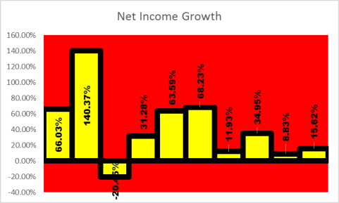

While the revenue growth is arguably normalizing and lowering to a more sustainable growth rate, assumedly in the 8-12% range, net income does not show a similar trend. Removal of the outlier of 2006 shows high volatility and drop-off of growth on the right tail, towards 2014. This trend could be a result of many factors, however, it is most likely a function of fluctuations in exchange rates and commodity prices. The fluctuation of exchange rates can be characterized by the growth of The LEGO Group’s foreign exchange losses as shown on the income statement. This item has increased 1300% from 2010-2014. While the effect on net income is not dramatic as a result of exchange rate losses (175m DKK on 28.6b DKK of revenue), the presence of volatility in exchange rates is a major risk for the going concern of a global company like The LEGO Group. Fluctuation in commodity pricing can be reflected in the cost of goods sold of The LEGO Group. COGS has increased 83% from 2010, compared to an increase of just over 78% of revenue. This is a major contributor to the fall of The LEGO Group’s net income growth. Below is a graph illustrating petroleum pricing in USD from 1/1/2010 – 12/31/2014. While LEGO’s massive plan to switch to a non-petroleum based brick is on its way towards implementation, petroleum fluctuation extends its reaches into all parts of manufacturing and operations. Distribution, transportation and manufacturing are all negatively affected by changes in petroleum pricing as oil and petroleum-based products are present throughout the business world. The LEGO Group’s initiative to switch to a more cost-efficient brick is a step in the right direction towards mitigation of this risk, however, clean transportation, manufacturing and distribution, a wholesale shift, would be necessary to fully mitigate the risks of commodity price changes.

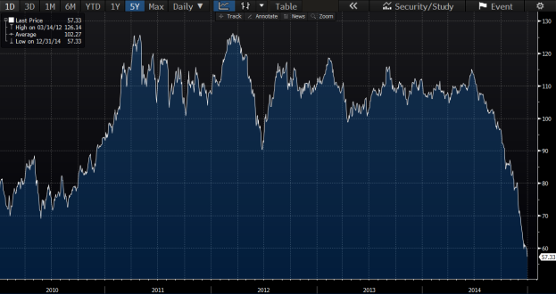

As mentioned above, the LEGO Group has been suffering from foreign exchange volatility. Mitigating foreign

exchange loss and risk would be beneficial to maintain a growth trend. Due to the globalization of the LEGO Group, headquartered in Billund, Denmark, there is an inherent risk to the foreign exchange rate of the Danish Krone. The LEGO Group has manufacturing plants in Kladno/Prague, Czech Republic, Nyíregyháza, Hungary, Monterrey, Mexico, and Jiaxing, China. Due to this distribution, the most important foreign exchange rates are the Mexican Peso (MXN), the United States Dollar (USD), the Forint (HUF), the Koruna (CZK), the Hong Kong Dollar (HKD) and the Krone (DKK). The forecasting method used was an ARIMA to forecast the exchange rates in order to get an idea of future trend and volatility. The exchange rates are shown below:

**DKK to USD:**

The model used to forecast the above data was an ARIMA(0,1,0)*(1,0,0) and the model had Root Mean Square

Error of .005. This Root Mean Square Error means that the test was accurate and this fact can be further seen by the low Ljung-Box Statistic of 6.79. The forecast showed that the currency exchange rate would remain constant around .15. However, the forecast had a standard deviation of .02, which is moderately volatile considering the scale of the data. This volatility can further be seen by the deviating upper and lower bounds. The LEGO Group should observe the potential for loss based on the United States Dollar exchange rate.

**DKK to HUF:**

The model used to forecast the above data was an ARIMA(0,1,0)*(0,0,2) and had a Root Mean Square Error of .85. Due to the scale of the data, this Root Mean Square Error suggests an accurate forecast and measurement. The accuracy of this forecast is also reflected by the low Ljung-Box Statistic of 8.80. By just looking at the data, there is a clear upward trend. This means that, in Hungary, the Krone is becoming more expensive. Therefore, the LEGO Group is taking a loss when converting Forints back to the Krone. Furthermore, the data forecasted seems to remain constant at 41.6 with small fluctuations. In addition, the model has a standard deviation of 3.18. This standard deviation shows volatility. Therefore, the potential for loss could be higher than forecasted. The LEGO Group needs to recognize the innate risk that is involved with the Hungarian Forint.

**DKK to CZK:**

The model used for the data above was an ARIMA(0,1,0)*(1,0,0) and had a Root Mean Square Error of .07. Based on the scale of the data, the Root Mean Square Error of .07 means that this forecast has a high level of accuracy. This point is further portrayed through the low Ljung-Box Statistic of 9.72. Initially the data shows a downward trend. This means that the LEGO Group is potentially making a gain as comparative to previous years. However, the forecasted data remains constant at 3.62 and has a standard deviation of .54. This standard deviation is relatively high given the bounds of the data. This points to a high volatility within the exchange rate of the Czech Republican Koruna. Therefore, the LEGO Group could receive a loss even though the exchange rate is trending downward. The upper bounds and the standard deviation suggest that the exchange rate could increase in the future.

**DKK to MXN:**

The model used for the above data was an ARIMA(0,1,0)*(2,0,0) and had a Root Mean Square Error of .06. Based on the bounds of the data, this Root Mean Square Error is relatively small. This means that the forecast of the data is a good fit and has a high level of accuracy. The accuracy is reflected in the low Ljung-Box Statistic of 10.19 and the fact that the forecast exceeds the accuracy of a simple average by 98.03%. Just by looking at the data, there is a clear consistent upward trend. The forecasted data seems to be holding consistently at 2.9. This means that the Krone is becoming more expensive based on the Mexican Peso. Therefore, the data forecasted suggests that the LEGO Group will lose money based on the DKK to MXN currency exchange rate. Furthermore, the data has a high level of volatility, evident by the standard deviation, and this could increase the potential for loss. The forecast had a standard deviation of .46, which is large when considering the bounds of the data. This volatility means more future risk to the LEGO Group when converting Mexican Pesos back to the Krone.

**DKK to HKD:**

The model used for the data above was an ARIMA(0,1,0)*(0,0,1) and had a Root Mean Square Error of .04. The Root Mean Square Error means that the forecasted model is accurate, based on the scale of the data. Furthermore, the accuracy can be seen in the low Ljung-Box Statistic of 13.47 and the fact that the forecast was 95.64% more accurate than a simple average. Initially looking at the data, there is a downward trend and a slight upward trend in recent months. This means that the Krone is becoming more expensive in respect to the Hong Kong Dollar. Therefore, every sale made in the Pacific region loses value when converted back to the Krone. Furthermore, the forecast is consistent at around 1.18, which does not indicate a decline in the exchange rate. In addition, there is a moderate amount of volatility based on the standard deviation of .19. This standard deviation is relatively large compared to the bounds of the data. This could indicate a greater potential loss if the currency exchange rate increases more than expected. The LEGO Group needs to be aware of the inherent risk of loss due to currency exchange rates.

All of the foreign exchange rates mentioned above show high rates of volatility based on the standard deviations. This means that the LEGO Group is facing a risk of loss due to these exchange rates because of the nature of their global manufacturing. The LEGO Group has the opportunity to mitigate and decrease the potential losses and the current losses that they are facing based on the foreign exchange rate. The method of mitigation involves forward and spot rates. The LEGO Group can analyze both the spot and forward rates to decide which rate would be most beneficial. The use of forward rates can control the volatility that is portrayed in the foreign exchange rates. This would in turn control the losses that the LEGO Group would incur from foreign exchange rates. This mitigation is an effective tool to decrease expenses in order to continue the trend of sustainable growth and profitability. By controlling the foreign exchange rates, the LEGO Group would retain their value when converting sales and expenses back to the Krone.

One of the risks that can be identified with the LEGO Group is the risk of innovation. Innovation, for most companies, is the key to future success. For the LEGO Group, however, the opposite seems to be true. The “back to the basics” strategy implemented with their management change was said to have worked almost too well. This shows that the LEGO Group is different from their competitors in the fact that they have a strong reputation of quality and consistency to uphold. As soon as the company re-established themselves with their original products, they saw a large increase in revenue. This is a clear indicator that product lines that deviate away from classic “brick” are not growth generating. This means that the LEGO Group has a disadvantage in the innovation game because other companies have the freedom to release several different products and ideas without losing sight of their values.

With extremely high-cost projects such as Galidor, LEGO lost what made them unique compared to the rest of the toy industry: their inspiration for creativity. On the other hand, LEGO has also made innovations in their product lines that have historically worked. With the creation of Bionicle and the production of the LEGO movie in 2014, we can see that the company has successfully supplied the market with creative ideas that have received attention from consumers in the global market. With that being said, not innovating or properly expanding product lines could be a lost opportunity for the company. Too much innovation, though, comes with higher financial risk, as failed projects will have huge sunk costs and opportunity costs.

LEGO also has an opportunity to market their products more uniquely than other toy companies. They have already done this in part with the many stores they have built in cities throughout the world. The stores, they say, are clubhouses, or experiences, rather than opportunities to sell their products. In making their stores, they want to market their products while at the same time avoid competition with their most important distributors, such as Wal-Mart and Toys R Us. These stores, on one hand, are good for marketing, but on the other hand, bad for sales, meaning that there are large costs going into them without a high return.

The LEGO Group is one that inspires creativity and cultivates the interest and minds of tomorrow’s builders. While their stores, with captivating structures and interesting toy sets, represent them well for what they are, they have the opportunity to go above and beyond with their marketing techniques. Since their products are meant for the users to create anything, they can put their ideas in the sights of more people than the ones who just walk in their stores. Imagine full-size LEGO “sculptures,” or public pieces that can be seen by those passing by a park in a metropolitan area. Public structures made of LEGOs, even ones as simple as flagpoles or tables could be put in the public spectacle and represent the company’s ideas and values at a lower cost and in a much more captivating way than the stores could do. By putting LEGOs in public areas and using them in ways that people are almost forced to look at them, LEGO can inspire the awe and creativity that they already do in their stores, but in a new and fun way that represents the creativity that their toys are supposed to provoke.

Licensing has been an important contribution to LEGO’s success. LEGO currently has license agreements with some of the most popular companies and brands in the world. Ranging from Disney to Warner Brothers, numerous products have been released on varying themes. The first of the major licenses was in 2001 with Warner Brothers for the *Harry Potter* theme sets to accompany the release of the films and it ended in 2007. When the license was renewed in 2010, LEGO saw a 32% increase in sales[30] following the release of *Harry Potter* themed products based off the seventh and final movie. Another company that has shown an extreme interest in an agreement with LEGO is Disney. Mostly known for the *Star Wars* collection, Disney has made license agreements with LEGO on other collections as well such as *Toy Story* and *Lone Ranger*.

The license agreements with other companies have been responsible for a majority of the retail revenue for the company in the last decade, proving that the money spent on the license agreements was worthwhile. By introducing other licenses with major companies, they would be able to reach other age groups and expand their target age groups. As LEGO gains more of a reputation and has more success, other companies will want to enter into similar agreements with them on products. The licensing agreements can lead to unique opportunities for new movies that enhance the user experience. Additionally, by having new agreements with other companies, LEGO can attract other interest groups and expand their marketability.

The risk of licensing agreements is that they are not necessarily good for long term profit. There is excitement that accompanies a new movie release or a new event but it only lasts a certain amount of time. The profitability from the product lines would create increases in profit over a short period of time but it would not be able to maintain growth over time without the introduction of other product lines. The product life of a special LEGO collection is incumbent on the product life of the reflected franchise.

As evident above, the current strategy that the LEGO Group employs is outdated and needs to be refocused in order to continue the trend of consistent growth and profitability. As highlighted in this paper, the LEGO Group needs to focus on controlling expenses while supplementing new streams of revenue. Expenses are controlled through currency exchange rates, petroleum and marketing expenses. The foreign exchanges rates based on the LEGO Groups manufacturing locations are highly volatile and can be controlled with forward and spot rates. The LEGO Stores are mainly utilized for marketing. However, the LEGO Group can market more cost-effectively and creatively. The new supplemented streams of revenues are seen in the forms of subletting and licensing. The LEGO Group can sublet their manufacturing equipment during low-production quarters in order to increase revenue. By implementing a strategy that concentrates on these two points, the LEGO group with continue their trend of growth and profitability.

1. It should be noted that the health implications of inequality extend beyond income- to gender, racial, and political inequality (Subramanian and Kawachi).
2. Beyond improved water, the environment has a substantial impact on health outcomes worldwide; an estimated 8-9% of the global disease burden attributable to environmental pollution (Briggs, 2003).
3. Path dependency is the widely accepted theory of economic development. Economists such as Paul Krugman, however, have argued that developing countries are unfortunate due to exogenous dispositions such as geography (Krugman, 1995).
4. Although certain economists, such as William Easterly, are skeptical of the efficacy of international aid and argue these efforts are a form of “postmodern imperialism”, the evaluation of these claims are beyond the scope of this paper (Easterly, 2006).
5. The complete list of the MDGs can be found in the appendix of this study.
6. A list of the SDGs can be found in the appendix of this report.
7. When GDP per capita, PPP data was not available, GDP divided by population was applied. A list of these countries where this applied can be found in the appendix.
8. Two previous papers that investigate the relationship between aid and health outcomes log life expectancy and/ or infant mortality in their specifications (Williamson, 2008; Mishra and Newhouse, 2007).
9. See footnote 8.
10. In particular, a logarithm was applied to income and health care spending. A visualization of the results can be found on Chart 3 in the appendix.
11. When GDP per capita, PPP data was not available, GDP divided by population was applied. A list of these countries where this applied can be found in the appendix.
12. Table 20 (in the appendix) provides a meta-analysis summary of all specifications.
13. From the force of the term
14. IQ is a measure of how quickly intelligence develops in children- an AI system does not have an IQ, per se. ASI will likely be much, much, much more intelligent than man though.
15. Gordon stratifies three industrial revolutions in his paper: “IR #1 (steam, railroads) from 1750 to 1830; IR #2 (electricity, internal combustion engine, running water, indoor toilets, communications, entertainment, chemicals, petroleum) from 1870 to 1900; and IR #3 (computers, the web, mobile phones) from 1960 to present” (Gordon 2012).
16. Gordon does note demographics as a headwind for economic growth, but also treats demographics as an isolated dynamic.
17. Data definitions can be found in the appendix of this report
18. Nanotechnology, not previously mentioned, may eventually have the potential to rearrange molecular and atomic structures, displacing the need for traditional means of production (Urban 2015).
19. New York defines the age of criminal responsibility to be 16 years old whereas most states set the minimum age at 17 or 18 years old.
20. The median age of the adult population in Albany is between 45 to 49 years old (U.S. Census Bureau, 2015).
21. We note that only 31 percent of Albany’s population and 5 percent of Cohoes’ population is Black (Census

    Bureau, 2015), suggesting that Blacks are overrepresented in CAB.
22. It is important to note that, for this analysis, we have not controlled for the year that the person participated in CAB, and Cohoes CAB first began in 2010. Future analysis should compare recidivism rates in Albany CAB and Cohoes CAB only for the cohort of people whose case closed in 2010 or 2011.
23. Reported in 2011 dollars.
24. Cost-savings are measured as direct costs to the state. It is important to note that the future victim, the community, and the offender are also spared direct costs by crime-avoided.
25. See Karp, Bazemore, and Chesire (2004) for a discussion of the link between volunteer participation and the success of the restorative process
26. Keller, K.L. (2013). *Strategic Brand Management:* *Building, Measuring, and Managing Brand Equity*, 4e. (Upper Saddle River, NJ: Pearson), p. 2.
27. Ibid.
28. Diana Plantic Tadic and Sandra Suca (2015). *Comparative Analysis of the Emotional and Cultural Branding Modelsi* (Zagreb, Croatia: International Proceedings of Social and Behavioral Sciences), p. 22
29. PewResearch Center, *Social Media Usage: 2005- 2015*, http://www.pewinternet.org/2015/10/08/social-networking-usage-2005-2015/*,* (2015)
30. Goodley, Simon. "Lego Profits Boosted by Harry Potter Magic." The Guardian. Guardian News and Media, 03 Mar. 2011. Web. 10 Feb. 2016.